The National Agenda for 2011 was established after review of the suggestions contained in the reports of the 2010 Fall Regional meetings, National CODE Meeting and from the Regional CODE Directors. Previous National agendas are reviewed to avoid topic duplication. Inclusion of a previous topic may occur for discussion from the aspect to what has changed and the response/action taken and the outcome.

Thank you to the Regional CODE Directors and the membership for making recommendations to establish the National Agenda. Each Region is encouraged to also have a Regional Agenda.

Each school attending the Regional Meetings is requested to bring their responses to the National Agenda in written form AND electronic media
This information is vital to the publication of the Annual Fall Regional Report.

Continue to invite your colleagues, who are Dental Licensure Board examiners and your Military and Public Health Service colleagues who head/instruct dental education programs to your Regional meetings.

Each Region should select next years meeting site, date or tentative date during your Fall Regional CODE meeting so this information may be published in the Annual Fall Regional Report and on the Web site.

The Regional meeting reports are to be submitted to the National Director in publishable format as an attachment to e-mail.
The required format and sequence will be:
1. CODE Regional Meeting Report Form**
2. Summary of responses to the National Agenda.
3. Individual school responses to the National Agenda
4. The Regional Agenda summary and responses.
5. CODE Regional Attendees Form**
** (Copies may be obtained from the Web site:
http://www.unmc.edu/code/).

NOTE: to locate the web site via a search engine, enter Academy of Operative Dentistry and then use the link CODE and ADEA.

Send a hard copy and an electronic copy of the report to the National Director. Both electronic and hard copy versions are to be submitted within thirty (30) days of the conclusion of the meeting.

National CODE Meeting:
The meeting will be held Monday, February 27, 2012 from 4:15 pm to 6:00 pm at the Westin Michigan Avenue Hotel, room TBA in Chicago, Illinois. Suggestions as to how to make this meeting productive and efficient are requested.

National Directory of Operative Educators:
The CODE National Office maintains the National Directory of Operative Educators as a source for other professionals. It is imperative that the information be as current as possible.

To update your universitys directory listing on the CODE website,

http://www.unmc.edu/code/,

Click on the red link, Please help update, found under the CODE menu on the left side of the screen. Make any necessary changes and click submit form.

Please have each school in your Region update the following information for the National Directory of Operative Educators:
School name and complete mailing address
Individual names: (full time), phone #, fax #, e-mail address of faculty who teach operative dentistry.
(This could be individuals in a comp care program, etc. if there is no defined operative section of department.)

Your help and cooperation in accomplishing the above tasks helps save time and effort in maintaining a complete web site and publishing the Annual Fall Regional Report in a timely fashion.

Thank you,

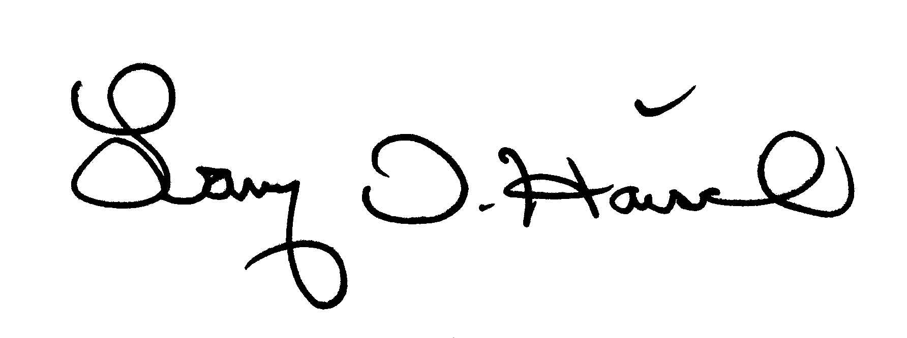

Larry D. Haisch, D.D.S. lhaisch@unmc.edu
National Director, C.O.D.E. Office: 402-472-1290
UNMC College of Dentistry Fax: 402-472-5290
40th & Holdrege Streets
Lincoln, Ne 68583-0750

2011 NATIONAL CODE AGENDA

(Please cite the evidence were applicable. If utilizing reports/forms/schedules from your Regional schools, please submit these as PDF files for utilization in the Annual Fall Regional Report)

I. SURVEY ON THE DEMOGRAPHICS OF FULL-TIME FACULTY THAT TEACH OPERATIVE DENTISTY IN YOUR SCHOOL

A. EDUCATION/TRAINING/SPECIALTY AFFILIATION
- What percentage are General Dentists?
- What percentage has formal ADA-recognized Specialty training such as Prosthodontics?
- What percentage has a graduate degree or certificate in Operative Dentistry?
- What percentage has a degree/certification in Advanced Education in General Dentistry?
- What percentage has a degree/certification from a General Practice Residency?
- What percentage has a graduate degree in Material Science?
- What percentage has formal instruction in teaching and learning theory (e.g., Med, etc)?
- What percentage has no formal post-graduate training?
- What percentage served as a dentist in the armed forces prior to joining your faculty?
- If other training or background is not included in the above, please describe.

B. CERTIFICATION IN OPERATIVE/RESTORATIVE DENTISTRY
- What percentage is certified by the American Board of Operative Dentistry?
- What percentage are fellows or masters in the Academy of General Dentistry?
- What percentage is certified in Restorative by some other agency such as the Armed Forces?
- If other certification relevant to Operative/Restorative, please describe.

C. EXPERIENCE IN TEACHING/PRACTICE
- What is the range of teaching experiences for your Operative Faculty (indicate percentage)? Years: 1-5, 6-10, 11-15, 16-20, 21-25, 25+ (e.g., 1-5: 20%, 6-10: 20%, 16-20: 50%, 25+:10%)
- What percentage of your Operative Faculty conducts a part-time practice in which they treat their own patients (intramural or extramural)?
- How much time, on average, is spent per week in practice? List by hours or half days.
(e.g., 50% spend 4 hrs; 30% spend 8 hrs; 20% spend 0 hrs)

D. TENURE STATUS/ACADEMIC RANK/EFFORT DISTRIBUTION
- What percentage of your Operative Faculty are Tenured/Tenure-track and Non-tenured?
- What is the percentage distribution by Academic Rank of your Operative teachers? Use: Instructor, Assistant Professor, Associate Professor, Professor (for tenured lines) Use: Clinical Instructor, Clinical Assistant, Clinical Associate, Clinical Professor (for non-tenured lines)
- What is the typical distribution of time for your Operative faculty between Teaching (T), Research/Scholarly activity (R/S), Service (S), Patient Care (PC), Administration (A) – effort reporting: e.g., 50% T, 20% R/S, 5% S, 25% PC, 0% A (Answer = average of full-time faculty; exclude exceptions such as Chairs with minimal teaching or significant administration time)
- Do you anticipate significant changes in the roles/duties of Operative/Restorative faculty in the next 5 years? If yes, give a concise description.
- Does your Operative/Restorative faculty feel that they are valued members of the faculty with a similar standing and status as enjoyed by other dental faculty?

E. DESIRABLE CHARACTERISTICS FOR OPERATIVE/RESTORATIVE FACULTY
- For the Chairmen/Section Directors - what personal traits or characteristics do you associate with an effective teacher of Operative/Restorative Dentistry (e.g., the “ideal faculty job description)?

II. DENTAL MATERIALS FOR OPERATIVE/RESTORATIVE DENTISTRY

A. How do you introduce new materials or products in your operative/restorative clinics?

B. Do you have any disclaimers, warnings, or other information documents that your patients have to read and sign relative to safety or risks for dental materials that may be used in their treatment? Yes/No. Examples might include: Amalgam (mercury), Resin (Bisphenol-A), non-precious casting metal (nickel). Describe the materials involved and the documentation used to satisfy informed consent goals.

C. Have you stopped using any dental materials or product categories in the past 5 years due to concerns described above? e.g., Latex Rubber dam

D. Rank the following reasons for using any dental material in your clinic by priority from High to Low: Evidence for Effectiveness, Safety, Economics, Packaging, Ease of Use, Manufacturer Reputation, Other – Describe.

III. ETHICS/PROFESSIONAL CONDUCT AND OPERATIVE/RESTORATIVE DENTISTRY

A. Is there any ethics instruction or other ethical didactic content in your Operative/Restorative curriculum? Identify the courses by name (content), and year in your curriculum (Fr, So, Jr, Sr).

B. If yes, what type of ethics instruction takes place in your restorative courses? Lecture only, small group discussions, on-line instruction, reading assignments, papers, others?

C. Are your Operative/Restorative faculty involved with teaching in an ethics course(s) that is (are) directed by another department? If yes, describe how many are involved as a percentage or fraction of the total faculty in this (these) course(s) e.g., 50% or 3/7ths.

D. If a student commits what would be considered an ethics violation in an Operative/Restorative CLINCIAL course, what types of punishment/sanctions could they face if found guilty? Briefly summarize the process from reporting to final outcome.
IV. CARIOLOGY

A. Which textbook is being used for Cariology?

B. In which department/section are the Cariology courses conducted?

C. What are the faculty qualifications for teaching Cariology?

D. Are full time faculty of Operative Dentistry provided the textbook(s)?

E. Are there concepts of Cariology which are not well supported by the Clinical faculty?

F. What are the concepts and why the lack of support?

G. What are the interpretations of textbook content as to Restorative intervention, caries removal, etc?
(Are there criteria and situations when caries could intentionally be left – restored or sealed?)

V. CARIES RADIOGRAPHIC INTERPRETATION

A. Is there current clinical evidence that supports restorative intervention on interproximal caries that show in the outer ½ of the enamel when viewed on digital imagery?

B. If yes, reference and summarize the conclusions.

C. Do current teaching concepts support restorative intervention on only these interproximal lesions that extend beyond the outer ½ of the enamel when viewed on digital imagery?

D. What are the current teachings for intervention based on 1/3 extensions in enamel and dentin? e.g., outer, middle, inner third

E. What is the evidence-based information that supports the current teaching concept?

F. Is there a discernible difference of radiographic evidence of actual clinical penetration of interproximal caries between conventionally exposed radiographs versus digital imagery? If so, which do you think represents a more accurate depiction of the clinical condition?

VI. COMMUNICATION IN OUR DIGITAL ERA
Students have critiqued faculty in course reviews as not being responsive if e-mails are not answered immediately or over the weekend prior to an examination early in the week.
A. How does the time required to implement and manage an electronic curriculum compare to before the use of online teaching resources?
1. More time
2. Same amount of time
3. Less time
List specifics as it relates to your answer

B. In your experience for individual student interactions do students prefer
1. E-mail to communicate
2. Office appointments
3. Online tools with your electronic curriculum resources

C. When students are e-mailing faculty, when are they expecting a faculty response?
1. Same day
2. Within several days
3. Within a week

D. When students ask a question about a specific course, lecture as it pertains to an upcoming examination, how do you manage your response?
1. Answer that student only.
2. Answer forwarded to entire class (keeping student anonymous) so that all students get the information.
3. No response, student must meet with the faculty member.
4. Faculty are not given any guidelines.

E. How are faculty directed to use e-mail as a communication with students?
1. Respond only during school hours.
2. Respond during school hours and evenings.
3. Respond during school hours, evenings and weekends.
4. Faculty are not given any guidelines.

F. What guidance are students given as it regards faculty responses to student e-mails that are sent off-school hours that the student requires an immediate response?
1. E-mails are responded to only during school hours.
2. E-mails are responded to whenever the faculty wants to.
3. No guidance is given to students about expectations to respond

Regional CODE Agenda
To be established by the respective Region and Regional Director. Please also report on responses to the Regional Agenda from all participants.

Suggestions for CODE.
NOTE: to locate the web site via a search engine, enter Consortium of Operative Dentistry Educators or Academy of Operative Dentistry and then use the link CODE.

