University of Nebraska Medical Center
Medical Laboratory Science Program
Degree Advancement Option (DAO)

Preceptor Responsibilities for Degree Advancement Students

The BSMLS Degree Advancement Option (DAO) at the University of Nebraska Medical Center provides a way for working medical laboratory technicians to obtain a baccalaureate degree through distance learning technology. The DAO is intended for people interested in completing their degree while they continue to work as medical laboratory professionals without having to leave their own community to attend on-campus classes.

A vital feature of the DAO is the support provided by volunteer program preceptors. The DAO would not be possible without the assistance and dedication of our preceptors. The purpose of the preceptorship is to provide a “mentor-student” relationship in the organization or community where the student works.

Preceptor Requirements
All preceptors must meet the following criteria (in order of priority):
- Supervisor/Educator experience
  - The preceptor must function in a leadership, supervisory, or educational role in relation to the student and may not be a peer or coworker at the same level.
- Current certification and in good standing, preferably MT(ASCP) or MLS(ASCP)
3) Baccalaureate degree, preferably in Clinical Laboratory Science/Medical Laboratory Science/Medical Technology or other healthcare-related field

Any deviations from these criteria require approval of the DAO Admissions Committee.

Preceptor Responsibilities to the Student and Program
Throughout the student’s enrollment in the DAO program, the preceptor may be called upon to:
- Proctor quizzes, exams and/or any required remedial work at a mutually agreeable time and location for the preceptor and the student. (Arrangements for alternative proctors may be made, but all proctors must be approved by the UNMC MLS Administration.)
- Inform the UNMC MLS program of any significant problems that develop which require faculty attention, knowledge, or consultation.

Student Responsibilities to the Preceptor
Throughout the student’s enrollment in the DAO program, the student will:
- Provide program advisors with the preceptor’s contact information when applicable.
- Notify the preceptor of any course activities that require their participation at the start of each enrolled semester.
- Initiate scheduling and coordination of activities at a mutually agreeable time and location for the proctor and the student.

Program Responsibilities to the Preceptor
Throughout the student’s enrollment in the DAO program, the UNMC MLS program will:
- Coordinate with the preceptor for delivery of testing materials.
- Provide instructions for exams, or other assignments that require proctoring.

Proctoring of Exams

All exam proctors must be approved by the UNMC MLS Administration. If a student’s approved preceptor/proctor is unable to proctor an exam and requests someone at their facility to substitute for them, UNMC must be notified in advance. Prior to taking the exam, an email including the name of the substitute proctor, their title, email address, phone number and brief explanation of their supervisory experience must be sent to the student’s faculty advisor. MLS administration approval/non-approval of the substitute proctor will be sent to the student’s preceptor prior to scheduling the exam.

Faculty advisors will send preceptors/proctors all passwords needed for any course in which the student is currently enrolled. These passwords should never be shared with the student to protect the integrity of our exams. The degree advancement option (DAO) student will need to make arrangements with their preceptor/proctor to schedule each exam session. As the student pulls up the exam in Examplify, the proctor needs to enter the appropriate password and then proctor the exam as the student completes it. The student should not leave the testing area during an exam. Once an exam is completed, the student will notify both the faculty advisor and the faculty contact for the course that the proctored exam has been completed.

The proctor will provide a writing utensil and scratch paper to the student while taking exams. Students should record their answers to the exam on the provided scratch paper. These items are to be returned to the proctor before the student leaves the testing area. In the event that there is a problem with Examplify and their answers are unable to be submitted, the preceptor/proctor can fax the scratch paper to the course instructor at 1-402-559-9044. If there is no problem in submitting the results on Examplify, the student will give the scratch paper to the proctor who will destroy it. Students will use the calculator available in the Examplify software.

After a student finishes his or her exam, the student must show you this screen on his or her computer before they can leave the testing area. Either of the following two screen shots is acceptable and indicates the exam has been submitted.

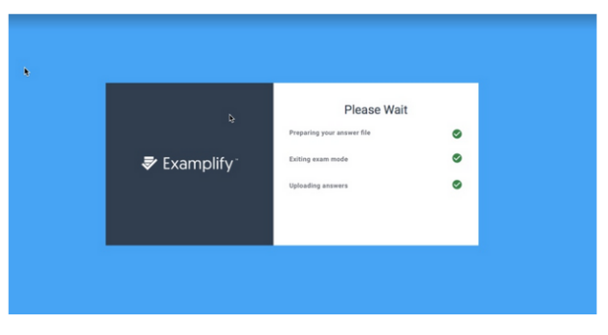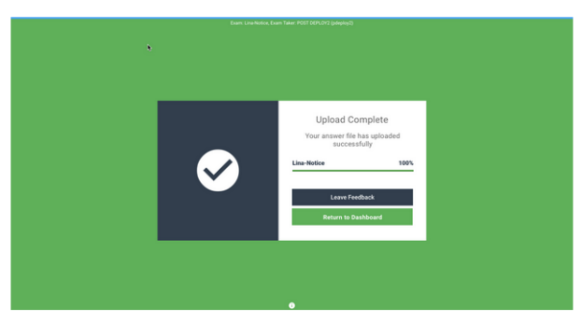
Students will not be permitted to have certain personal items or academic material near their seats while taking exams, unless approved for use during the examination. Examples include, but are not limited to the following:

a. Cellular telephones, electronic devices other than what is required to utilize examination software, such as personal smart devices (e.g., smart watches), recording or filming devices

b. Coats, jackets, headwear, backpacks, book bags, briefcases

c. Books, notes, study materials
If the computer malfunctions while the student is taking an exam, the proctor should attempt to log back in using the password when reconnected. If this does not work, immediately contact either the course faculty contact(s) or faculty advisor via phone. They will try to resolve the issue or send the exam by email to be taken by hand and faxed when completed.

Any student who abuses the testing guidelines will be asked to: submit the unfinished examination along with any scratch paper, writing utensils, etc. to the proctor; exit Examplify; leave the examination area. The proctor will notify the appropriate UNMC faculty contact and faculty advisor. The proctor will be sent an Unprofessional Behavior Documentation Form, asking that it be signed by the student, and returned to the UNMC faculty advisor. A conference with a UNMC program official will follow. This form then becomes part of the student’s permanent record and may be grounds for dismissal from the Medical Laboratory Science Program.

BSMLS DAO Preceptor Agreement Form

I hereby agree to serve as a preceptor for the applicant listed below during their enrollment in the BSCLS Degree Advancement Option at the University of Nebraska Medical Center.

I agree to perform the following services on an “as needed” basis when sufficiently notified by the student or program faculty and staff:

- Proctor quizzes, exams and/or any required remedial work at a mutually agreeable time and location for the proctor and the student or make arrangements for another proctor approved by UNMC.
- Inform the UNMC MLS Program of any significant problems that develop which require faculty attention, knowledge, or consultation.
______________________________________________
Student Name Typed or Printed

I verify that I meet the preceptor requirements. I agree to provide a current resume or CV and my contact information below for use by the student and the program faculty and staff.

Preceptor Information
NAME:
Typed or Printed

Signature Date

CREDENTIALS: _______________________________________________

TITLE:

PLACE of EMPLOYMENT: _______________________________________________

WORK ADDRESS:

City:

State: Zip:

WORK PHONE:
(Include area code and extensions if applicable)

WORK EMAIL:

Are you in a leadership, supervisory, or educational role in relation to the student and not a peer or coworker at the same level? Yes No

What is your highest degree completed? _____________________________________

