**Zero-Waste Event Instruction Manual**

Updated August 2025

**Kit Contents:**

|  |  |
| --- | --- |
| **2 laminated signs for each waste stream** | **1 bucket** |
| **1 box each of large and medium vinyl gloves** | **1 erasable marker** |
| **1 roll of 13 gallon Hefty ReNew (orange) bags** | **1 Handheld scale** |
| **1 roll of 55-gallon compost bags** | **1 roll of tape** |

**Before Event: Make sure these things are done first!**

1. PLANNING is key to success: Consider all aspects of your event and find opportunities to REDUCE and/or opt for supplies that are COMPOSTABLE and RECYCLEABLE
   1. Instead of bottled water, ask participants to bring their own containers
   2. Opt for compostable plates, cutlery, and cups if possible
      1. If using Sodexo, contact catering manager to help with this (559-4029)
   3. Use décor that is compostable/recyclable/giftable (anything that won’t be thrown away!)
   4. Make a plan for unused food – Find a department (with a fridge) that will take it or contact Saving Grace at 402-651-0887 to discuss requirements for food rescue
      1. Emergency Department will often take food
   5. Visit livegreennebraska.com/zerowastetoolkit for more in depth information
2. Borrow necessary waste bins from immediate area
   1. Scout the area about 1 week before your event to look for bins
      1. For large events, contact EVS at 402-559-4073 or [EVS@nebraskamed.com](mailto:EVS@nebraskamed.com)
   2. Bins needed for each station: (Ensure they are empty before event starts)
      1. Compost bin – Heavy duty bin to use with provided compost bag. Can repurpose available trash bin
      2. Mixed Recycling –Should be able to use green slim-jim from the area
      3. Orange Bag Recycling –Likely can just use a bag, don’t need a bin. New to Orange Bags? Learn more: <https://www.hefty.com/hefty-renew/communities>)
      4. Landfill – Use available trash bin
      5. Liquid Disposal – 5-gallon bucket (provided) Dump excess beverages into the bucket to dump down a toilet/drain, rinse and dry bucket after use
3. Solicit volunteers from your group. Staffing each waste station with a sorting volunteer is essential for success
   1. Contact the LiveGreen Ambassadors if you need support! livegreenerg@nebraskamed.com

**Event Set-Up:**

1. Collect previously scouted bins and set up a single waste collection area if possible (reduces number of volunteers/ supplies needed)
2. Avoid confusion and make it easy for your attendees to discard waste correctly:
   1. Ensure *each* waste station has a container for each waste stream
   2. Make sure each container is labeled with signage as to what materials are accepted  
      *(signage included in ZWE Kit)*
   3. Communicate to attendees, at the start of the event and throughout, that your goal is to make the event a Zero Waste Event
      1. Instruct on the correct stream for the different waste items present at the event.
3. Weigh and record each of the containers empty for your base-line weight  
   *(handheld scales included in ZWE Kit. Hold onto the handles and pick up the container with the hanging hook)*
4. Staff each waste station to help attendees put waste into the correct stream

**Event Conclusion:**

1. Send unused food to pre-planned location. Unsalvageable food goes into compost stream
2. After all materials are discarded into the appropriate waste stations, weigh and record each container. Subtract the weight of the empty containers for each stream to determine the total number of pounds of waste per waste stream. (You can also weigh the bags directly, if easier)
   1. To be a ZWE, 90% of all waste (by weight) must be diverted away from the landfill
3. Disposal:
   1. Return full trash and recycling bins to original locations. If additional bags exist, place next to the bin. For large events, provide a courtesy call to EVS notifying them of the extra landfill/recycling bags for disposal
   2. **Orange bag recycling is now accepted as part of the med center’s single-stream recycling process.** Tie orange bags closed and place on top of the indoor mixed recycling bins (green slim-jim containers) or directly in the outdoor cardboard dumpsters located around campus. The bags will be pulled out at the recycling facility.
   3. Compost bag(s) can be dropped off at the Hillside Solutions UNMC campus Center for Healthy Living collection point, 39th St & Jones, in the parking lot.
      1. Visit [www.hillside.solutions/map](http://www.hillside.solutions/map) (password **goteamcompost**) for detailed drop-off instructions.
4. Wash and dry the 5-gallon bucket that was used for liquid disposal.
5. Return all kit contents, including the laminated signs, unused gloves and bags, tape, marker, scale(s), and instruction sheets into the bucket and return to front desk of the Center for Healthy Living or DRC.
6. Notify the LGA at [livegreenerg@nebraskamed.com](mailto:livegreenerg@nebraskamed.com) that the kit was returned and note if any supplies are running low.

Share your successes with the LGA!

Send photos from your event to [livegreenerg@nebraskamed.com](mailto:livegreenerg@nebraskamed.com)!

Kit Contents

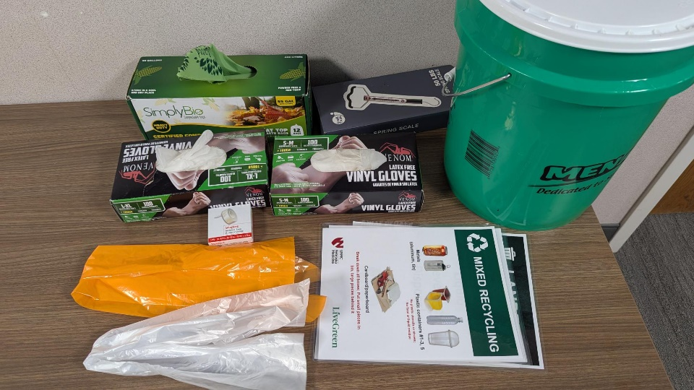

Waste Station Collection Set Up

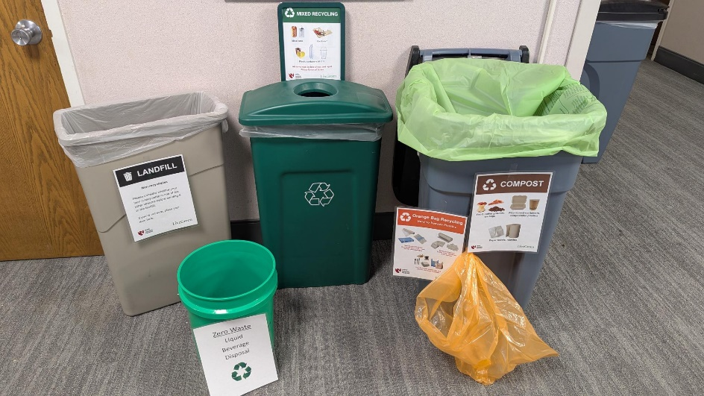

Compost Bag Drop-Off Location

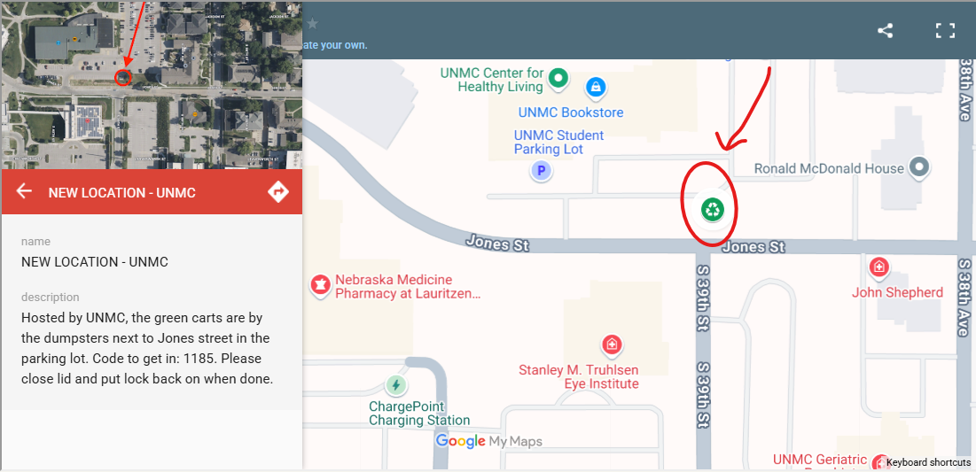

|  |  |  |  |
| --- | --- | --- | --- |
| **Waste Stream** | **Beginning Weight**  (Bins Empty) | **End Weight** (Bins Full) | **Net Weight**  (Full minus empty bin, or can just the weigh bag) |
| **Compost** |  |  |  |
| **Mixed Recycling** |  |  |  |
| **Orange Bag** |  |  |  |
| **Landfill** |  |  |  |
|  |  | **Total Weight:** (sum of all net weight) |  |
|  |  | **% Diverted:**  (landfill net weight divided by total net weight x100) |  |

If your diversion rate is >90%, congratulations! You’ve achieved “Zero-Waste” status for your event!