

Biohazard Waste Collection Container Labels
Biohazardous waste will be managed and disposed of in accordance with DOT, EPA, OSHA, and State of Nebraska Regulations. Biohazardous waste (infectious waste or medical waste) is waste contaminated with biological material that is infectious or potentially infectious to humans, animals, or plants. Materials contaminated with recombinant and synthetic nucleic acids, as well as genetically modified organisms, are also considered biohazardous. Please refer to the UNMC Waste Handling Policy for proper disposal methods of biohazard waste.
Just like chemical waste collection containers, all biohazard waste collection containers must be properly labeled to identify their contents.
These labels (page 2) are designed to be printed on the Avery 5160 label template. The label is has space to write the contents on the label. Laboratories can also print them on regular paper, cut them out, and tape them to the container.

Below is an example of a properly labeled biohazard waste collection container.
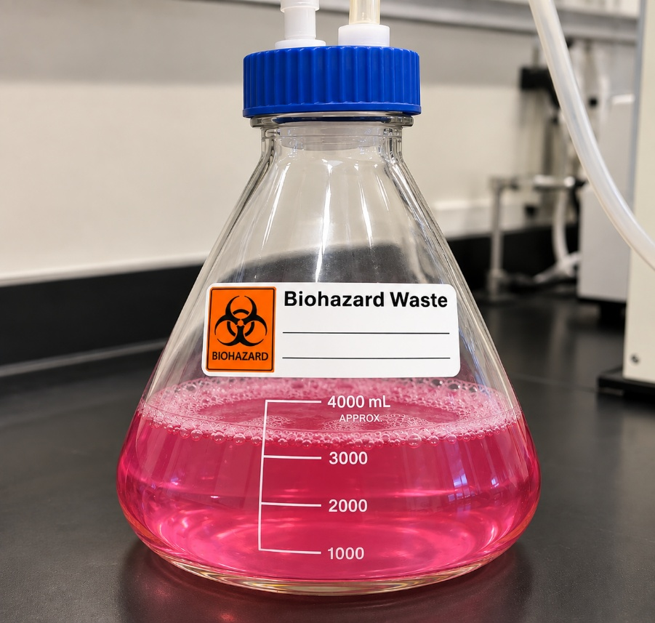

Used Media & Bleach

Updated 09/2026

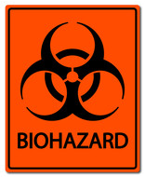  b Biohazard Waste  __________________  _________________ |  | b Biohazard Waste  __________________  _________________ |  | b Biohazard Waste  __________________  _________________
b Biohazard Waste  __________________  _________________ |  | b Biohazard Waste  __________________  _________________ |  | b Biohazard Waste  __________________  _________________
b Biohazard Waste  __________________  _________________ |  | b Biohazard Waste  __________________  _________________ |  | b Biohazard Waste  __________________  _________________
b Biohazard Waste  __________________  _________________ |  | b Biohazard Waste  __________________  _________________ |  | b Biohazard Waste  __________________  _________________
b Biohazard Waste  __________________  _________________ |  | b Biohazard Waste  __________________  _________________ |  | b Biohazard Waste  __________________  _________________
b Biohazard Waste  __________________  _________________ |  | b Biohazard Waste  __________________  _________________ |  | b Biohazard Waste  __________________  _________________
b Biohazard Waste  __________________  _________________ |  | b Biohazard Waste  __________________  _________________ |  | b Biohazard Waste  __________________  _________________
b Biohazard Waste  __________________  _________________ |  | b Biohazard Waste  __________________  _________________ |  | b Biohazard Waste  __________________  _________________
b Biohazard Waste  __________________  _________________ |  | b Biohazard Waste  __________________  _________________ |  | b Biohazard Waste  __________________  _________________
b Biohazard Waste  __________________  _________________ |  | b Biohazard Waste  __________________  _________________ |  | b Biohazard Waste  __________________  _________________

