

Biohazard Waste Labels for Pipettes & Tips Disposal
All collection boxes for pipettes and tips should be labeled as biohazard waste. Pipettes and pipette tips readily puncture biohazard waste bags and must be disposed of in a rigid container (bag-lined cardboard box). Lining the pipette disposal box with plastic keeps residual liquids from soaking the box and seeping onto the floor/counter. Once pipette disposal boxes are full, tape them shut and place them in the biohazard waste bin.
These labels (page 2) are designed to be printed on the Avery 5160 label template. Laboratories can also print them on regular paper, cut them out, and tape them to their collection boxes.
When collection boxes are full, they must be taped shut and placed in the red biohazard waste bin for proper disposal. Additional information is available in the Biohazard Waste Disposal Safety Guideline.

Below is an example of a properly lined and labeled collection box for pipettes and tips.
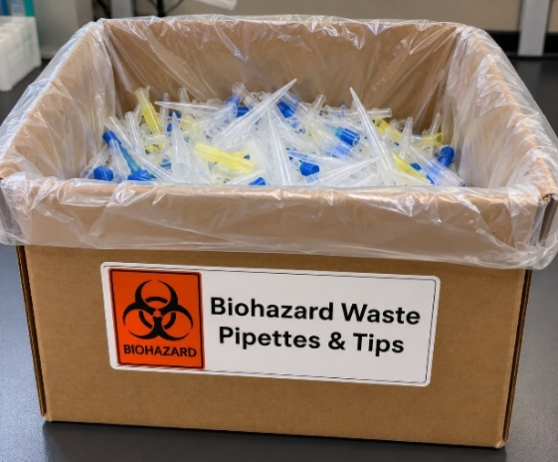

When full, tape the box shut and place it in the red biohazard waste bin.
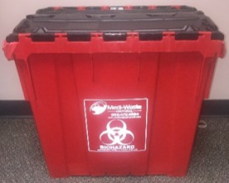
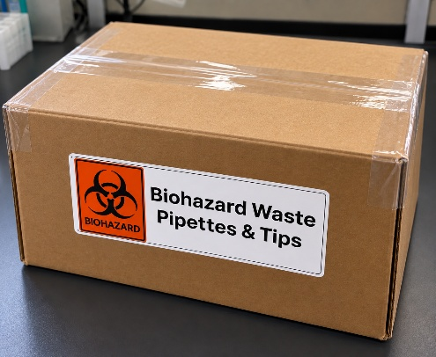

Updated 09/2026
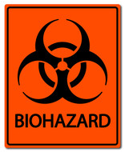  Biohazard Waste  Pipettes & Tips |  | Biohazard Waste  Pipettes & Tips |  | Biohazard Waste  Pipettes & Tips
Biohazard Waste  Pipettes & Tips |  | Biohazard Waste  Pipettes & Tips |  | Biohazard Waste  Pipettes & Tips
Biohazard Waste  Pipettes & Tips |  | Biohazard Waste  Pipettes & Tips |  | Biohazard Waste  Pipettes & Tips
Biohazard Waste  Pipettes & Tips |  | Biohazard Waste  Pipettes & Tips |  | Biohazard Waste  Pipettes & Tips
Biohazard Waste  Pipettes & Tips |  | Biohazard Waste  Pipettes & Tips |  | Biohazard Waste  Pipettes & Tips
Biohazard Waste  Pipettes & Tips |  | Biohazard Waste  Pipettes & Tips |  | Biohazard Waste  Pipettes & Tips
Biohazard Waste  Pipettes & Tips |  | Biohazard Waste  Pipettes & Tips |  | Biohazard Waste  Pipettes & Tips
Biohazard Waste  Pipettes & Tips |  | Biohazard Waste  Pipettes & Tips |  | Biohazard Waste  Pipettes & Tips
Biohazard Waste  Pipettes & Tips |  | Biohazard Waste  Pipettes & Tips |  | Biohazard Waste  Pipettes & Tips
Biohazard Waste  Pipettes & Tips |  | Biohazard Waste  Pipettes & Tips |  | Biohazard Waste  Pipettes & Tips

