
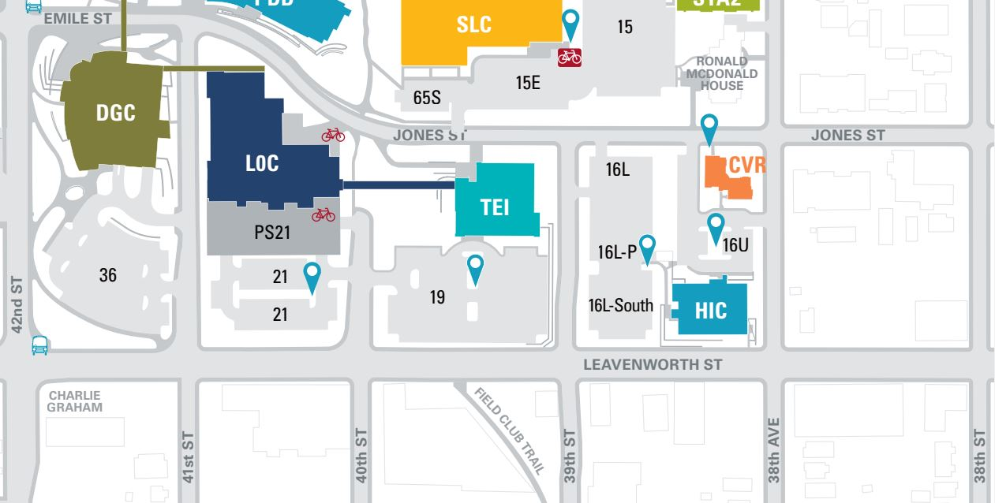
38th Street

39th Street
38th Avenue

The Cosgrove
Boutique Apartments

Engage Wellness Parking is off of 39th & Leavenworth Street (on the South side of Lot 16L)
Engage Wellness Entrance (located on the West side of the Home Instead Center for Successful Aging)

