
Guide for UNMC Faculty

© all rights reserved worldwide
Table of Contents
1. Access to Seguidor 4
2. Seguidor Home Screen 4
3. Menu Bar 5
4. Pending Actions 6
5. Dashboard 7
5.1. Applicant Tab 9
5.2. Student Tab 10
5.3. Program of Study Tab 11
5.4. Meeting Tab 12
6. Committee Management 13
6.1. Advisory / Supervisory Committee 13
6.1.1. Accept nomination as Advisory/Supervisory Committee Chair (Advisor/Supervisor) 13
6.1.2. Advisory/Supervisory Committee Approvals – Approval of Chair & Co-Chair 14
6.1.3. Approve Student Advisory/Supervisory Committee Members 15
6.2. Exam Committee 17
6.2.1. Approval Process for Exam Committee 17
6.2.2. Exam Committee Grading and Student Notification Process 18
7. Program of Study 22
7.1. Approval Process for Program of Study 22
7.1.1. Order of Approval 22
7.1.2. Approve Program of Study 26
7.2. View Program of Study 30
8. Reports 33
8.1. Report Previews 33
8.2. Reports by Requirement 34
8.2.1. Advisory/Supervisory Committees by Student Report 34
8.2.2. Meetings by Student Report 39
8.2.3. Program of Study by Student Report 48
8.2.4. Exam Committees by Student Report 53
8.3. Other Useful Reports 56
8.3.1. Program/Sub-Plan Committees Report 56
8.3.2. Advisory/Supervisory Committees by Member Report 58
8.3.3. Applicant List Report 61
8.3.4. Student List Report 62
8.3.5. Special Attributes/Designations Report 63
8.4. Favorite Reports 65
8.4.1. Create Favorite Report 65
8.4.2. Generate Favorite Report 68
8.4.3. Delete Favorite Report 69

For additional assistance with Seguidor, please contact the Graduate Studies Office at unmcgraduatestudies@unmc.edu or 402-559-4476.

Access to Seguidor
All UNMC faculty can log into Seguidor using the link found on the Graduate Studies Faculty & Staff webpage or by entering the following URL into your internet browser https://net.unmc.edu/seguidor/index.php.

Seguidor Home Screen

The Seguidor home screen is the screen that first appears after logging in to the Seguidor web application. To return to the Seguidor home screen at any time, click on the Seguidor logoⒶ in the upper left corner of the screen.

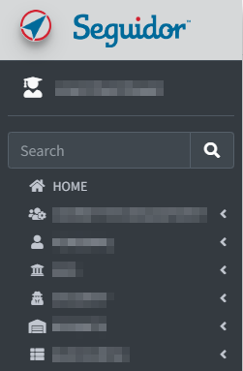
Ⓐ

Ⓐ

Menu Bar

Items that appear on the menu bar are dependent on the user’s security profile in Seguidor.

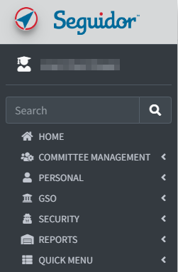
Ⓑ
Ⓔ
Ⓓ
Ⓒ

Ⓑ
Committee Management
Visible to Graduate Program Committee Chairs (Program Directors), MSIA Sub-Plan Committee Chairs, and Student Advisory/Supervisory Committee Chairs (Advisors/Supervisors), as well as these individuals’ assigned designees.
Ⓒ
Personal
Visible to all users.
Ⓓ
Reports
Visible to Graduate Program Committee Chairs (Program Directors), MSIA Sub-Plan Committee Chairs, and assigned program staff. Security is assigned at the individual and program levels by the Graduate Studies Office.
Ⓔ
Quick Menu
Visible to all users.

Pending Actions

A pending action indicates an action that you must take to approve/disapprove a student’s request or you have an upcoming meeting. The pending action will remain on the Seguidor home screen until action is taken to address the identified task or the meeting has passed.

Click anywhere in the actionⒶ to go directly to the related Seguidor page.

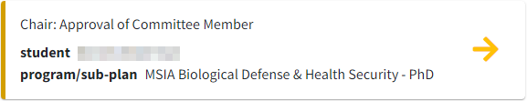
Ⓐ

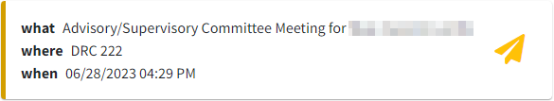
Ⓐ

Dashboard

Seguidor’s security settings allow academic personnel to view student records through the Dashboard if they meet at least one of the conditions below:
- Member of student’s Advisory/Supervisory Committee
- Chair/Co-Chair of Graduate Program Committee or Sub-Plan Committee in which student is currently enrolled (security privileges granted by Graduate Studies Office personnel)
- Authorized administrative staff of Graduate Program or Sub-Plan in which student is currently enrolled (security privileges granted by Graduate Studies Office personnel)
- Graduate Studies Office personnel

- Mouseover PERSONAL Ⓐ on the toolbar.
- Click Dashboard Search Ⓑ

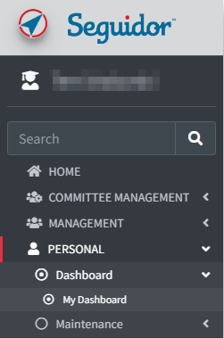
Ⓒ
Ⓑ
Ⓐ

- Student Advisory/Supervisory Committee Members: Click the quick search Ⓓ dropdown to select students for whom you serve on their committee.
Graduate Program Committee Chairs (Program Directors) and those with Program Security: Click the quick search Ⓓ dropdown to select students for whom you serve on their committee. To access all other students within your program, type the last name, first name of the student in the search box Ⓔ. Click on the student name to select.

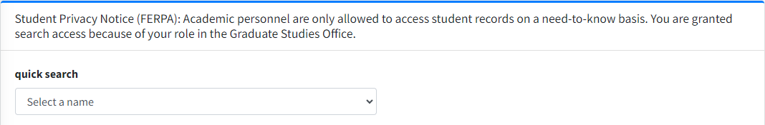
Ⓓ

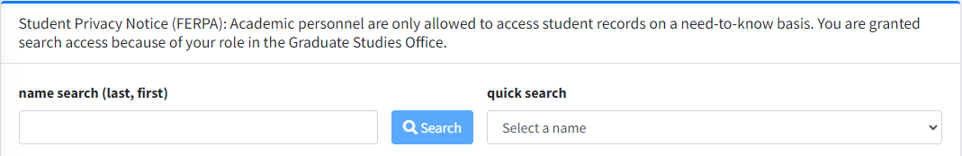
Ⓓ
Ⓔ

Applicant Tab

The applicant tab displays data regarding the students’ admission test scores, prior education, and UNMC application(s).

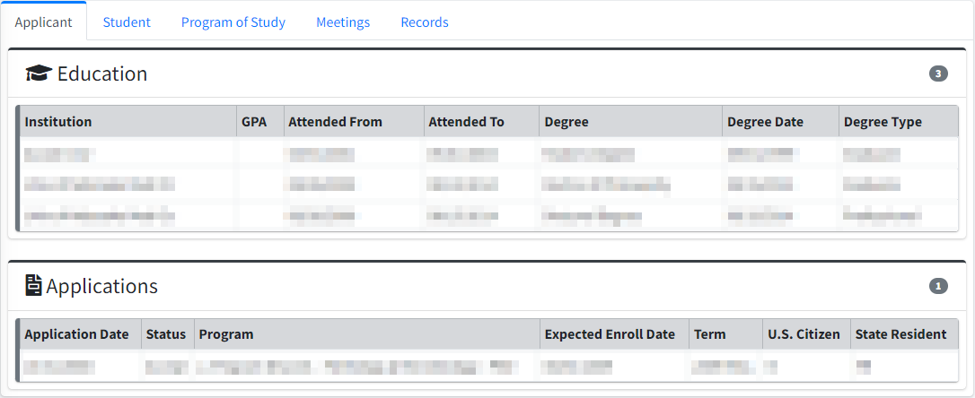

Student Tab

The student tab displays data regarding a students’ academic career, Advisory/Supervisory Committee, and Exam Committees.

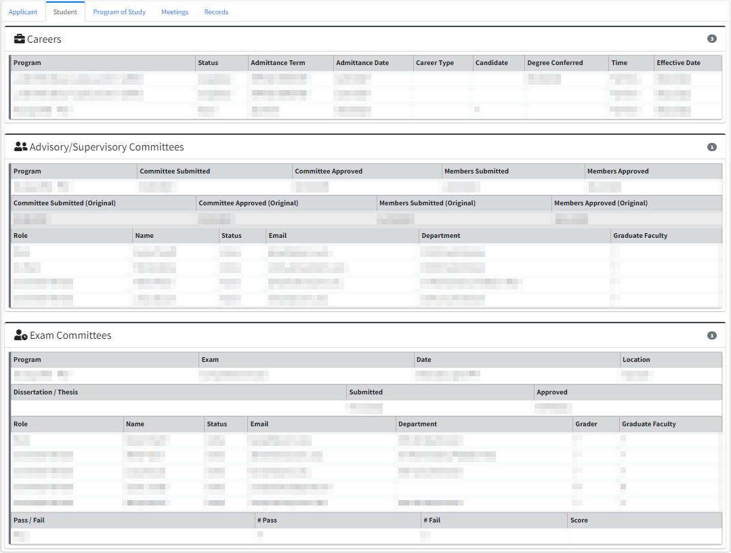

Program of Study Tab

The Program of Study tab displays data regarding the students’ course requirements.

Click the active version of the Program of Study to view the status of the requirements.

The letter “Y” indicates the active version Ⓐ.

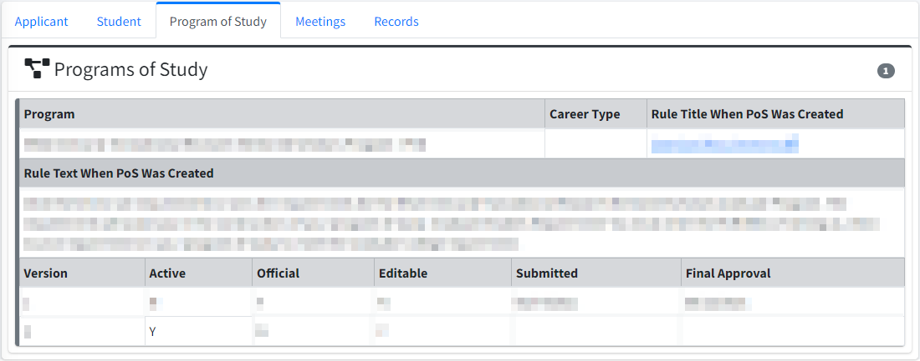
Ⓐ

Meeting Tab

The meeting tab displays data regarding the students’ Advisory/Supervisory Committee Meetings and their Individual Development Plan.

- Click on the meeting of interest Ⓐ for additional meeting information.

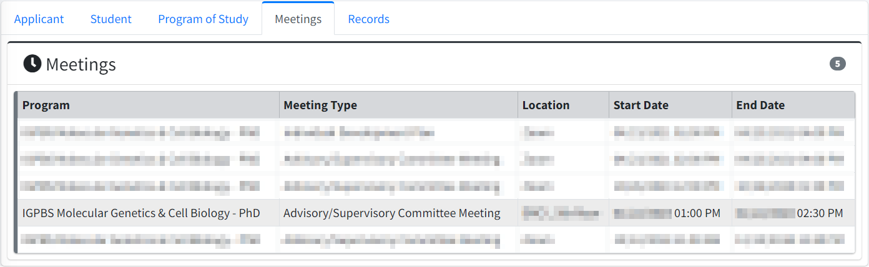
Ⓐ

- After a meeting has been selected, meeting attendees Ⓐ and documents are viewable. Click the paper icon to open a document. Ⓑ

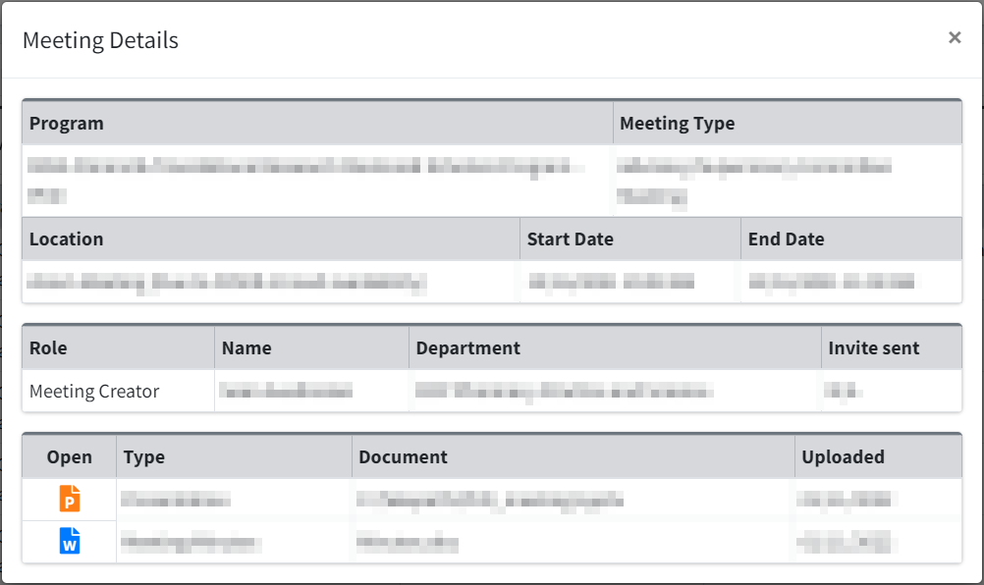
Ⓑ
Ⓐ

Committee Management

Advisory / Supervisory Committee

Accept nomination as Advisory/Supervisory Committee Chair (Advisor/Supervisor)

- From the home Screen under Your Pending Actions, click anywhere in the action Ⓐ to go directly to COMMITTEE MANAGEMENT | Advisory/Supervisory Committee Chair/Co-Chair Approval.

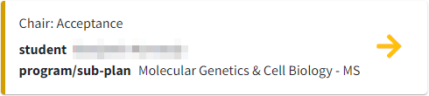
Ⓐ

- Click the green shieldⒷ to approve or the red shieldⒸ to disapprove the nomination.

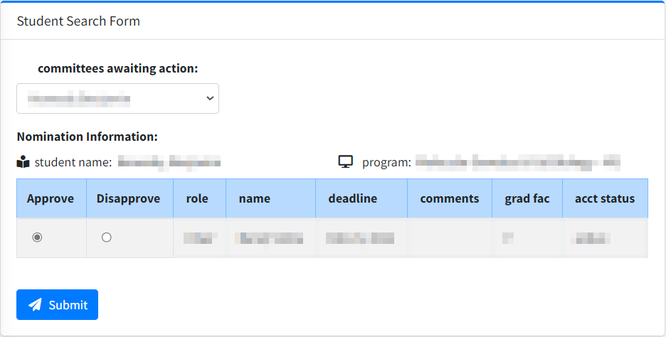
Ⓑ
Ⓒ
Ⓓ

- After submitting approval, a notification email will be sent to the Graduate Program Committee Chair (Program Director) and a pending action will be generated in Seguidor to prompt him/her to approve or disapprove of the individual nominated to chair the student’s Advisor/Supervisory Committee.
- After approval from the Graduate Program Committee Chair (Program Director), a notification email will be sent to the student and a pending action will be generated in Seguidor prompting the student to select Advisory/Supervisory Committee Members.
- If the nomination is disapproved at any point in the approval process an email will be automatically sent to the student notifying them of the action. The pending action to select a committee chair will reappear on the student’s home page in Seguidor.

Advisory/Supervisory Committee Approvals – Approval of Chair & Co-Chair

- From the Seguidor Home Screen under Your Pending Actions, click anywhere in the actionⒶ to go directly to COMMITTEE MANAGEMENT | Chair/Co-Chair Approval.

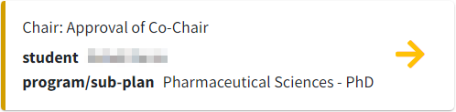
Ⓐ

- Click the appropriate button Ⓑ to approve or disapprove Chair/Co-Chair.

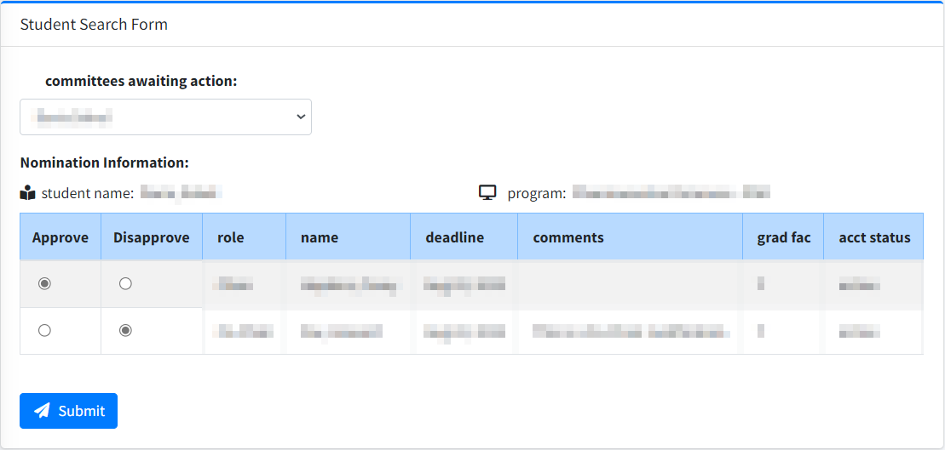
Ⓒ
Ⓑ
Ⓓ

- If approving as a MSIA Sub-plan Committee Chair, a notification email will be sent and a pending action will be generated in Seguidor to prompt the MSIA Graduate Program Committee Chair (Program Director) to approve or disapprove of the members selected for the student’s Supervisory/Advisory Committee.
- After approval from the Graduate Program Committee Chair, a notification email will be sent and a pending action will be generated in Seguidor prompting the student to select Advisory/Supervisory Committee Members.

Approve Student Advisory/Supervisory Committee Members

If any committee member is disapproved at any point in the approval process, an email will be automatically sent to the student notifying him/her of the action. The pending action to select committee members will reappear on the student’s home page in Seguidor.

Advisory/Supervisory Committee Chair Approval of Committee Members

- From the Home Screen under Your Pending Actions, click anywhere in the actionⒶ to go directly to COMMITTEE MANAGEMENT | Advisory/Committee Membership Approval.

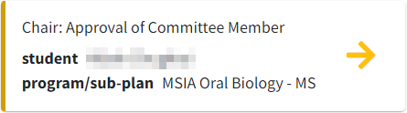
Ⓐ

- Click the appropriate box under approveⒷ or disapproveⒸ for each pending committee member.
- Click Submit Ⓓ to confirm selections.

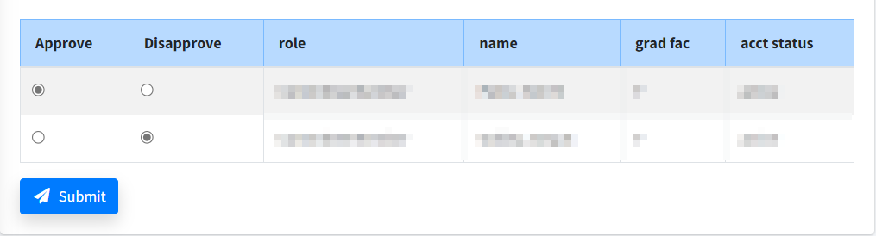
Ⓒ
Ⓑ
Ⓓ

After submitting approval, a notification email will be sent and a pending action will be generated in Seguidor to prompt the Graduate Program Committee Chair (Program Director) to approve or disapprove of the members selected for the student’s Supervisory/Advisory Committee.

Graduate Program Committee Chair (Program Director) Approval of Committee Members

- From the Home screen under Your Pending Actions, click anywhere in the action to go directly to COMMITTEE MANAGEMENT | Advisory/Supervisory |Committee Membership Approval.
- Click the appropriate button to Approve or Disapprove committee members.

After approval from the Graduate Program Committee Chair, a notification email will be sent and a pending action will be generated in Seguidor prompting the Dean of Graduate Studies to make the final approval or disapproval.

Exam Committee

Students eligible to schedule a program exam according to approved program policy will have a pending action titled Exam to Schedule on their Seguidor home screen. Through the pending action link, students will be guided through the steps to select Exam Committee members and enter a date, time, and location for exam agreeable to all Exam Committee members (process external to Seguidor). Rules defining exam eligibility, the timeline for exams, and composition of Exam Committees are set up in Seguidor by the Graduate Studies Office following approved graduate program policies. Please contact the Graduate Studies Office for more information.

Approval Process for Exam Committee

The process to approve the composition of the Exams Committees is similar to the process of approving Advisory/Supervisory Committees. Typical order of approval is Advisory/Supervisory Committee Chair → Graduate Program Committee Chair (Program Director) → Dean of Graduate Studies.

Exam Committee Grading and Student Notification Process

Student Exam Committee members are responsible for evaluating the performance of the student and entering the exam outcome into Seguidor. Individual exam grades may be entered by each member and/or by a committee representative according to approved program policy. A pending action titled “Exam Grade” will appear on the Seguidor home screen of each Exam Committee member who has been designated as a grader.
- From the Home screen, click the Exam Grade pending action or mouseover COMMITTEE MANAGEMENT and click Grade to access the Exam Grade Page.
- Click the edit icon Ⓐ in the actions column next to the grader’s name to make the grader active. Indicate Pass/Fail in the dropdown box and enter the score and any comments (optional). Click Save Individual Grade Ⓑ for each grader. The table of individual grades Ⓒ will be updated with the grade entered. Continue the process for each grader.

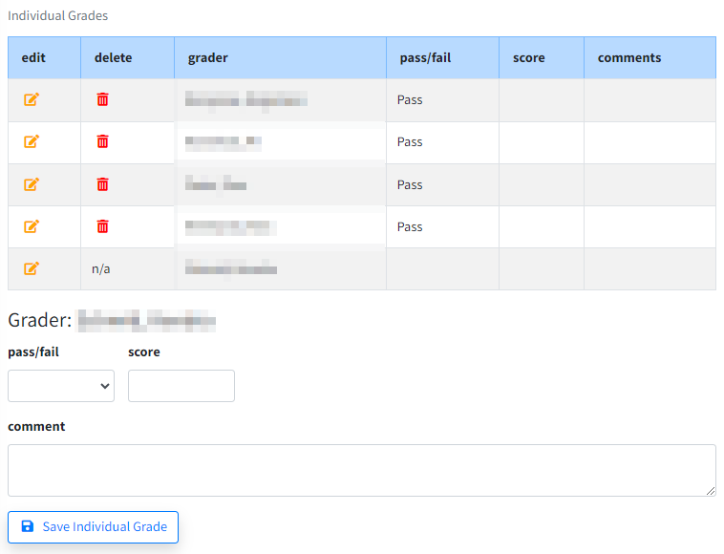
Ⓑ
Ⓒ
Ⓐ

- After a grade has been entered for each grader, confirm that the overall grade is correct.
If the student passed Ⓓ the exam, the committee has the opportunity to note areas of weakness.
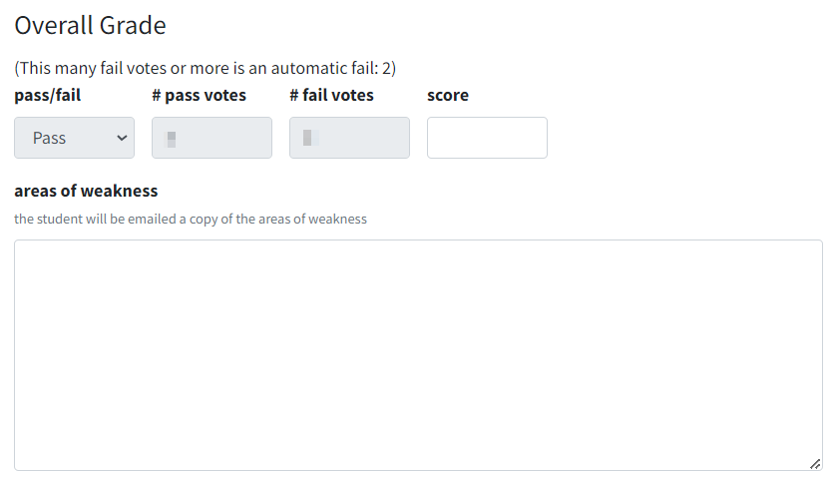
Ⓓ

- If the student failed Ⓔ the exam, click the drop down box to indicate the committee recommendation for the student to continue in the program (Yes/No), indicate areas of weakness, and provide a remediation plan.
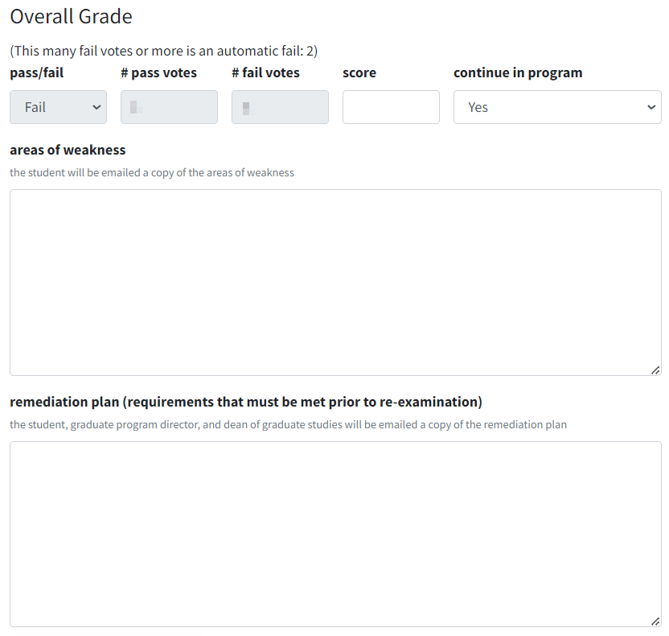
Ⓔ

- Click Save Overall Grade Draft Ⓕ to save the exam results for future editing.

- Discuss the exam outcome (pass/fall) with the student. Then, check the affirmation box to verify that you: 1) have talked to the student about the grade, 2) are finished grading and entering comments, and 3) understand that the student will be emailed the exam results immediately.
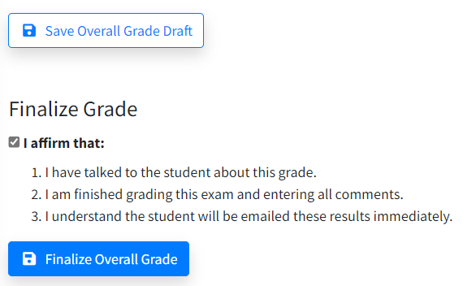
Ⓖ
Ⓕ
- Click Finalize Overall GradeⒼ to finish the exam grading process and send the results to the student and to the Dean of Graduate Studies.

Program of Study

Students are required to submit a Program of Study. Students will have a pending action on their Seguidor home screen. Through the pending action link, students will be guided through the steps of selecting their rule (requirements) title and the entering of course and non-course requirements.

Rule (requirements) titles defining the program requirements and career type are setup in Seguidor by the Graduate Studies Office following approved graduate program policies. Please contact the Graduate Studies Office for more information.

Approval Process for Program of Study

7.1.1. Order of Approval

After the student submits the Program of Study, a notification email will be sent to the Advisor/Supervisor and a pending action will be generated in Seguidor to prompt him/her to approve or disapprove of the Program of Study.

After each subsequent approval, a notification email will be sent to the next approver (based on the order of approval) and a pending action will be generated in Seguidor to prompt him/her to approve or disapprove of the Program of Study.

Important Note: The student cannot make changes to the Program of Study while the Program of Study is in the approval process.

Status of Approval

At any point in the approval process you may view who the Program of Study is pending approval by.

- Mouseover PERSONAL Ⓐ on the toolbar.
- Click Dashboard Search Ⓑ

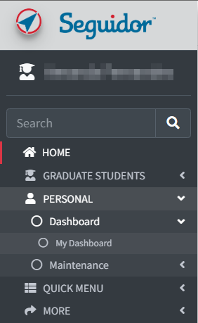
Ⓒ
Ⓑ
Ⓐ

- Student Advisory/Supervisory Committee Members: Click the quick search Ⓓ dropdown to select students for whom you serve on their committee.
Graduate Program Committee Chairs (Program Directors) and those with Program Security: Click the quick search Ⓓ dropdown to select students for whom you serve on their committee. To access all other students within your program, type the last name, first name of the student in the search box Ⓔ. Click on the student name to select.

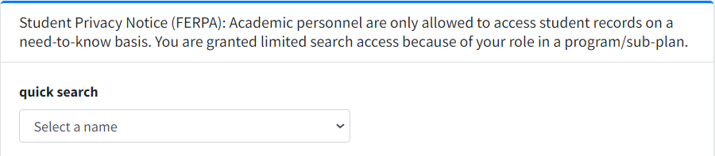
Ⓓ

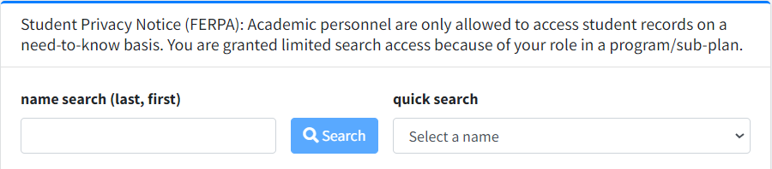
Ⓓ
Ⓔ

- Click the Program of Study tab Ⓕ.
Ⓕ

- Select the active version of the Program of Study.

The letter “Y” indicates the active version Ⓖ.

Ⓖ

- View the approver’s name Ⓗ.

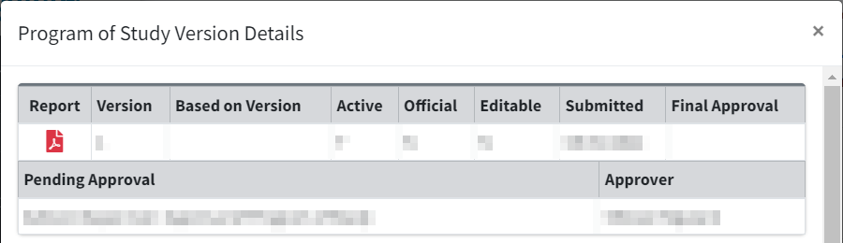
Ⓗ

Approve Program of Study

If the Program of Study is disapproved at any point in the approval process, an email will be automatically sent to the student notifying him/her of the action. The pending action will reappear on the student’s home page in Seguidor. The disapprover must notify the student of why the Program of Study was disapproved, so that the student may make the appropriate changes.

1. From the home page in Seguidor under Your Pending Actions, click anywhere in the action Ⓐ.

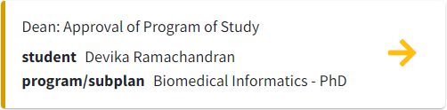
Ⓐ

2. Review the rule (requirements) title selection for accuracy Ⓑ.

The rule (requirements) title that a student selects establishes the course and examination requirements

Important Note: If a student selected the wrong rule (requirements) title, the Program of Study must be disapproved.

Rule (requirements) Title Examples:

M.S. Rule Title
Thesis Requirements
Non-Thesis Requirements

Ph.D. Rule Title
Standard Requirements
MD/PhD Requirements

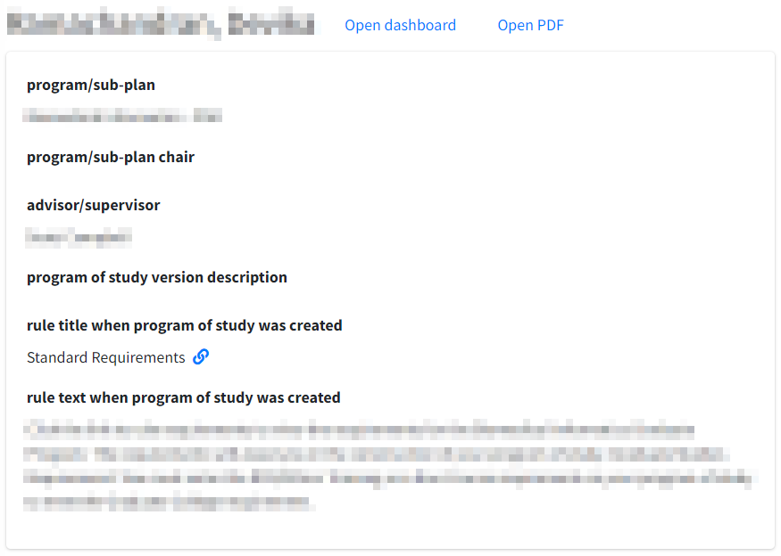
Ⓑ

3. Review the Student Requirements to ensure that the student has entered all of the graduate program requirements (rule) Ⓒ.

Click open PDF Ⓓ for a printable version of the Program of Study. Use the PDF to crosscheck with the rule (requirements) title to ensure that the student entered all of courses to satisfy the requirements for the graduate program.

Important Note: If a student omitted a requirement, the Program of Study must be disapproved.
Ⓓ
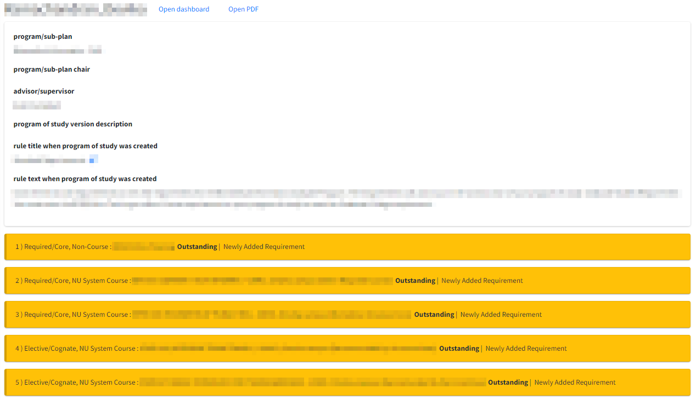
Ⓒ

There are three requirement type options. The requirement type options are explained in detail in the Seguidor Guide for UNMC Graduate Students. Please see above for how the requirement types are displayed and see below for an explanation of each requirement type.

NU System Course – this requirement type is used to add a course from UNMC, UNO, UNL and/or UNK; including professional level courses (500-600 level).

Non-NU System Course – this requirement type is used to add a course from an institution outside of the Nebraska University system. This is frequently referred to as transfer credit.

Non-Course – this requirement type is used to add a requirement outside of a course. Ph.D. students will use this requirement type to document the Responsible Conduct in Research (RCR) Program requirement.

Important Note: All requirements will show Outstanding, even if the requirement has been completed, until the final approval has been processed by the Dean of Graduate Studies.

4 Click the appropriate button to approve or disapprove the Program of Study Ⓔ.

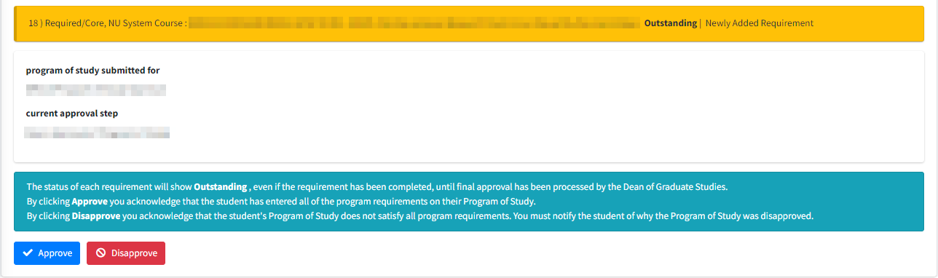
Ⓔ

Important Note: If the Program of Study is disapproved at any point in the approval process, an email will be automatically sent to the student notifying him/her of the action. The pending action will reappear on the student’s home page in Seguidor. The disapprover must notify the student of why the Program of Study was disapproved, so that the student may make the appropriate changes.

View Program of Study

After a Students Program of Study has been approved you may view their program of study at any time to track the completion of their requirements.

- Mouseover PERSONAL Ⓐ on the toolbar.
- Click Dashboard Search Ⓑ

Ⓒ
Ⓑ
Ⓐ

- Student Advisory/Supervisory Committee Members: Click the quick search Ⓓ dropdown to select students for whom you serve on their committee.
Graduate Program Committee Chairs (Program Directors) and those with Program Security: Click the quick search Ⓓ dropdown to select students for whom you serve on their committee. To access all other students within your program, type the last name, first name of the student in the search box Ⓔ. Click on the student name to select.

Ⓓ

Ⓓ
Ⓔ

- Click the Program of Study tab Ⓕ.
Ⓕ

- Select the active version of the Program of Study.

The letter “Y” indicates the active version Ⓖ.

Ⓖ

- Review the requirements Ⓗ.

After a Students Program of Study has been approved the status of each requirement will change as each requirement is completed, waived, or removed. The statuses are color coded to visibly show the status of each requirement.
Outstanding
Removed
Waived
Completed

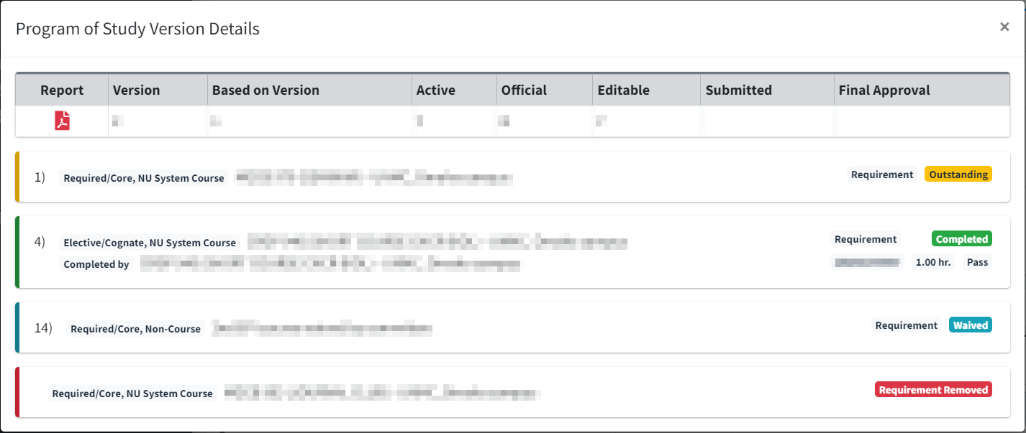
Ⓗ

Reports

UNMC Graduate Program Committee Chairs (Program Directors) and Sub-Plan Committee Chairs are granted program security for each graduate program/sub-plan they oversee. Program security allows the user to track the status and academic progress of all students, current and historically, registered in the program. Users may access this information for an individual student through the Dashboard Search, or for multiple students through the REPORTS tab.

Important Note: Ensure the popup blocker is turned off in your web browser prior to generating reports. The reports will open in Excel.

Report Previews

Report Previews were added to Seguidor for the 2023-2024 school year. After you press "Generate Report", the report preview is displayed. You can use this preview to determine if your selected parameters are producing the expected results.

The report preview is often much wider than your screen width. There are multiple ways to navigate vertically in the preview, but the most common are as follows.

- Hover anywhere over the report. Then, press and hold SHIFT and rotate the mouse wheel up (for left) or down (for right).
- Click anywhere in the report. Then you can use your arrow keys to move to the right on the report or to move again back to the left.
- Scroll down until you reach the scroll bar at the bottom of the report and use the scroll bar to navigate right and left.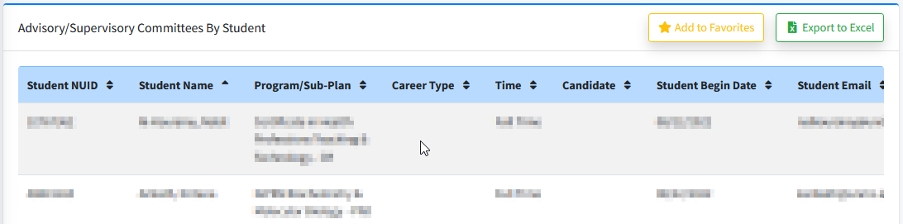

You can select which column you want to sort the preview with by clicking on the up/down arrows next to the column header.
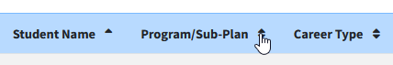

When you are satisfied with the preview, you may export the report to Excel and/or add it to your Favorite Reports (See Favorite Reports). If you sorted by another column other than the default sort, that sort will carry over during the file export, but Favorite Reports will only save the default sort.

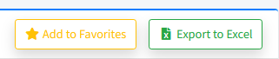

Reports by Requirement

The reports covered in this section should be generated frequently to ensure students are compliant with Graduate Studies requirements.

These reports display a deadline date for each student for a specific requirement. The deadline date is based on the student’s matriculation date. The matriculation date is the begin date of classes for the term that the student was admitted.

Important Note: It is imperative that a representative from each graduate program generates the reports frequently to ensure students compliance with Graduate Studies guidelines. The representative is responsible for emailing the Office of Graduate Studies a list of students who are past due in meeting a requirement deadline to have the students account placed on hold, preventing any future enrollment.

Advisory/Supervisory Committees by Student Report

The Advisory/Supervisory Committees by Student report displays data for students by program/sub-plan. This is a robust report. Key uses include:
- Identifying students who have an upcoming Advisory/Supervisory Committee deadline.
- Identifying students who are past due in submitting their Advisory/Supervisory Committee.
- Viewing the Advisor/Supervisor and committee members who serve/d on students Advisory/Supervisory Committees.

Report Established

The advisory/supervisory committee functionality was launched in Seguidor in spring 2014. Advisory/supervisory committee data was only entered in Seguidor for active students. The report will not display advisory/supervisory committee data for students who completed their degree or withdrew/withdrawn from UNMC prior to spring 2014.

Report Frequency

The numbers of times you generate the report within a year is dependent upon your admission. If your graduate program admits for all 3 semesters, you should generate the report at least 3 times a year for each degree type (Master’s or Doctoral).

Master’s Degree

The advisory committee must be approved within 6 months after matriculation. You are encouraged to run the report by the following dates so that you can remind your students of their upcoming deadline.
- January 2 – Generate report to communicate with fall admits of the previous year.
E.g. On January 2, 2018 you would generate the report and select 2017 Fall for the admit term in the report specifications.
- June 1 – Generate report to communicate with spring admits of the current year.
E.g. On June 1, 2018 you would generate the report and select 2018 Spring for the admit term in the report specifications.
- October 1 – Generate report to communicate with summer admits of the current year.
E.g. On October 1, 2018 you would generate the report and select 2018 Summer for the admit term in the report specifications.

Doctoral Degree

The supervisory committee must be approved within 12 months after matriculation. You are encouraged to run the report by the following dates so that you can remind your students of their upcoming deadline.

- April 1 – Generate report to communicate with summer admits of the previous year.
E.g. On April 1, 2018 you would generate the report and select 2017 Summer for the admit term in the report specifications.
- July 1 – Generate report to communicate with fall admits of the previous year.
E.g. On July 1, 2018 you would generate the report and select 2017 Fall for the admit term in the report specifications.
- December 1 – Generate report to communicate with spring admits of the previous year.
E.g. On December 1, 2018 you would generate the report and select 2017 Spring for the admit term in the report specifications.

Generate the Advisory/Supervisory Committees by Student Report

- To access reports, mouseover REPORTS Ⓐ in the menu bar and click Adv/Sup Comm. by Student Ⓑ

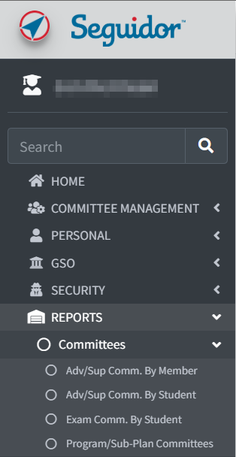
Ⓒ
Ⓑ
Ⓐ

- Adjust report criteria to view data for students who have an upcoming advisory/supervisory committee deadline.

- Select the appropriate program(s)/sub-plan(s) Ⓐ
- Click Active for the student status Ⓑ
- Click the appropriate admit term Ⓒ
- Select Yes for include committees with an upcoming deadline Ⓓ
  - Input 45 for deadline in this number of days Ⓔ (if you run this report on a different date then specified in these instructions, you will have to calculate the number days to input).
- Leave the include committees with Adv/Sup submitted and the include committees with Members submitted fields defaulted to Yes Ⓕ
- Select Yes for both the include committees with Adv/Sup overdue and the include committees with Members overdue fields Ⓖ
- Leave the display columns with code values, the display extra columns for sorting, and the add columns showing all members fields defaulted to No Ⓗ
  - Important Note: If you are running this report to view the Advisor/Supervisor and committee members who serve/d on students Advisory/Supervisory Committees you will need select Yes for the add columns showing all members field.
- Click Generate Report Ⓘ

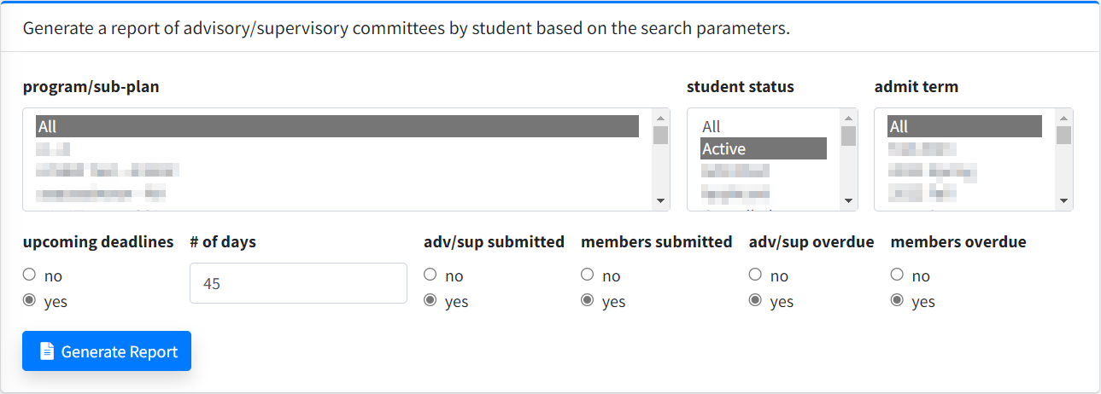
Ⓗ
Ⓖ
Ⓖ
Ⓕ
Ⓕ
Ⓒ
Ⓑ
Ⓐ
Ⓔ
Ⓓ

Data Displayed on the Advisory/Supervisory Committees by Student Report

The report will show the columns outlined below in Excel. Sort & filter the data by Committee Member Approve Date, then by Advisor/Supervisor Submitted, then by Committee Member Submitted.

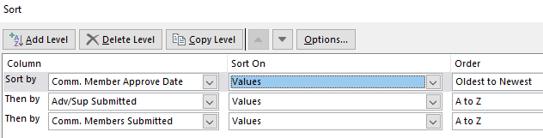

If the Committee Member Approve Date field is blank and the Advisor/Supervisor Submitted and Committee Member Submitted fields display N for no, the student has not initiated the advisory/supervisory committee approval process and you will need to remind the student of the upcoming deadline (see the email templates section).

If the Committee Member Approve Date field is blank and either/both the Advisor/Supervisor Submitted and Committee Member Submitted fields display Y for yes, the student has initiated the advisory/supervisory committee approval process but has not completed it. You can view the next step by viewing the individual student’s dashboard.

Column | Heading Text
1 | Student NUID
2 | Student Name
3 | Program/Sub-Plan
4 | Career Type
5 | Time
6 | Candidate
7 | Student Begin Date
8 | Student Email
9 | Advisor/Supervisor Submitted
10 | Advisor/Supervisor Submitted Date
11 | Committee Members Submitted
12 | Committee Members Submitted Date
13 | Advisor/Supervisor Name
14 | Advisor/Supervisor Email
15 | Advisor/Supervisor Department
16 | Admit Term Description
17 | Student Status
18 | Advisor/Supervisor Approve Date
19 | Advisor/Supervisor Deadline Days
20 | Advisor/Supervisor Deadline Date
21 | Advisor/Supervisor Overdue Days
22 | Committee Member Approve Date
23 | Committee Member Deadline Days
24 | Committee Member Deadline Date
25 | Committee Member Overdue Days
26 | Original Advisor/Supervisor Submit Date
27 | Original Advisor/Supervisor Approve Date
28 | Original Committee Member Submit Date
29 | Original Committee Member Approve Date

Email Templates

Master’s Degree

Advisory Committee Deadline Approaching
Student Name,

I am reaching out to remind you of an upcoming M.S. deadline. Your advisory committee is due on Date. Please initiate the appointment of an advisory committee in Seguidor, instructions can be viewed in the Seguidor Student Instructions.

Advisory Committee Past Due
Student Name,

A registration hold has been placed on your account. You will not be able to enroll for future courses until you become compliant.

Your advisory committee was due for approval on Date. You must initiate the appointment of an advisory committee in Seguidor, instructions can be viewed in the Seguidor Student Instructions.

Review the Master’s Degree timeline to familiarize yourself with future requirements and deadlines.

Doctoral Degree

Supervisory Committee Deadline Approaching
Student Name,

I am reaching out to remind you of an upcoming PhD deadline. Your supervisory committee is due on Date. Please initiate the appointment of a supervisory committee in Seguidor, instructions can be viewed in the Seguidor Student Instructions.

Supervisory Committee Past Due
Student Name,

A registration hold has been placed on your account. You will not be able to enroll for future courses until you become compliant.

Your supervisory committee was due for approval on Date. You must initiate the appointment of a supervisory committee in Seguidor, instructions can be viewed in the Seguidor Student Instructions.

Review the Doctoral Degree timeline to familiarize yourself with future requirements and deadlines.

Meetings by Student Report

The Meetings by Student report displays data for students by program/sub-plan. This report is used to track 2 separate requirements.

- Advisory/Supervisory Committee Meetings
- Individual Development Plan (IDP)

Report Established

The meetings functionality was launched in Seguidor on February 8, 2016. Meeting and IDP data was not retroactively inputted for students. Students were advised to record their last committee meeting to establish their next meeting deadline and to upload their IDP if previously completed. The report will not display meeting and IDP data for students prior to February 8, 2016 unless a student retroactively recorded their meetings or uploaded their IDP certificate of completion.

Generate the Report to Track Advisory/Supervisory Committee Meetings

Report Frequency

Students are required to have advisory/supervisory committee meetings at a minimum of every 6 months until completion of degree.

You are encouraged to run the report on July 1 and January 2 to ensure that students are routinely meeting with their advisory/supervisory committees.

Generate the Report

- To access reports, mouseover REPORTS Ⓐ in the menu bar and click Meetings by Student Ⓑ

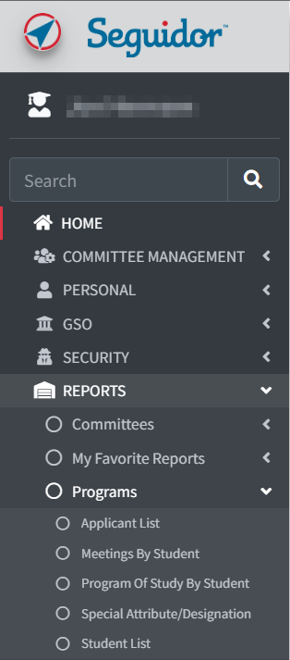
Ⓒ
Ⓑ
Ⓐ

- Adjust report criteria to view meeting data for all active students.

- Select the appropriate program(s)/sub-plan(s) Ⓐ
- Click Active for the student status Ⓑ
- Click All for the admit term Ⓒ
- Click Advisory/Supervisory Committee Meeting for meeting type Ⓓ
- Leave the show meetings field defaulted to Show All Ⓔ
- Leave the display columns with code values, the display extra columns for sorting, and the display extra rows with meeting history fields defaulted to No Ⓕ
  - Important Note: If you are running this report to view the complete meeting history for all students you will need select Yes, all occurrences for the display extra rows with meeting history field.
- Click Generate Report Ⓖ

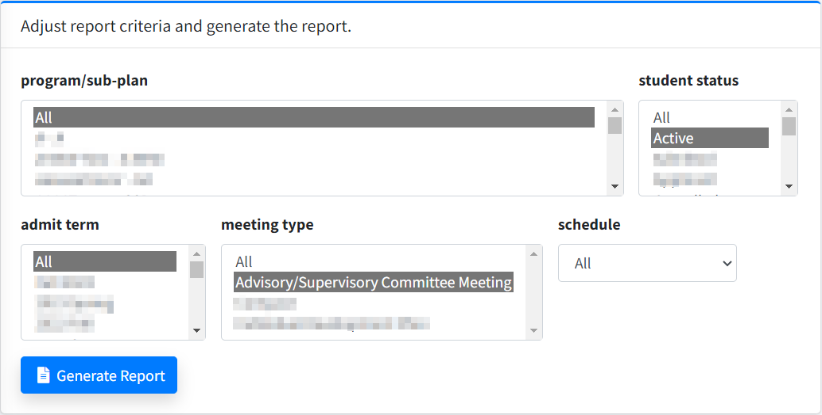
Ⓕ
Ⓔ
Ⓓ
Ⓒ
Ⓑ
Ⓐ

Data Displayed on the Report

The report will show the columns outlined below in Excel. Sort & filter the data by Meeting Start, then by Doc Types Uploaded.

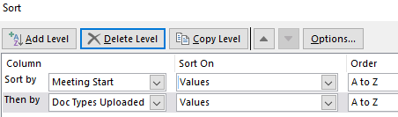

If the Meeting Start field is blank, the student has not recorded an advisory/supervisory committee meeting. View the meeting deadline in the Meeting Deadline column to determine if you need to remind the student of an upcoming deadline or if they are past due in meeting with their advisory/supervisory committee (see the email templates section).

If the Meeting Start field displays a date that has passed and the Doc Types Uploaded field is blank, the student has recorded an advisory/supervisory committee but has not uploaded their required meeting minutes. You will need to remind the student to upload their meeting minutes (see the email templates section).

Column | Heading Text
1 | Student NUID
2 | Student Name
3 | Program/Sub-Plan
4 | Career Type
5 | Time
6 | Candidate
7 | Student Begin Date
8 | Student Email
9 | Meeting Start
10 | Meeting End
11 | Meeting Location
12 | Meeting Type
13 | Number Attendees
14 | Number Documents
15 | Document Types Uploaded
16 | Meeting Deadline
17 | Days Until Deadline
18 | Admit Term Description
19 | Student Status

Email Templates

Master’s Degree

Advisory Committee Meeting Deadline Approaching
Student Name,

I am reaching out to remind you of an upcoming M.S. deadline. You need to have a meeting with your advisory committee by Date. Please schedule your advisory committee meeting in Seguidor, instructions can be viewed in the Seguidor Student Instructions. Don’t forget to upload your meeting minutes in Seguidor after the meeting.

Advisory Committee Meeting Past Due
Student Name,

A registration hold has been placed on your account. You will not be able to enroll for future courses until you become compliant.

You were to meet with your advisory committee by Date. You have not recorded a meeting with your advisory committee in Seguidor since Date. If you have since met with your advisory committee, record your meeting and upload the meeting minutes in Seguidor, instructions can be viewed in the Seguidor Student Instructions.

Review the Master’s Degree timeline to familiarize yourself with future requirements and deadlines.

Advisory Committee Meeting Minutes Required
Student Name,

I am reaching out to remind you to upload your meeting minutes in Seguidor for your advisory committee meeting that was held on Date. Instructions can be viewed in the Seguidor Student Instructions.

Doctoral Degree

Supervisory Committee Meeting Deadline Approaching
Student Name,

I am reaching out to remind you of an upcoming PhD deadline. You need to have a meeting with your supervisory committee by Date. Please schedule your supervisory committee meeting in Seguidor, instructions can be viewed in the Seguidor Student Instructions. Don’t forget to upload your meeting minutes in Seguidor after the meeting.

Supervisory Committee Meeting Past Due
Student Name,

A registration hold has been placed on your account. You will not be able to enroll for future courses until you become compliant.

You were to meet with your supervisory committee by Date. You have not recorded a meeting with your supervisory committee in Seguidor since Date. If you have since met with your supervisory committee, record your meeting and upload the meeting minutes in Seguidor, instructions can be viewed in the Seguidor Student Instructions.

Review the Doctoral Degree timeline to familiarize yourself with future requirements and deadlines.

Supervisory Committee Meeting Minutes Required
Student Name,

I am reaching out to remind you to upload your meeting minutes in Seguidor for your supervisory committee meeting that was held on Date. Instructions can be viewed in the Seguidor Student Instructions.

Generate the Report to Track Individual Development Plans (IDPs)

Report Frequency

Students are required to prepare an IDP within 12 months after matriculation.

You are encouraged to run the report by the following dates so that you can remind your students of their upcoming deadline.

- April 1 – Generate report to communicate with summer admits of the previous year.
E.g. On April 1, 2018 you would generate the report and select 2017 Summer for the admit term in the report specifications.
- July 1 – Generate report to communicate with fall admits of the previous year.
E.g. On July 1, 2018 you would generate the report and select 2017 Fall for the admit term in the report specifications.
- December 1 – Generate report to communicate with spring admits of the previous year.
E.g. On December 1, 2018 you would generate the report and select 2017 Spring for the admit term in the report specifications.

Generate the Report

- To access reports, mouseover REPORTS Ⓐ in the menu bar and click Meetings by Student Ⓑ

Ⓒ
Ⓑ
Ⓐ

- Adjust report criteria to view IDP data for students by admit term.

- Select the appropriate program(s)/sub-plan(s) Ⓐ
- Click Active for the student status Ⓑ
- Click the appropriate admit term Ⓒ
- Click Individual Development Plan for meeting type Ⓓ
- Leave the show meetings field defaulted to Show All Ⓔ
- Leave the display columns with code values, the display extra columns for sorting, and the display extra rows with meeting history fields defaulted to No Ⓕ
- Click Generate Report Ⓖ

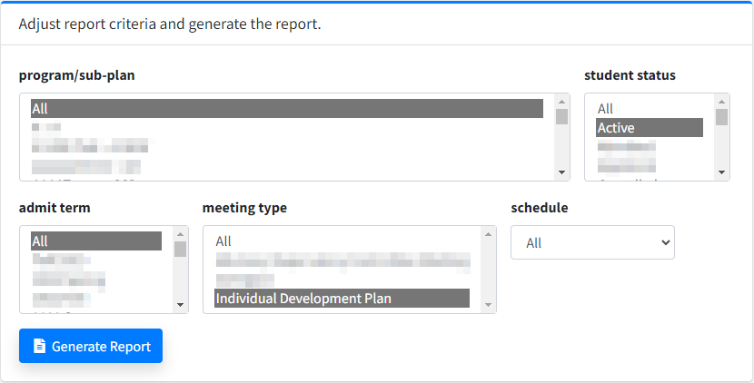
Ⓑ
Ⓐ
Ⓒ
Ⓓ
Ⓔ
Ⓕ

Data Displayed on the Report

The report will show the columns outlined below in Excel. Sort & filter the data by Meeting Start, then by Doc Types Uploaded.

If the Meeting Start field is blank, the student has not recorded completing an IDP and you will need to remind the student of the upcoming deadline (see the email templates section).

If the Meeting Start field displays a date that has passed and the Doc Types Uploaded field is blank, the student has recorded completing an IDP but has not uploaded their IDP certificate of completion. You will need to remind the student to upload their IDP certificate of completion (see the email templates section).

Column | Heading Text
1 | Student NUID
2 | Student Name
3 | Program/Sub-Plan
4 | Career Type
5 | Time
6 | Candidate
7 | Student Begin Date
8 | Student Email
9 | Meeting Start
10 | Meeting End
11 | Meeting Location
12 | Meeting Type
13 | Number Attendees
14 | Number Documents
15 | Document Types Uploaded
16 | Meeting Deadline
17 | Days Until Deadline
18 | Admit Term Description
19 | Student Status

Email Templates

Individual Development Plan Deadline Approaching
Student Name,

I am reaching out to remind you of an upcoming deadline. You need to complete an individual development plan (IDP) by Date. Please complete your IDP using myIDP and upload your IDP certificate of completion in Seguidor, instructions can be viewed in the Seguidor Student Instructions.

Individual Development Plan Past Due
Student Name,

A registration hold has been placed on your account. You will not be able to enroll for future courses until you become compliant.

You were to complete an individual development plan (IDP) by Date. You must complete your IDP using myIDP and upload your IDP certificate of completion in Seguidor, instructions can be viewed in the Seguidor Student Instructions.

Individual Development Plan Certificate of Completion Required
Student Name,

You indicated that you completed your IDP on Date. I am reaching out to remind you to upload your IDP certificate of completion in Seguidor. Instructions can be viewed in the Seguidor Student Instructions.

Program of Study by Student Report

The Program of Study by Student report displays data for students by program/sub-plan. Key uses include:
- Identifying students who have an upcoming Program of Study deadline.
- Identifying students who are past due in submitting their Program of Study.

Report Established

The program of study functionality was launched in Seguidor on June 29, 2018. Program of study data was not inputted for students who had submitted a paper program of study to the Office of Graduate Studies. The report will not display program of study data for students who completed their program of study prior to June 29, 2018.

Report Frequency

The numbers of times you generate the report within a year is dependent upon your admission. If your graduate program admits for all 3 semesters, you should generate the report at least 3 times a year for each degree type (Master’s or Doctoral).

Master’s Degree

The program of study must be approved within 7 months after matriculation. You are encouraged to run the report by the following dates so that you can remind your students of their upcoming deadline.

- February 1 – Generate report to communicate with fall admits of the previous year.
E.g. On February 1, 2018 you would generate the report and select 2017 Fall for the admit term in the report specifications.
- July 1 – Generate report to communicate with spring admits of the current year.
E.g. On July 1, 2018 you would generate the report and select 2018 Spring for the admit term in the report specifications.
- November 1 – Generate report to communicate with summer admits of the current year.
E.g. On November 1, 2018 you would generate the report and select 2018 Summer for the admit term in the report specifications.

Doctoral Degree

The supervisory committee must be approved within 13 months after matriculation. You are encouraged to run the report by the following dates so that you can remind your students of their upcoming deadline.

- January 1 – Generate report to communicate with spring admits of the previous year.
E.g. On January 1, 2018 you would generate the report and select 2017 Spring for the admit term in the report specifications.
- May 1 – Generate report to communicate with summer admits of the previous year.
E.g. On May 1, 2018 you would generate the report and select 2017 Summer for the admit term in the report specifications.
- August 1 – Generate report to communicate with fall admits of the previous year.
E.g. On August 1, 2018 you would generate the report and select 2017 Fall for the admit term in the report specifications.

Generate the Program of Study by Student Report

- To access reports, mouseover REPORTS Ⓐ in the menu bar and click Program of Study by Student Ⓑ

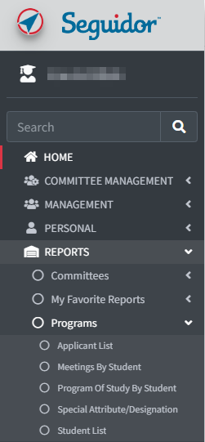
Ⓒ
Ⓐ
Ⓑ

- Adjust report criteria to view data for students who have an upcoming program of study deadline.

- Select the appropriate program(s)/sub-plan(s) Ⓐ
- Click Active for the student status Ⓑ
- Click the appropriate admit term Ⓒ
- Select Yes for include program of study with an upcoming deadline Ⓓ
  - Input 45 for deadline in this number of days Ⓔ (if you run this report on a different date then specified in these instructions, you will have to calculate the number days to input).
- Leave the include programs of study with overdue approvals field defaulted to Yes Ⓕ
- Leave the display columns with code values and the display extra columns for sorting fields defaulted to No Ⓖ
- Click Generate Report Ⓗ
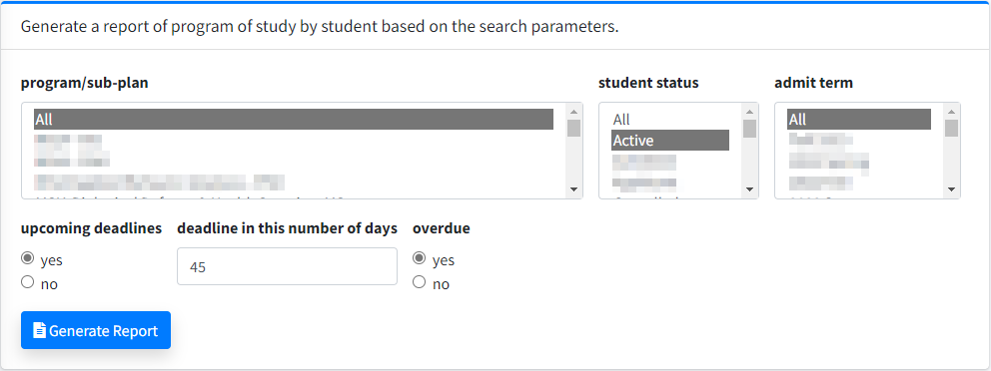
Ⓖ
Ⓕ
Ⓔ
Ⓓ
Ⓒ
Ⓑ
Ⓐ

Data Displayed on the Program of Study by Student Report

The report will show the columns outlined below in Excel. Sort & filter the data by Official Program of Study Approval Approval Date, then by POS Started.

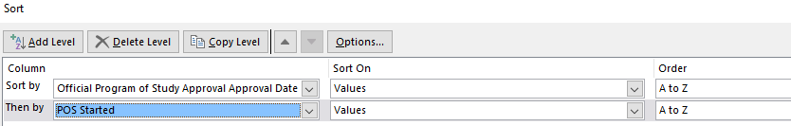

If the Official Program of Study Approval Approval Date field is blank and the POS started field displays N for no, the student has not initiated the program of study approval process and you will need to remind the student of the upcoming deadline (see the email templates section).

If the Official Program of Study Approval Approval Date field is blank and the POS started field displays Y for yes, the student has initiated the program of study approval process but has not completed it. You can view the next step by viewing the individual student’s dashboard.

Column | Heading Text
1 | Student NUID
2 | Student Name
3 | Program/Sub-Plan
4 | Career Type
5 | Time
6 | Candidate
7 | Student Begin Date
8 | Student Email
9 | Advisor/Supervisor Name
10 | Advisor/Supervisor Email
11 | Admit Term Description
12 | Student Status
13 | Program of Study Started
14 | Program of Study Rule Career Type (original)
15 | Program of Study Rule Title (original)
16 | Program of Study Rule Text (original)
17 | Program of Study Last-Submitted Date
18 | # of Outstanding Approvals (active version)
19 | Program of Study Final Approval Date (first)
20 | Official Program of Study Approval Deadline
21 | Official Program of Study Approval Date
22 | Official Program of Study Approval Deadline Days
23 | Official Program of Study Overdue Days

Email Templates

Master’s Degree

Program of Study Deadline Approaching
Student Name,

I am reaching out to remind you of an upcoming M.S. deadline. Your program of study is due on Date. Please initiate the program of study approval process in Seguidor, instructions can be viewed in the Seguidor Student Instructions.

Program of Study Past Due
Student Name,

A registration hold has been placed on your account. You will not be able to enroll for future courses until you become compliant

Your program of study was due for approval on Date. You must initiate the program of study approval process in Seguidor, instructions can be viewed in the Seguidor Student Instructions.

Review the Master’s Degree timeline to familiarize yourself with future requirements and deadlines.

Doctoral Degree

Program of Study Deadline Approaching
Student Name,

I am reaching out to remind you of an upcoming PhD deadline. Your program of study is due on Date. Please initiate the program of study approval process in Seguidor, instructions can be viewed in the Seguidor Student Instructions.

Program of Study Past Due
Student Name,

A registration hold has been placed on your account. You will not be able to enroll for future courses until you become compliant

Your program of study was due for approval on Date. You must initiate the program of study approval process in Seguidor, instructions can be viewed in the Seguidor Student Instructions.

Review the Doctoral Degree timeline to familiarize yourself with future requirements and deadlines.

Exam Committees by Student Report

The Exam Committees by Student report displays data for students by program/sub-plan. Key uses include:
- Identifying students who have an upcoming comprehensive/final oral examination deadline.
- Identifying students who are past due in taking the comprehensive/final oral examination.
- Identifying exam committees past due in grading the comprehensive/final oral examination.

Report Established

The examination functionality was launched in Seguidor in spring 2015. Examination data was only entered in Seguidor for active students. The report will not display examination data for students who completed their degree or withdrew/withdrawn from UNMC prior to spring 2015.

Report Frequency

You are encouraged to run the report at least 4 times a year to ensure students are progressing towards meeting their examination deadline.

Generate the Exam Committees by Students Report

1. To access reports, mouseover REPORTS Ⓐ in the menu bar and click Exam Comm. by Student Ⓑ

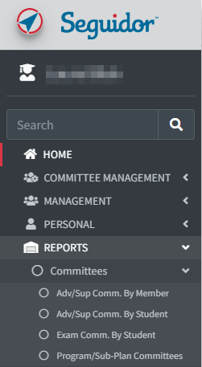
Ⓐ
Ⓑ
Ⓒ

2. Adjust report criteria to view examination data for active students.

- Select the appropriate program(s)/sub-plan(s) Ⓐ
- Click Active for the student status Ⓑ
- Click All for the admit term Ⓒ
- Click All for exam Ⓓ
- Click All for career type Ⓔ
- Leave the shows exams field defaulted to Show All Ⓕ
- Select Yes for the include exams where grading isn’t finalized field Ⓖ
- Leave the show pass/fail field defaulted to Show All Ⓗ
- Leave the display columns with code values, display extra columns for sorting, add columns showing all members, and the add columns showing grade detail fields defaulted to No Ⓘ
  - Important Note: If you would like to see the grading details (Pass or Fail) you will need select Yes for the add columns showing grade detail field.
- Click Generate Report Ⓙ

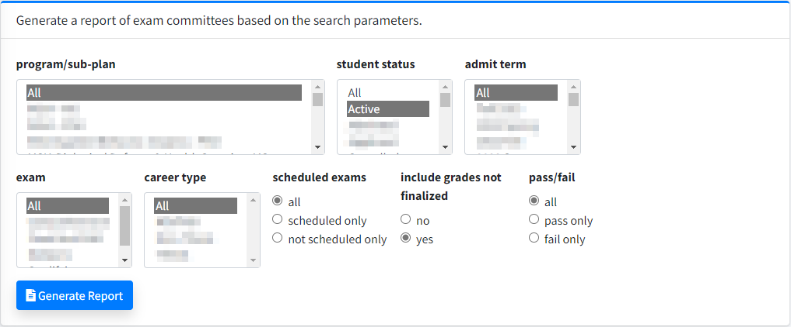
Ⓗ
Ⓘ
Ⓕ
Ⓖ
Ⓔ
Ⓓ
Ⓒ
Ⓑ
Ⓐ

Data Displayed on the Exam Committees by Students Report

The report will show the columns outlined below in Excel. The Office of Graduate Studies is working with IT to have additional columns added to assist with tracking of completion and data sorting.

Column | Heading Text
1 | Student NUID
2 | Student Name
3 | Program/Sub-Plan
4 | Career Type
5 | Time
6 | Candidate
7 | Student Begin Date
8 | Student Email
9 | Schedule Date
10 | Schedule Location
11 | Thesis Title
12 | Exam Committee Submitted Date
13 | Exam Committee Approved Date
14 | Exam Committee Disapproved Date
15 | Exam
16 | Grading Finalized
17 | Exam Committee Chair Name
18 | Exam Committee Chair Email
19 | Admit Term Description
20 | Student Status

Other Useful Reports

The reports covered in this section can be generated at any time, dependent upon your needs.

Important Note: You are encouraged to select All for the admit term when generating the reports in this section. If you want to limit the data to students who were admitted during a specific term, then it would be appropriate to select the appropriate term.

Program/Sub-Plan Committees Report

The Program/Sub-Plan Committees report is a historical record of who has served on a graduate committee by program/sub-plan.

Generate the Program/Sub-Plan Committees Report

- To access this report, click on REPORTS Ⓐ in the menu, then on Committees Ⓑ , and then on Program/Sub-Plan Committees Ⓒ.

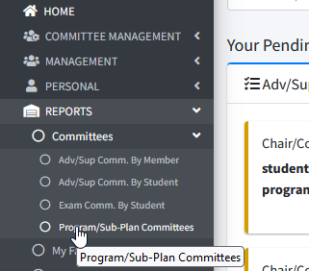
Ⓒ
Ⓑ
Ⓐ

- Adjust report criteria to view data for a program/sub-plan committee.

- Select the appropriate program(s)/sub-plan(s) Ⓐ
- Select the appropriate committee members role(s) Ⓑ
- Select the appropriate committee members status Ⓒ
- Click Generate Report Ⓓ

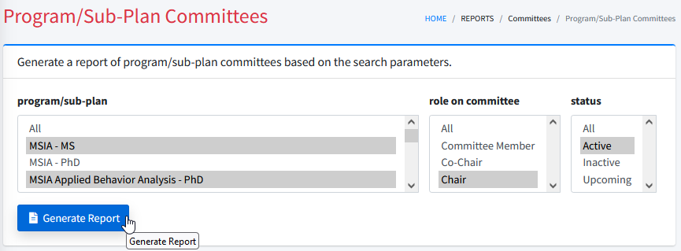
Ⓓ
Ⓒ
Ⓑ
Ⓐ

Data Displayed on the Program/Sub-Plan Committees Report

The report will show the columns outlined below in Excel.

Column | Heading Text
1 | Program/Sub-Plan
2 | Member Name
3 | Member Email
4 | Member Status
5 | Member Role
6 | Start Date
7 | End Date
8 | Member Duration (to date)

Advisory/Supervisory Committees by Member Report

The Advisory/Supervisory Committee by Member report displays data for students who have worked with a specific faculty member.

Generate the Advisory/Supervisory Committees by Member Report

- To access this report, click on REPORTS Ⓐ in the menu, then on Committees Ⓑ , and then on Adv/Sup Comm. by Member Ⓒ.

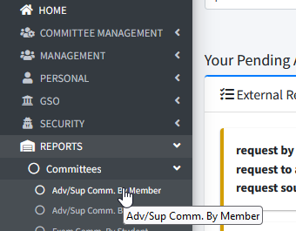
Ⓒ
Ⓑ
Ⓐ

- Adjust report criteria to view data for students who have been mentored by a specific faculty member.

- Select the appropriate status of the students Ⓐ
- Select the appropriate committee members role(s) Ⓑ
- Select the appropriate status of the committee member Ⓒ
- Input the name of the specific faculty member and press "Search" Ⓓ
  - Possible name matches will be displayed. Click the appropriate name Ⓔ
  - To remove the name from the search parameter, press "Clear". Ⓕ
- Click Generate Report Ⓖ
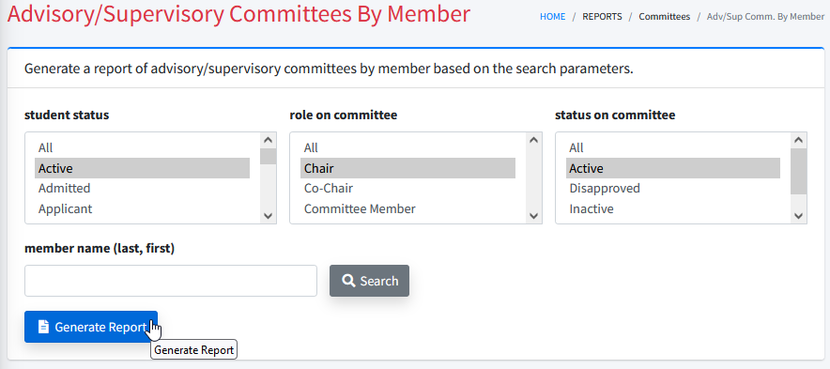
Ⓓ
Ⓖ
Ⓒ
Ⓑ
Ⓐ

Ⓓ
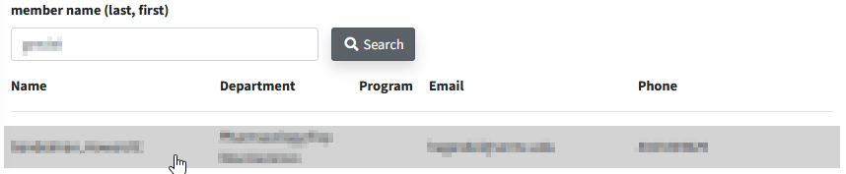
Ⓔ

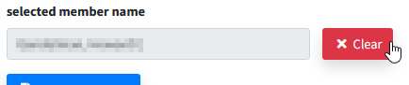
Ⓕ

Data Displayed on the Advisory/Supervisory Committees by Member Report

The report will show the columns outlined below in Excel.

Column | Heading Text
1 | Member Name
2 | Member Email
3 | Role
4 | Member Status
5 | Comments
6 | Student Name
7 | Student Email
8 | Student Status
9 | Student Begin Date
10 | Degree Requirements Completion Date
11 | Student Degree Conferred Date
12 | Days to Graduate
13 | Admit Term Description
14 | Program/Sub-Plan

Applicant List Report

The Applicant List report displays data for applicants by program/sub-plan. Key uses include:
- Finding the sum of applicants.
- Identifying the final application status for each applicant.

Generate the Applicant List Report

- To access this report, click on REPORTS Ⓐ in the menu, then on Programs Ⓑ , and then on Applicant List Ⓒ.

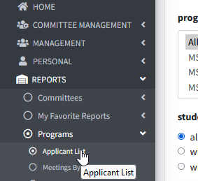
Ⓑ
Ⓒ
Ⓐ

- Adjust report criteria to view applicant data.

- Select the appropriate program(s)/sub-plan(s) Ⓐ
- Select the appropriate status of the applicants application Ⓑ
- Click the appropriate expected enrollment (admit) term Ⓒ
- Click Generate Report Ⓓ
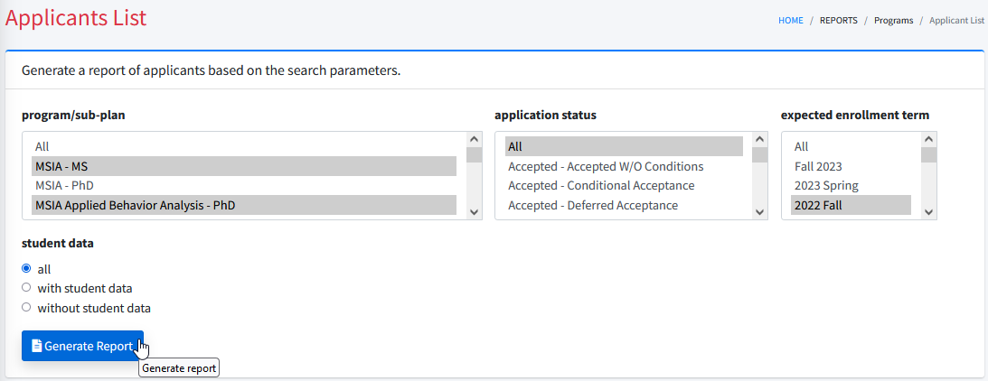
Ⓓ
Ⓒ
Ⓑ
Ⓐ

Data Displayed on the Applicant List Report

The report will show the columns outlined below in Excel.

Column | Heading Text
1 | Applicant NUID
2 | Applicant Name
3 | Program/Sub-Plan
4 | Applicant Email
5 | Application Date
6 | Expected Enroll Date
7 | Enroll Term Date
8 | Enroll Term Description
9 | US Citizen
10 | US State Resident
11 | Application Status

Student List Report

The Student List report displays data for students by program/sub-plan. Key uses include:
- Identifying students by status (i.e. active, leave of absence, completed, etc.).
- Identifying students who have been admitted to Candidacy.

Generate the Student List Report

- To access this report, click on REPORTS Ⓐ in the menu, then on Programs Ⓑ, and then on Student List Ⓒ.

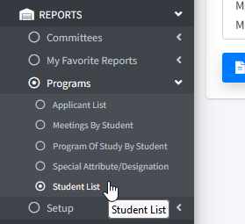
Ⓒ
Ⓑ
Ⓐ
Ⓒ

- Adjust report criteria to view data for students by program/sub-plan.

- Select the appropriate program(s)/sub-plan(s) Ⓐ
- Select the appropriate status of the students Ⓑ
- Click the appropriate admit term(s) Ⓒ
- Click Generate Report Ⓓ

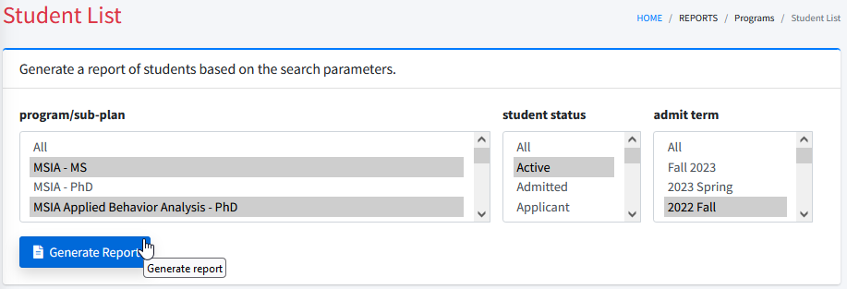
Ⓓ
Ⓒ
Ⓑ
Ⓐ

Data Displayed on the Student List Report

The report will show the columns outlined below in Excel.

Column | Heading Text
1 | Student NUID
2 | Student Name
3 | Program/Sub-Plan
4 | Student Begin Date
5 | Student Email
6 | Admit Term Description
7 | Student Status
8 | Career Type
9 | Time
10 | Candidate
11 | Degree Conferred
12 | Degree Completed

Special Attributes/Designations Report

The Special Attributes/Designations report displays data for students who have a special attribute/designation by program/sub-plan. The special attributes/designations are:
- Chinese Scholarship Council (CSC)
- Saudi Arabia Scholarship (SAS)

Generate the Special Attributes/Designations Report

- To access this report, click on REPORTS Ⓐ in the menu, then on Programs Ⓑ, and then on Special Attribute/Designation Ⓒ.
Ⓐ
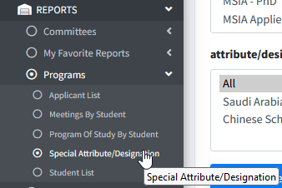
Ⓑ
Ⓒ

- Adjust report criteria to view data for students by attribute/designation.

- Select the appropriate program(s)/sub-plan(s) Ⓐ
- Select the appropriate status of the students Ⓑ
- Click the appropriate admit term(s) Ⓒ
- Select the appropriate attribute/designation assigned to the students Ⓓ
- Leave the display columns with code values and the display extra columns for sorting fields defaulted to No Ⓔ
- Click Generate Report Ⓕ

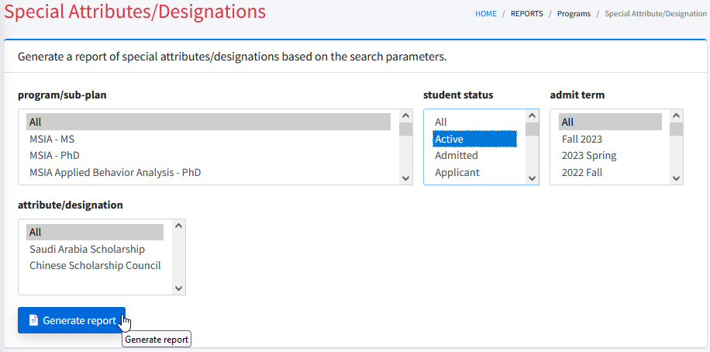
Ⓔ
Ⓓ
Ⓑ
Ⓒ
Ⓐ

Data Displayed on the Special Attributes/Designations Report

The report will show the columns outlined below in Excel.

Column | Heading Text
1 | Student NUID
2 | Student Name
3 | Program/Sub-Plan
4 | Attribute/Designation
5 | Attribute Start Date
6 | Attribute End Date
7 | Student Begin Date
8 | Student Email
9 | Admit Term Description
10 | Student Status
11 | Career Type
12 | Time

Favorite Reports
Favorite Reports allows users to save report criteria for frequently used reports.

Create Favorite Report

- To access reports, mouseover REPORTS Ⓐ in the menu bar and click on the name of the report that you would like to establish as a favorite report Ⓑ.

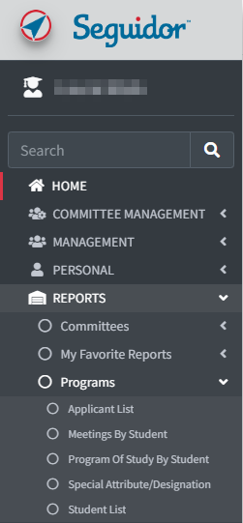
Ⓑ
Ⓐ

- Adjust report criteria (review the appropriate report section to determine how to adjust your criteria) and click the Generate Report button. For this example, we will be creating a favorite report to view data for all active students in a specific program.

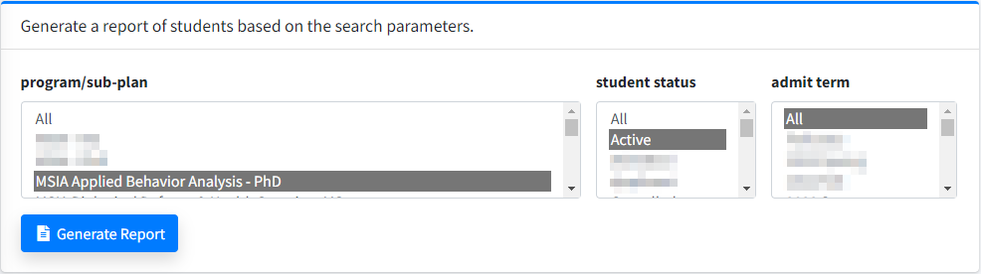

- Click the Add to Favorites button Ⓐ above the report.

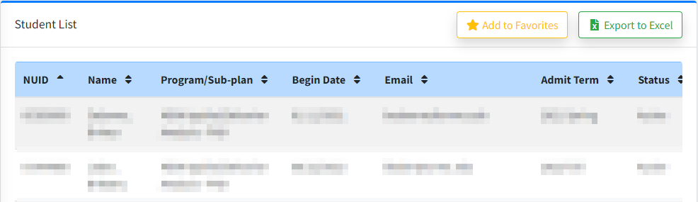
Ⓐ

- Input name of this report specification (name the report something that clearly defines the reports use for you) Ⓐ and click Save Specification as Favorite Ⓑ.

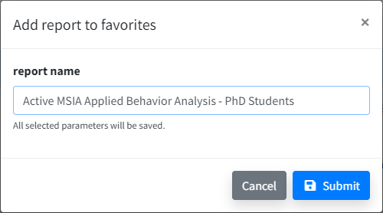
Ⓑ
Ⓐ

Generate Favorite Report

After you have established a favorite report, you will see a Favorite Reports section on your Seguidor landing page.

- Click on the name of the report you want to generate Ⓐ.
Otherwise, click the View All (#) button Ⓑ to open the My Favorite Reports page.

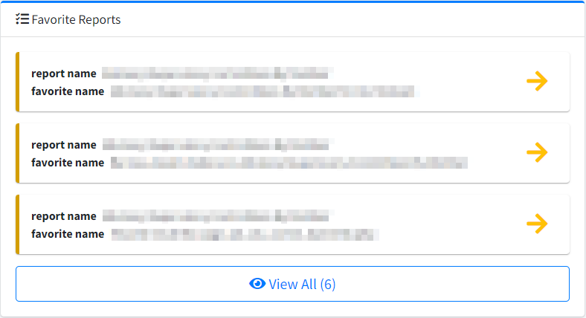
Ⓑ
Ⓐ

Delete Favorite Report

- To access reports, mouseover REPORTS Ⓐ in the menu bar and click on the name of the report Ⓑ.

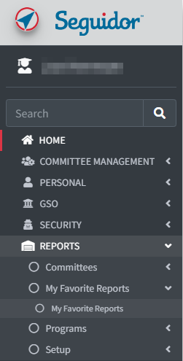
Ⓑ
Ⓒ
Ⓐ

- Click the red X Ⓐ for the favorite report that you want to delete.




