
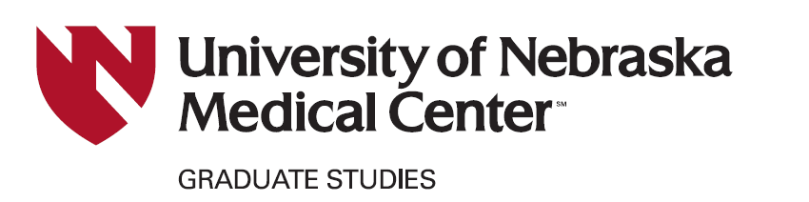


Graduation Instructions
for M.S. Students (Non-Thesis Option)

Use the checklist below to ensure that you have completed all steps required to graduate (do these tasks in order):

- Prior to February 10th (for May graduation), June 10th (for August graduation) or October 10th (for December graduation): Complete the degree application on MyRecords.
- Complete the Convocation & Accomplishments Survey. The information that you provide is presented in the Convocation program and ceremony.
- Complete the Graduate Program Effectiveness & Student Satisfaction Survey.
- Obtain Verification by the Program Director and Supervisor certifying completion of program requirements (see additional details below).

- After completing the above requirements, complete the online Checklist Before Graduation**.
**In order to complete the Checklist Before Graduation, you will first need to complete the above steps. The Office of Graduate Studies will only accept the fully completed checklist and will not accept the requirements one at a time.
The student is solely responsible for ensuring that all of the tasks listed above are completed, including submission of the appropriate documents prior to the deadline established by the Graduate Studies Office.

TIMELINE FOR GRADUATION
- Prior to February 10th (for May graduation), June 10th (for August graduation) or October 10th (for December graduation): Complete the degree application on MyRecords.
- Recommended: Two-to-three months in advance of the approximate date of the Comprehensive Exam, the student should consult with his/her Advisor and Advisory Committee and establish the tentative (unofficial) date and time for the exam. Note that the exam must be completed no sooner than 10 months and at least 2 weeks, prior to commencement/graduation.

At least 2 weeks before the Comprehensive Exam (at least 4 weeks before commencement):
  - With approval from the Advisor, the student must (via Seguidor™) establish the Examining Committee (typically, the student’s Advisory Committee) and officially schedule the Comprehensive exam to be held at least 2 weeks prior to commencement/graduation. The Examination Committee must agree to the date & time before this information is entered into Seguidor. The exam location must also be established at this time. Advance planning is necessary, because Seguidor will not allow exam scheduling within 2 weeks of the desired exam date.

At least 2 weeks before commencement: Complete the Comprehensive Exam.
- No more than 7 days after the Comprehensive Exam: Results of the Exam must be reported to the Graduate Studies Office (via Seguidor). It is recommended that the Examining Committee complete this task immediately.

3

Additional Details of the Requirements Listed on Page 1
Convocation & Accomplishments Survey, https://forms.office.com.mcas.ms/r/2USCJNEqZN?McasTsid=27548&McasCtx=4 . You will find it useful to have your CV handy when completing this survey.
The information collected via this survey provides Graduate Studies with data that are needed for program evaluation, accreditation and other reports. It will also facilitate the celebration of your accomplishments at the Graduate Studies Convocation Ceremony, as well as allowing us to contact you in the future.
Graduate Program Effectiveness and Student Satisfaction Survey, https://forms.office.com.mcas.ms/r/C3GwjYGGH2?McasTsid=27548&McasCtx=4.
The information collected via this survey will help Graduate Studies improve the education experience for future students. Please be thoughtful and truthful in completing this survey and be reassured that the results are completely anonymous.

Verification from the Program Director and Supervisor that you have completed the program requirements.
To do so, you will need a copy of an email chain (print to pdf) with both the Program Director and Supervisor responding “I agree” to the following statement: “I verify that [student name] has completed all requirements in the [program name] for graduation under supervision of [mentor name]”. Alternatively, you can use the physical form to gather signatures (template provided on the last page of these instructions).

1

Verification that the Student Meets Program Requirements
Use this form if you wish to gather physical signatures. Alternatively, we also accept a pdf (click print to pdf) of an email chain with both the Program Director and Supervisor responding “I agree” to the following statement: “I verify that [student name] has completed all requirements in the [program name] for graduation under supervision of [mentor name]”.

Date:
Student Name:

Graduate Program Name and Acronym:

The above-named student has been reported as follows concerning the degree requirements. All requirements established by the listed Graduate Program have been satisfied.

Supervisor Name and Signature:

Graduate Program Director Name and Signature:

Name

Signature

Name

Signature

