
Guide for UNMC Graduate Students

© all rights reserved worldwide
Contents
1. Access to Seguidor 4
2. Seguidor Home Screen 4
2.1. Pending Actions 4
3. My Dashboard 5
3.1. Applicant Tab 5
3.2. Student Tab 6
3.3. Program of Study Tab 6
3.4. Meeting Tab 7
4. Advisory/Supervisory Committee 8
4.1. Advisor/Supervisor Selection 8
4.2. Advisory/Supervisory Committee Member Selection 10
4.3. Restructuring your Advisory/Supervisory Committee 12
4.4. Add and Remove Advisory/Supervisory Committee Members 12
5. Meetings/Individual Development Plan (IDP)/Annual Report 13
5.1. Add an Advisory/Supervisory Committee Meeting 13
5.1.1. Cancelling a Meeting 16
5.1.2. Rescheduling/Moving a Meeting 17
5.1.3. Add and Remove Meeting Attendees 18
5.1.4. Upload Meeting Documents 19
5.2. Uploading Individual Development Plan (IDP) Certificate of Completion 20
5.3. Uploading Annual Report 22
6. Program of Study 24
6.1. Submit Program of Study 24
6.2. Approval Process for Program of Study 30
6.2.1. Order of Approval 30
6.2.2. Status of Approval 30
6.3. Program of Study Dissaproved 31
6.3.1. Selected Wrong Rule (requirements) Title 31
6.3.2. Missing a Requirement 38
6.4. Edit your Program of Study 43
6.5. View your Program of Study 45
1. Exam Committee / Schedule 47
1.1. Establish Exam Committee 47
1.2. Schedule Exam 49
1.3. Reschedule Exam 50
1.4. Notification of Exam Results 50

For additional assistance with Seguidor, please contact the Graduate Studies Office at unmcgraduatestudies@unmc.edu or 402-559-4476.

Access to Seguidor
All students enrolled in a UNMC Graduate Program can log into Seguidor using the link found on the Graduate Studies Student Portals webpage or by entering the following URL into your internet browser https://seguidor.unmc.edu/seguidor/public/login

Seguidor Home Screen

The Seguidor home screen is the screen that first appears after logging into the Seguidor web application. To return to the Seguidor home screen at any time, click on the Seguidor logo Ⓐ in the upper left corner of the screen or on the "HOME" link on the left menu. Click on Your Name to

Ⓐ
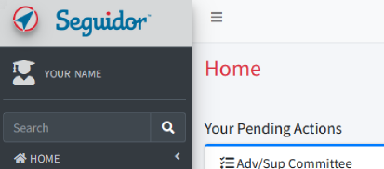

Pending Actions

A pending action indicates an action you must take to fulfill the requirements for your academic program. The pending action will remain on the Seguidor home screen until action is taken to address the identified task.

Click on the gold arrow of the pending action Ⓑ to go directly to the related Seguidor page.

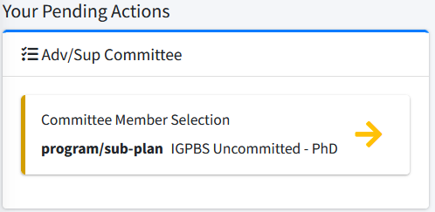
Ⓑ

My Dashboard

The Dashboard allows you to view your academic progress throughout your graduate program. Only members of your Advisory/Supervisory Committee, the Chair of your Graduate Program Committee (Program Director), administrative staff of your graduate program, the Dean of Graduate Studies, and Graduate Studies Office personnel have security access to your Dashboard.

- To access your Dashboard, click on PERSONAL Ⓐ on the side menu and then on Dashboard (B?) and then on My Dashboard Ⓑ or click on Your Name. Ⓒ

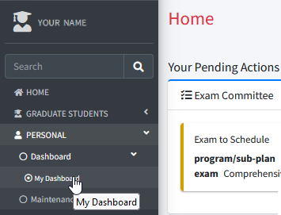
Ⓒ
Ⓐ
Ⓑ

You will be directed to the STUDENT tab to view details regarding your Advisory/Supervisory Committee, and Exam Committees.

Applicant Tab

The applicant tab displays data regarding your admission test scores, prior education, and UNMC applications.

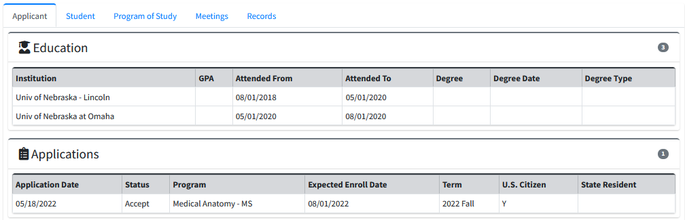

Student Tab

The student tab displays data regarding your academic career, Advisory/Supervisory Committee, and Exam Committees.

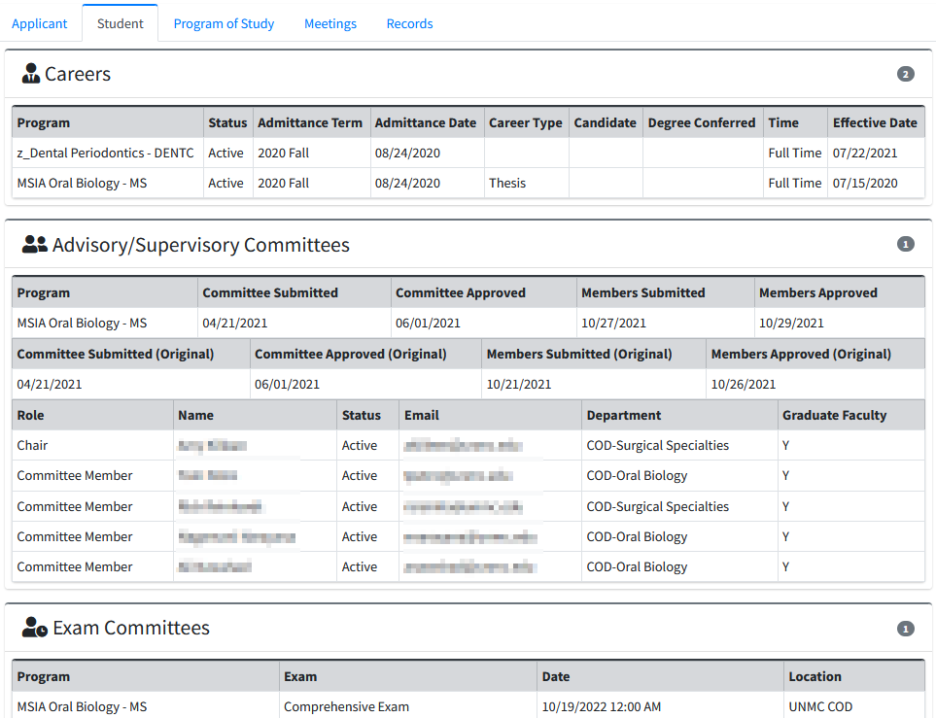

Program of Study Tab

The Program of Study tab displays data regarding your course requirements.

Click the active version of the Program of Study to view the status of the requirements.

The letter “Y” indicates the active version Ⓐ.

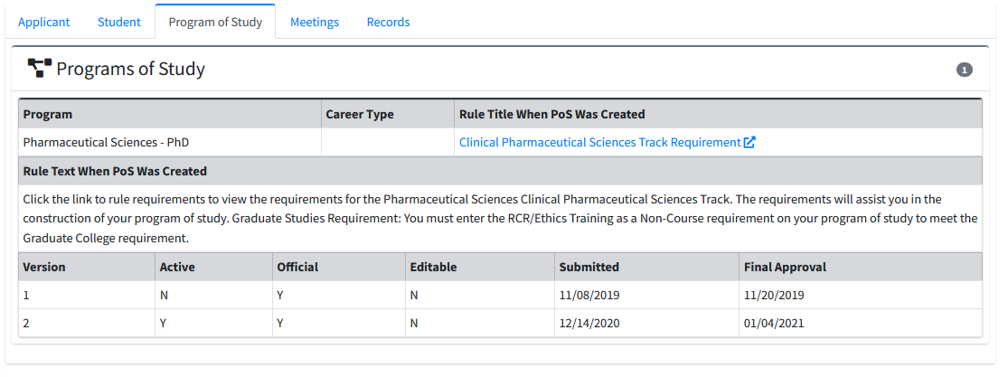
Ⓐ

Meeting Tab

The meeting tab displays data regarding your Advisory/Supervisory Committee Meeting and your Individual Development Plan.

Click the meeting of interest Ⓑ for additional meeting information.

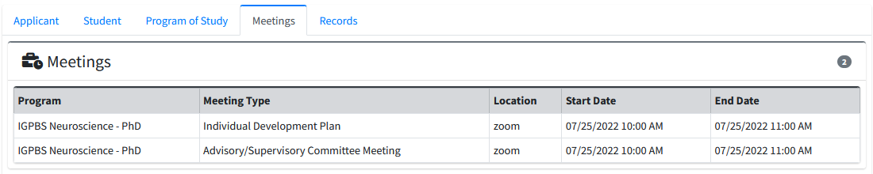
Ⓑ

Advisory/Supervisory Committee

Advisor/Supervisor Selection

Please note: If you are enrolled in an MSIA sub-plan (e.g. MSIA Clinical & Translational Research) your Advisor/Supervisor will be entered into Seguidor by the Chair of the MSIA Graduate Committee (MSIA Program Director). After the role has been accepted by your Advisor/Supervisor, a pending action to select committee members will appear on your Seguidor home screen.

- On the menu, click on GRADUATE STUDENTS Ⓐ , on Committee Management Ⓑ , and on Adv/Sup Comm. Member Selection Ⓒ , or click on the Pending Action on the Home Page.

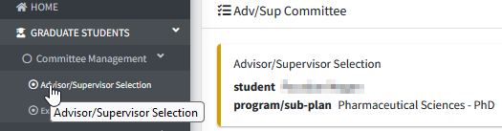
Ⓒ
Ⓑ
Ⓐ

- Click Begin selection process Ⓒ

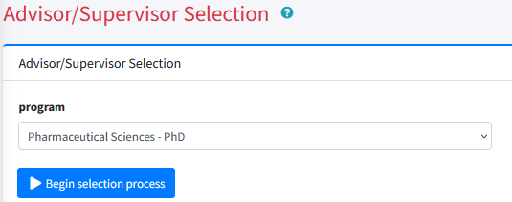
Ⓒ

- Type the last name, first name of the Graduate Faculty Member in the Advisor/Supervisor search box Ⓓ
OR Click the dropdown arrow Ⓔ in the department selection box to view all departments. Click a department to view Graduate Faculty in that department.
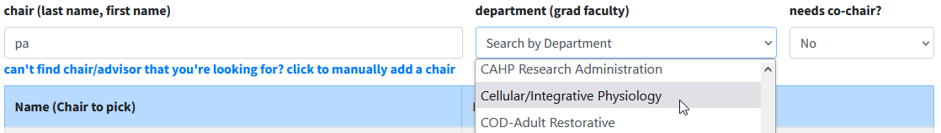
Ⓔ
Ⓓ

4. Mouseover and Click the appropriate name Ⓕ to select. (Note: To undo the selection, select a different name.) If the person you are searching for is not listed in the results table, click can’t find who you’re looking for? Ⓖ and complete the External Account Request Form that appears in the pop-up window (for more information please see Section 2.4).
Ⓖ
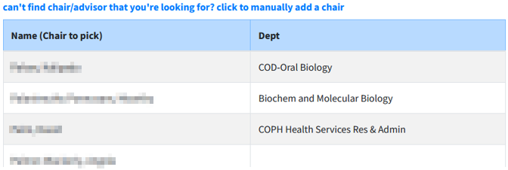
Ⓕ

5. Affirm that you have discussed the designation with the selected Graduate Faculty Member by clicking in the check box. Click the Submit button to confirm and submit.
- Clicking the submit button triggers an email to the selected faculty member notifying him/her of the designation and requesting their approval in Seguidor. Once approved, a final notification is sent to the Chair of your Graduate Program Committee (Program Director) requesting final approval.
- Once approved, you should receive an email and pending action to select your remaining Advisory/Supervisory Committee Members.

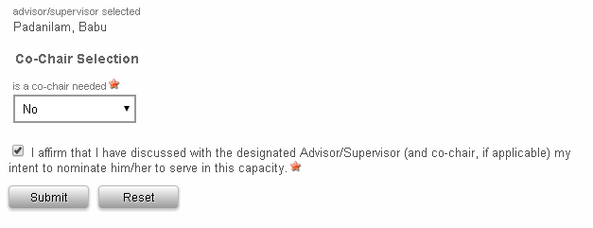
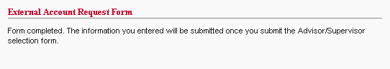

Change Advisory/Supervisory Committee Chair (Advisor/Supervisor)

Students may request to change their Advisory/Supervisory Committee Chair (Advisor/Supervisor) by sending an email to the Graduate Studies Office (unmcgraduatestudies@unmc.edu) stating the name of their current Chair and the name of the Graduate Faculty Member selected as their new Chair. Please copy both of these individuals and the Chair of your Graduate Program on the email request.

Advisory/Supervisory Committee Member Selection

- On the menu, click on GRADUATE STUDENTS Ⓐ , on Committee Management Ⓑ , and on Adv/Sup Comm. Member Selection Ⓒ , or click on the Pending Action on the Home Page.

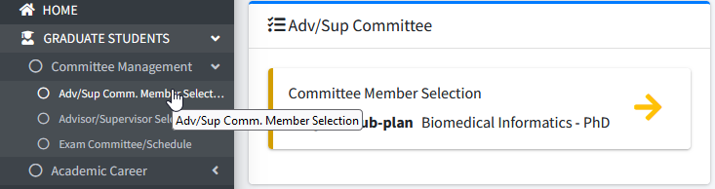
Ⓐ
Ⓑ
Ⓒ

2. Click Add Committee Member Ⓑ

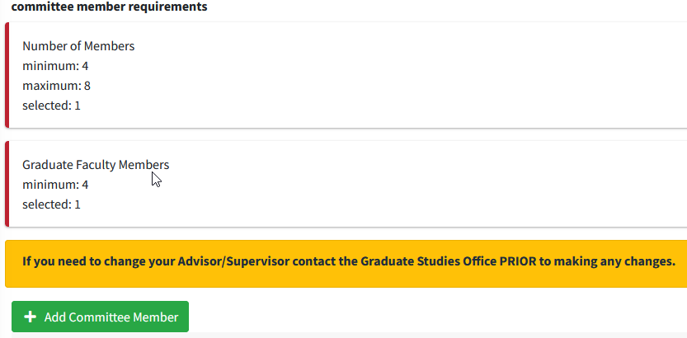
Ⓑ

3. Search for potential committee members by name Ⓒ and/or by clicking on the drop down box under department Ⓓ and selecting the academic department of the committee member.
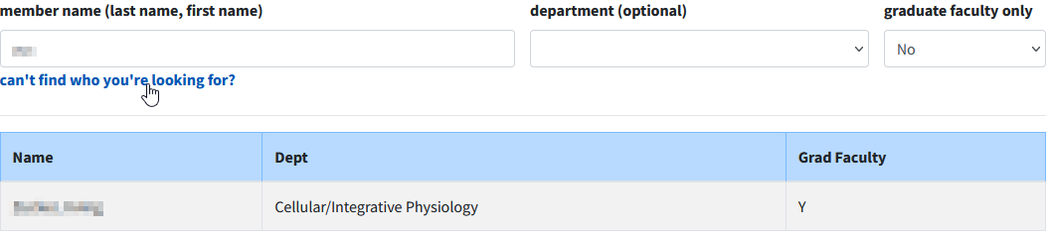
Ⓔ
Ⓒ
Ⓓ
4. Click on the name in the result table to add to your committee. Return to step 2 to add additional members. If no records are found for the individual you are searching for click can’t find who you’re looking for Ⓔ and follow the prompts to request an External Account for your committee member.

5. Once the minimum number of members has been added to your Advisory/Supervisory Committee, the requirements indicator bar will turn green. If you are satisfied with the composition of your committee, affirm that you have contacted each of the named individuals and confirmed their willingness to serve on your Advisory/Supervisory Committee by clicking the checkbox next to the affirmation statement.

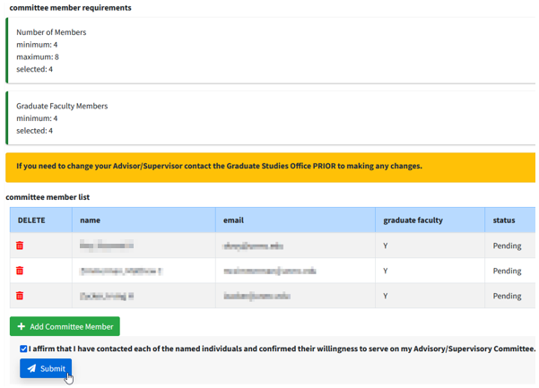
6. Click the Submit button to begin the Advisory/Supervisory Committee approval process. Your committee will be presented for approval in the following order:
1) Chair of Advisory/Supervisory Committee (your Advisor/Supervisor)
2) Chair of MSIA Sub-Plan Committee (Sub-plan Director - MSIA only)
3) Chair of Graduate Program Committee (Program Director)
4) Dean of Graduate Studies

After final approval by the Dean of Graduate Studies the status of your Advisory/Supervisory Committee will be Active. At any time after final approval you may change the composition of your Advisory/Supervisory Committee by returning to Step 1 and following the procedure to add new members. Members may be removed from the committee by clicking the red X next to the appropriate name. Please note: any change to the composition of your Advisory/Supervisory Committee will change the status of all committee members to pending and the approval process noted above will be followed.

Restructuring your Advisory/Supervisory Committee

Students may make changes to the composition of their Advisory/Supervisory Committee only after their initial committee has been approved. Please Note: If you plan to change your Advisor/Supervisor AND add or remove committee members, you must follow the instructions outlined in section 3.1.1.1 to change your Committee Advisor/Supervisor BEFORE making any changes in Seguidor.

Add and Remove Advisory/Supervisory Committee Members

Mouseover GRADUATE STUDENTS in the toolbar and click Adv/Sup Comm. Member Selection to access the Advisory/Supervisory Committee Member Selection page.

ADD committee members follow the steps outlined in 2.2 Initial Committee Member Selection.
REMOVE committee members click on the red trash can Ⓐ in the committee member list.
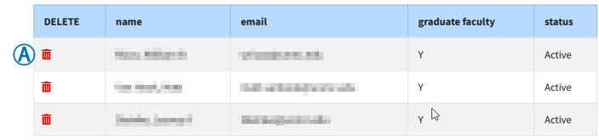
After confirming the revised composition of your Advisory/Supervisory Committee, click the checkbox Ⓑ to affirm that you have contacted each of the individuals and confirmed their willingness to serve on the committee. Click the Submit button Ⓒ to start the committee approval process.
Ⓑ
Ⓒ

Meetings/Individual Development Plan (IDP)/Annual Report

The Meetings/Individual Development Plan (IDP)/Annual Report page is for students to input their advisory/supervisory committee meetings and upload supporting documents, upload their IDP certificate of completion and upload their annual report.

The Office of Graduate Studies has created several document templates to assist students in composing their meeting minutes, annual report, etc.

Add an Advisory/Supervisory Committee Meeting

1. On the menu, click on Graduate Students Ⓐ , on Academic Career Ⓑ. and on Meetings/IDP/Annual Report Ⓒ

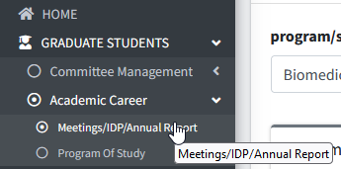
Ⓒ
Ⓑ
Ⓐ

2. Select Advisory/Supervisory Committee Meeting Ⓐ.

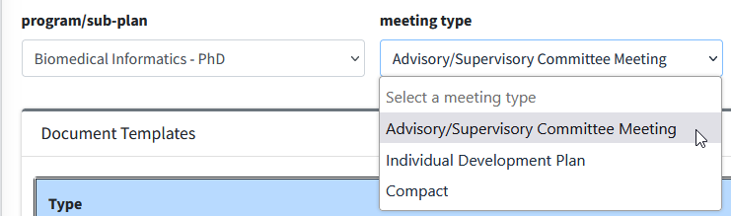
Ⓐ

3. Click the "Add New Meeting" button Ⓐ to add a new meeting.
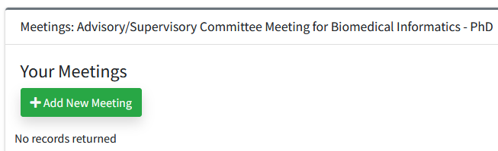
Ⓐ
4. Input dates/times Ⓐ and location Ⓑ and click Add Ⓒ.

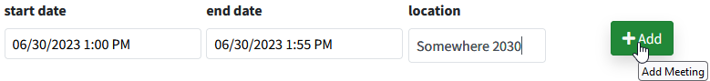
Ⓒ
Ⓐ
Ⓑ

5. Click on the Edit icon in the Edit/View column for the new meeting Ⓐ.
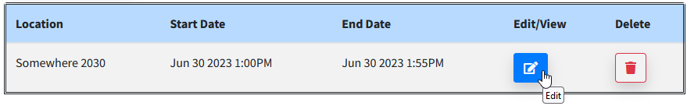
Ⓐ

6. Search for potential meeting attendees by name Ⓐ.

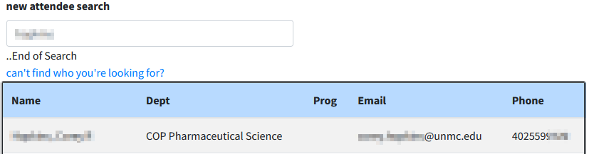
Ⓑ
Ⓒ
Ⓐ

6.1. Click on the name in the result table Ⓑ to add to your meeting attendees. Return to step 4 to add additional meeting attendees. If no records are found for the individual you are searching for click can’t find who you’re looking for Ⓒ and follow the prompts to request an External Account for your meeting attendee.

7. Send meeting invitation by clicking Invite all Attendees Ⓐ or individually by clicking the calendar icon Ⓑ for each attendee you want to send an invite to.
Ⓐ
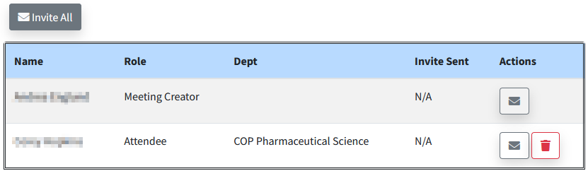
Ⓑ

If you do not have a PowerPoint or other documents that will be referenced at the meeting, you have completed the scheduling process. After the meeting you will need to refer to section 6.1.4. for the steps to upload your meeting minutes.

If you do have a PowerPoint or other documents that will be referenced at the meeting, please continue to step 7.

8. Select Presentation Ⓐ. Browse computer for document Ⓑ. Click Upload Ⓒ.

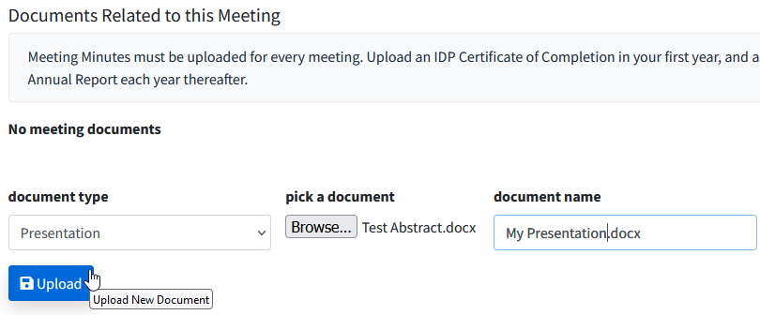
Ⓒ
Ⓑ
Ⓐ

Cancelling a Meeting

A meeting cannot be cancelled after the meeting's recorded end date & time.

1. On the menu, click on Graduate Students Ⓐ , on Academic Career Ⓑ. and on Meetings/IDP/Annual Report Ⓒ

Ⓒ
Ⓑ
Ⓐ

2. Click the red trash can Ⓐ.

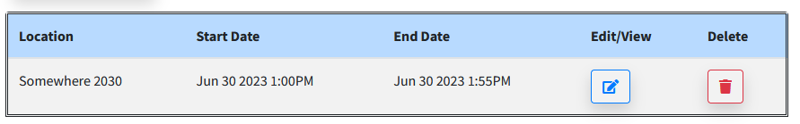
Ⓐ

3. A dialogue box will open. Click Confirm Ⓐ to delete the meeting.

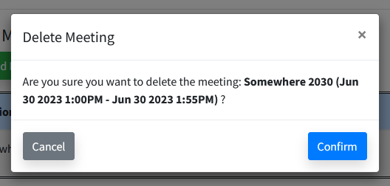
Ⓐ

Rescheduling/Moving a Meeting

Meeting location and start/end date & time cannot be edited after the meeting's recorded end date & time.

1. On the menu, click on Graduate Students Ⓐ , on Academic Career Ⓑ. and on Meetings/IDP/Annual Report Ⓒ

Ⓒ
Ⓑ
Ⓐ

2. Click on the Edit icon in the Edit/View column for the meeting in question Ⓐ.
Ⓐ

3. Change location Ⓐ and/or time Ⓑ and click Save Meeting Details Ⓒ.

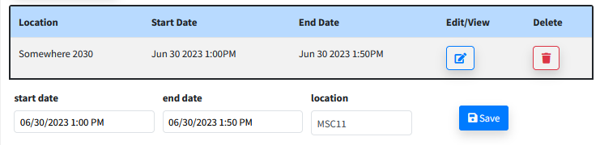
Ⓒ
Ⓑ
Ⓐ

Add and Remove Meeting Attendees

1. On the menu, click on Graduate Students Ⓐ , on Academic Career Ⓑ. and on Meetings/IDP/Annual Report Ⓒ

Ⓒ
Ⓑ
Ⓐ

2. Click on the Edit icon in the Edit/View column for the meeting in question Ⓐ.
Ⓐ

3. ADD meeting attendees. Search for potential meeting attendees by name Ⓐ.

Ⓑ
Ⓒ
Ⓐ

3.1. Click on the name in the result table Ⓑ to add to your meeting attendees. Return to step 3 to add additional meeting attendees. If no records are found for the individual you are searching for click can’t find who you’re looking for Ⓒ and follow the prompts to request an External Account for your meeting attendee.

3.2. REMOVE meeting attendees. Click on the red trash can Ⓐ in the meeting attendees list.

Ⓐ

Upload Meeting Documents

1. On the menu, click on Graduate Students Ⓐ , on Academic Career Ⓑ. and on Meetings/IDP/Annual Report Ⓒ

Ⓒ
Ⓑ
Ⓐ

2. Click on the Edit icon under Edit/View for the meeting you would like to upload a document for Ⓐ.
Ⓐ

3. Select document type Ⓐ. Browse computer for document Ⓑ. Click Upload Ⓒ.

Meeting minutes are required to be uploaded following each semi-annual advisory/supervisory committee meeting. The “Documents Templates” section contains a meeting minute’s template that will assist you in composing your meeting minutes.

Presentation documents are optional; you may choose to upload PowerPoint or other documents that will be discussed at the advisory/supervisory committee meeting.

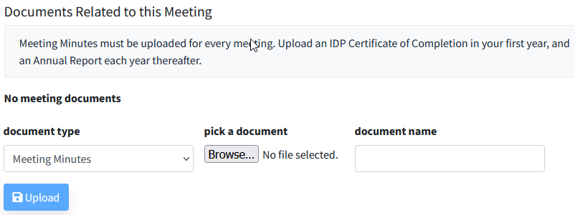
Ⓑ
Ⓒ
Ⓐ

Uploading Individual Development Plan (IDP) Certificate of Completion

1. On the menu, click on Graduate Students Ⓐ , on Academic Career Ⓑ. and on Meetings/IDP/Annual Report Ⓒ

Ⓒ
Ⓑ
Ⓐ

2. Select Individual Development Plan Ⓐ.

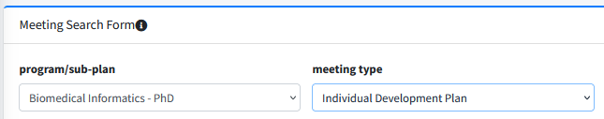
Ⓐ

3. Click the "Add New Meeting" button Ⓐ to create a new entry.

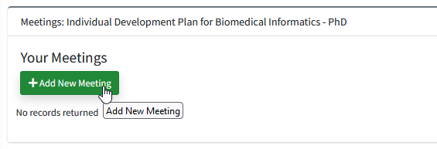
Ⓐ

4. Input “Computer” for the location Ⓐ and the date that you completed the IDP for the start date and end date and “12:00” for the start time and end time Ⓑ and click Add Ⓒ.
Ⓒ
Ⓑ
Ⓐ

5. Bypass the Meeting Attendees section.

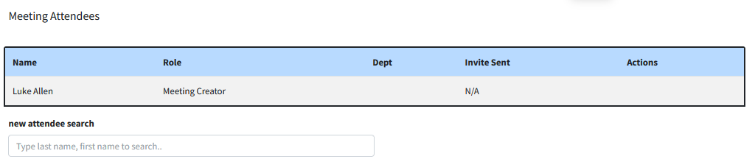

6. Select IDP Certificate of CompletionⒶ. Browse computer for your IDP certificate of completionⒷ. Click Upload Ⓒ.
Ⓐ
Ⓑ
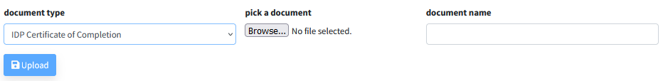
Ⓒ

Uploading Annual Report

An annual report is required to be uploaded annually following one of your semi-annual advisory/supervisory committee meetings. The Annual report is in addition to the meeting minutes. The “Documents Templates” section contains an annual report’s template that will assist you in composing your annual report.

1. On the menu, click on Graduate Students Ⓐ , on Academic Career Ⓑ. and on Meetings/IDP/Annual Report Ⓒ

Ⓒ
Ⓑ
Ⓐ

2. Click on the Edit icon under Edit/View for the meeting you would like to associate the annual report with Ⓐ.

“Meeting list with Edit/View icon selected to upload a document.”
Ⓐ

3. Select “Annual Report” Ⓐ. Browse computer for document Ⓑ. Click Upload Ⓒ.

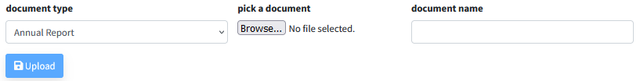
Ⓒ
Ⓑ
Ⓐ

Program of Study

The Program of Study must list all required courses and options for electives. You construct your Program of Study by following the Graduate Program requirements (rule) and with the assistance of your Advisory/Supervisory Committee.

If you have a course that needs to be waived or transferred from another program, please refer to the Transfer Credit and Waiver Policy.

To request a transfer of credit, complete this form.
To request a course waiver, complete this form.

Important Note: If you are eligible for tuition remission and plan to complete a certificate program (e.g. Business for Bioscientists, at UNO) while pursuing a graduate degree at UNMC, this plan must be indicated in the first approved version of the Official Program of Study in order for Graduate Studies to provide tuition assistance for those courses. You must list individually every course (NU System Course) required for the certificate program.

Submit Program of Study

1. On the menu, click on Graduate Students Ⓐ , Academic Career Ⓑ and Program of Study Ⓒ

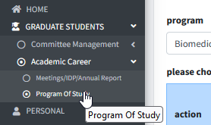
Ⓒ
Ⓑ
Ⓐ

2. Select Ⓐ the appropriate rule (requirements) title.

See picture on the next page for a visual example of rule (requirements) titles. The rule (requirements) title that you select establishes the course and examination requirements.

Rule (requirements) Title Examples:

M.S. Rule Title
Thesis Requirements
Non-Thesis Requirements

Ph.D. Rule Title
Standard Requirements
MD/PhD Requirements

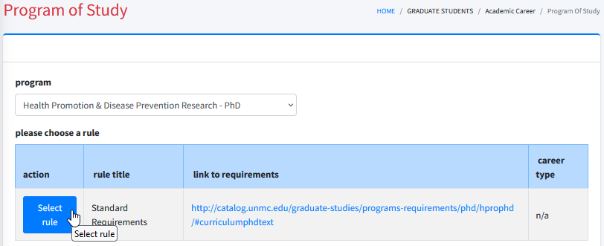
Ⓐ

3. A dialogue box will open. Click Ok to confirm that you have selected the correct rule (requirements) title. If you have selected the wrong rule (requirements) title, click Cancel and repeat step 2.

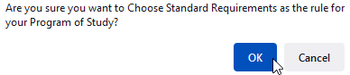

4. Click Add Requirement Ⓐ. Note that the link to rule requirements will assist you with the process. You must enter each requirement individually in order to construct your Program of Study.

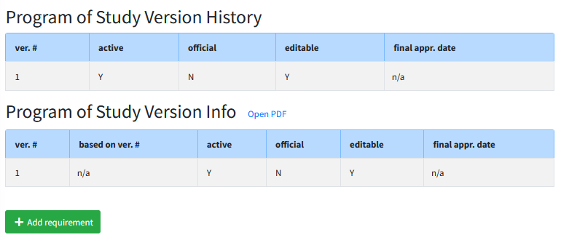
Ⓐ

5. Select requirement type Ⓐ.

There are three requirement type options (NU System Course, Non-NU System Course & Non-Course). Please see below for an explanation of each requirement type and further instructions on how to enter the specific requirement types.

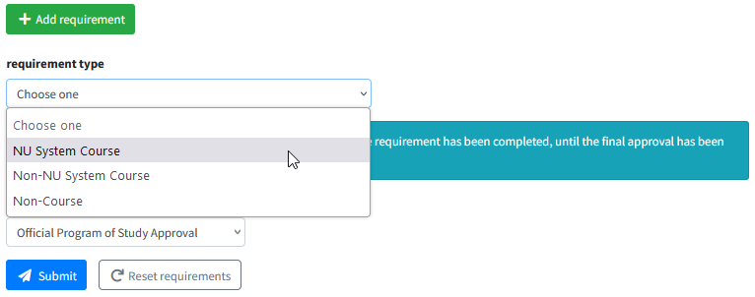
Ⓐ

NU System Course – this requirement type is used to add a course from UNMC, UNO, UNL and/or UNK; including professional level courses (500-600 level). See the important note on the top of the next page if you have professional level courses.

Select Institution Ⓐ. Select Department Ⓑ.

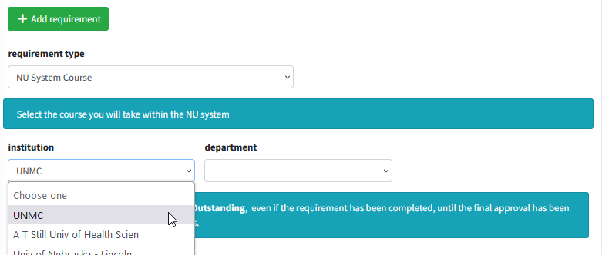
Ⓐ
Ⓑ

Select Course Ⓒ. Select Required/Core or Elective/Cognate to appropriately classify the requirement Ⓓ. Enter requirement description, if applicable Ⓔ. Click Save Ⓕ.

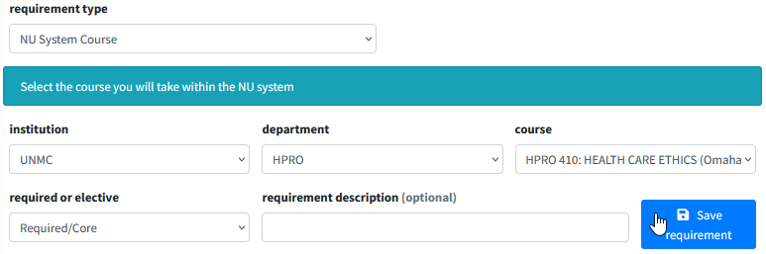
Ⓓ
Ⓒ
Ⓕ
Ⓔ

Important Note: If you are transferring professional level courses (500-600 level) completed at UNMC, you need to select the appropriate 500-600 level course and in the requirement description note which graduate level course (800 level) requirement that the professional level course is fulfilling. See example below.

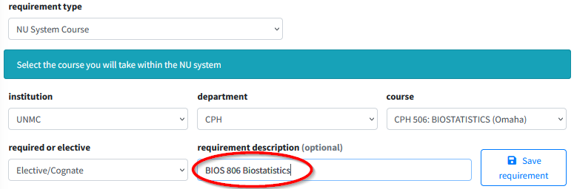

Non-NU System Course – this requirement type is used to add a course from an institution outside of the Nebraska University system. This is frequently referred to as transfer credit.

Select Required/Core or Elective/Cognate to appropriately classify the requirement Ⓐ. Input course number & title, name of institution where the course was completed, the UNMC equivalent course number & title Ⓑ. Click Save Ⓒ.

Important Note: You are to work with your Advisory/Supervisory Committee to determine which prior coursework, if any, is acceptable for transfer to UNMC and to designate the UNMC equivalent of the prior course.

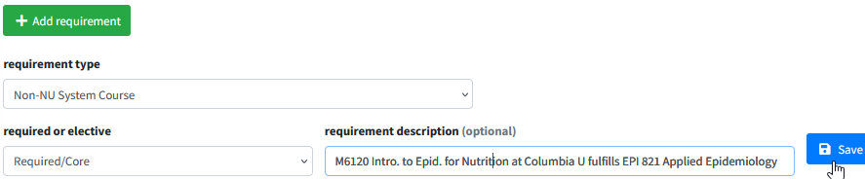
Ⓐ
Ⓒ
Ⓑ

Non-Course – this requirement type is used to add a requirement outside of a course. Ph.D. students will use this requirement type to document the Responsible Conduct in Research (RCR) Program requirement.

Select Required/Core or Elective/Cognate to appropriately classify the requirement Ⓐ. Input requirement description Ⓑ. Click Save Ⓒ.

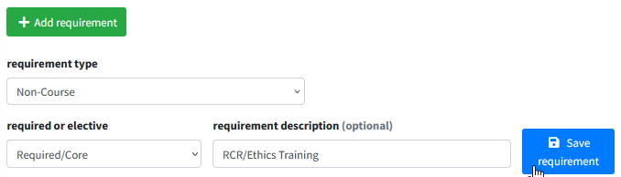
Ⓒ
Ⓑ
Ⓐ

6. Review the entries to ensure that you have satisfied the requirements (rule).

Click open PDF Ⓐ for a printable version of the Program of Study. Use the PDF to crosscheck with the rule requirements to ensure that you entered all of courses to satisfy the requirements for your graduate program.

The system allows you to edit a requirement by clicking . A requirement added in error can be deleted by clicking .

Ⓐ
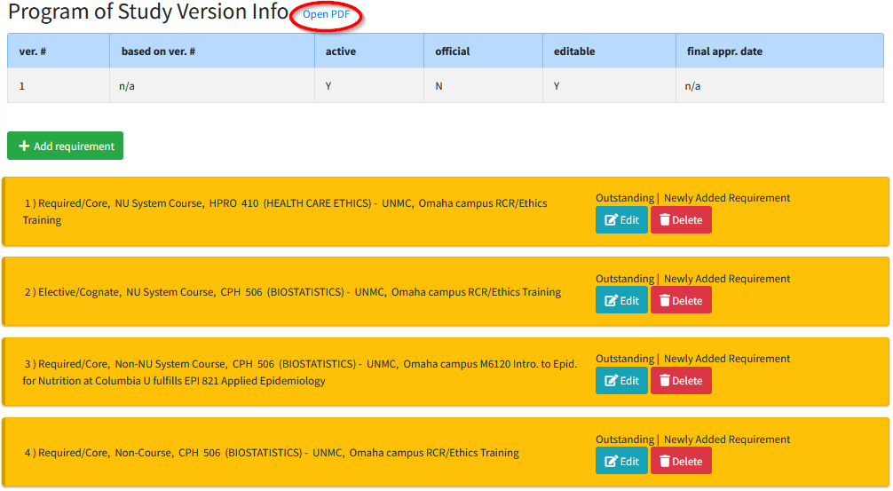

Important Note: The status of each requirement will show Outstanding, even if the requirement has been completed, until the final approval has been processed by the Dean of Graduate Studies.

7. Click Submit Ⓐ at the bottom of the page, below your entries.

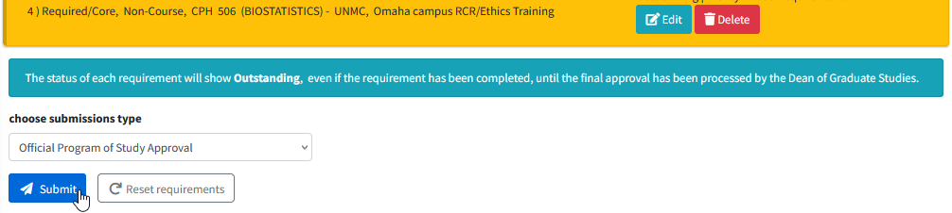
Ⓐ

8. A dialogue box will open. Click Ok to confirm that you want to submit.

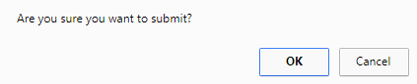

Approval Process for Program of Study

Order of Approval

After you submit your Program of Study, a notification email will be sent to your Advisor/Supervisor and a pending action will be generated in Seguidor to prompt him/her to approve or disapprove of the Program of Study.

After each subsequent approval, a notification email will be sent to the next approver (based on the order of approval) and a pending action will be generated in Seguidor to prompt him/her to approve or disapprove of the Program of Study.

Important Note: No changes can be made to the Program of Study during the approval process.

Status of Approval

At any point in the approval process you may view who the Program of Study is pending approval by.

1. On the menu, click on Personal Ⓐ , Dashboard Ⓑ and My Dashboard Ⓒ, or click on your name.

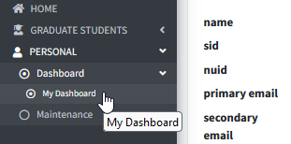
Ⓒ
Ⓑ
Ⓐ

2. Click the Program of Study tab Ⓐ.

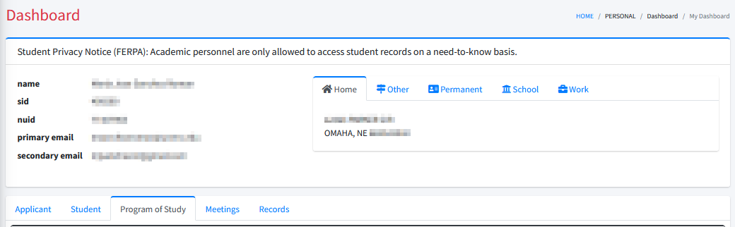
Ⓐ

3. Select the active version of the Program of Study.

The letter “Y” indicates the active version Ⓐ.

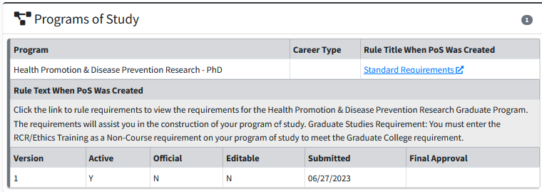
Ⓐ

4. Click on the Version record to view the Program of Study Details. View the approver’s name Ⓐ.

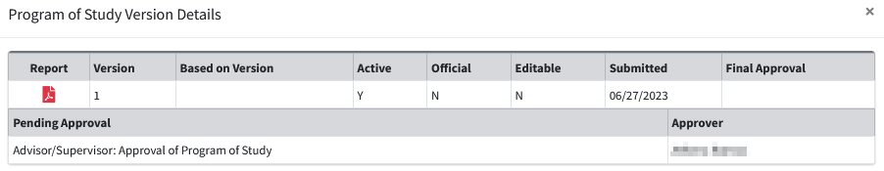
Ⓐ

Program of Study Dissaproved

Your Program of Study may be disapproved in the review process. If your program of study is disapproved, the disapprover will notify you of why the Program of Study was disapproved. The following subsections will assist you with making the required changes to resubmit the Program of Study for approval.

Selected Wrong Rule (requirements) Title

To change your rule (requirements) title you must delete this version of your Program of Study and start over.

1. On the menu, click on Personal Ⓐ , Dashboard Ⓑ and My Dashboard Ⓒ, or click on your name.

Ⓒ
Ⓑ
Ⓐ

2. Click Delete Program of Study Ⓐ.

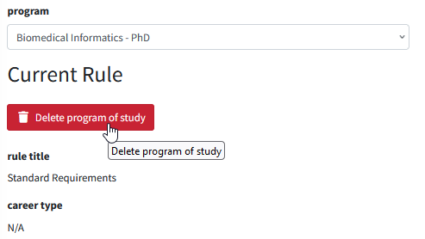
Ⓐ

3. A dialogue box will open. Click Ok to confirm that you want to delete the Program of Study.

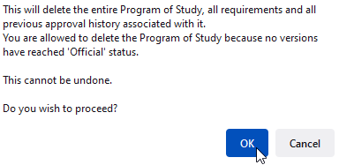

4. Select the correct rule title Ⓐ.

See picture on the next page for a visual example of rule (requirements) titles. The rule (requirement) title that you select establishes the course and examination requirements.

Rule (requirements) Title Examples:

M.S. Rule Title
Thesis Requirements
Non-Thesis Requirements
Ph.D. Rule Title
Standard Requirements
MD/PhD Requirements

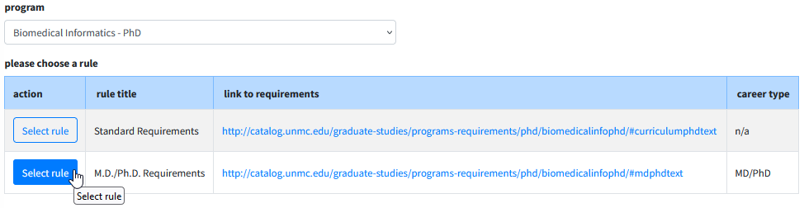
Ⓐ

5. A dialogue box will open. Click Ok to confirm that you have selected the correct rule (requirements) title. If you have selected the wrong rule (requirements) title, click Cancel and repeat step 4.

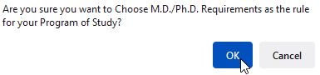

Steve's comment: At this point, I suggest for Step 6, instead of repeating all of the instructions that have already been presented above, instruct the user to turn to Page 24 (or whichever page that ends up being on), Step 4, and follow the instructions from that point on. I would do that for every set of instructions that are repeated in the manuals. It would make the manuals a lot shorter, easier to navigate, and less intimidating. We're not going to take the time to copy and paste repeated instructions.

6. Click Add Requirement Ⓐ. Note that the link to rule requirements will assist you with the process. You must enter each requirement individually in order to construct your Program of Study.

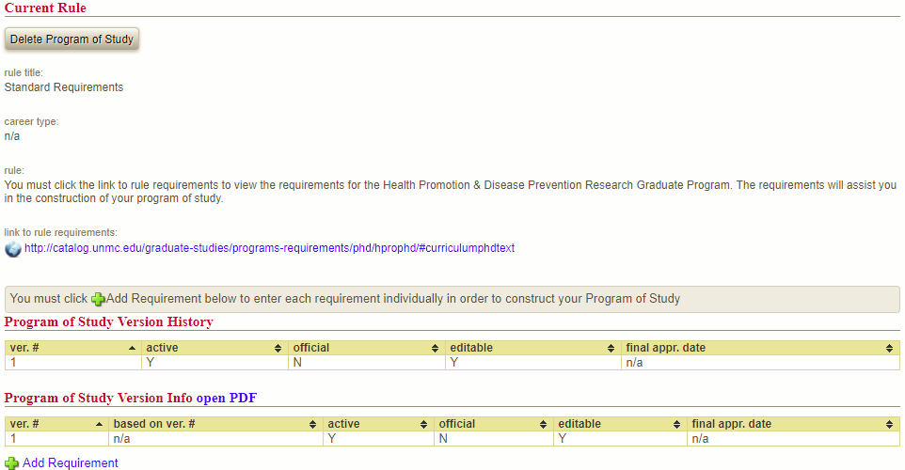
Ⓐ

7. Select requirement type Ⓐ.

There are three requirement type options (NU System Course, Non-NU System Course & Non-Course). Please see below for an explanation of each requirement type and further instructions on how to enter the specific requirement types.

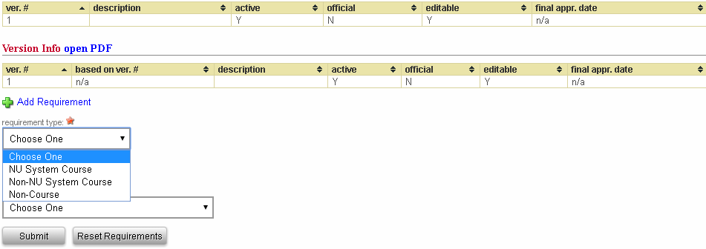
Ⓐ

NU System Course – this requirement type is used to add a course from UNMC, UNO, UNL and/or UNK; including professional level courses (500-600 level). See the important note on the top of the next page if you have professional level courses.

Select Institution Ⓐ. Select Department Ⓑ.

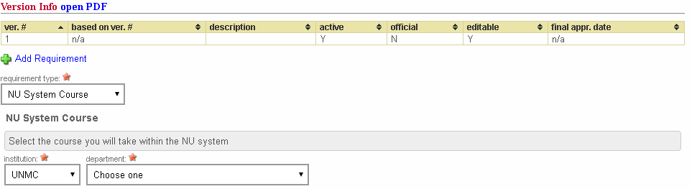
Ⓑ
Ⓐ

Select Course Ⓒ. Select Required/Core or Elective/Cognate to appropriately classify the requirement Ⓓ. Enter requirement description, if applicable Ⓔ. Click Save Ⓕ.

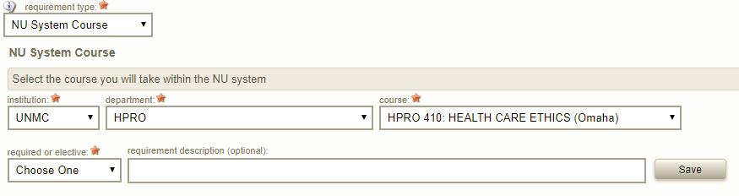
Ⓕ
Ⓔ
Ⓓ
Ⓒ

Important Note: If you are transferring professional level courses (500-600 level) completed at UNMC, you need to select the appropriate 500-600 level course and in the requirement description note which graduate level course (800 level) requirement that the professional level course is fulfilling. See example below.

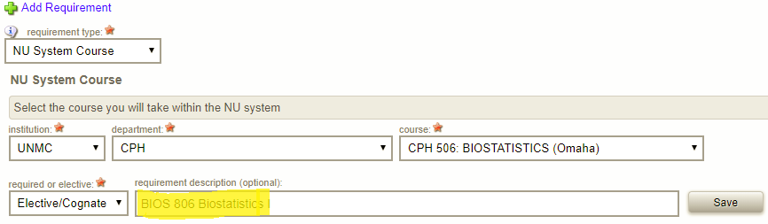

Non-NU System Course – this requirement type is used to add a course from an institution outside of the Nebraska University system. This is frequently referred to as transfer credit.

Important Note: You are to work with your Advisory/Supervisory Committee to determine which prior coursework, if any, is acceptable for transfer to UNMC and to designate the UNMC equivalent of the prior course.

Select Required/Core or Elective/Cognate to appropriately classify the requirement Ⓐ. Input course number & title, name of institution where the course was completed, the UNMC equivalent course number & title Ⓑ. Click Save Ⓒ.

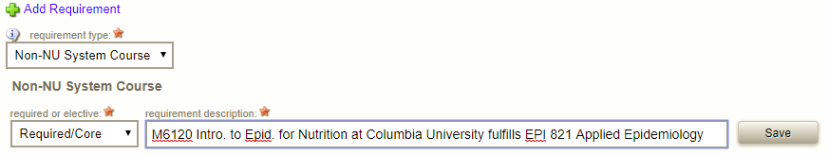
Ⓒ
Ⓑ
Ⓐ

Non-Course – this requirement type is used to add a requirement outside of a course. Ph.D. students will use this requirement type to document the Responsible Conduct in Research (RCR) Program requirement.

Select Required/Core or Elective/Cognate to appropriately classify the requirement Ⓐ. Input requirement description Ⓑ. Click Save Ⓒ.

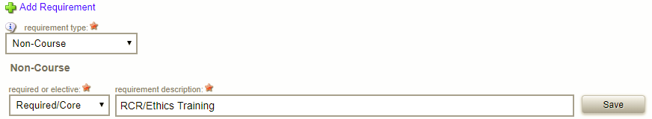
Ⓒ
Ⓑ
Ⓐ

8. Review the entries to ensure that you have satisfied the requirements (rule).

Click open PDF Ⓐ for a printable version of the Program of Study. Use the PDF to crosscheck with the rule requirements to ensure that you entered all of courses to satisfy the requirements for your graduate program.

The system allows you to edit a requirement by clicking the icon. A requirement added in error can be deleted by clicking the icon.
Ⓐ

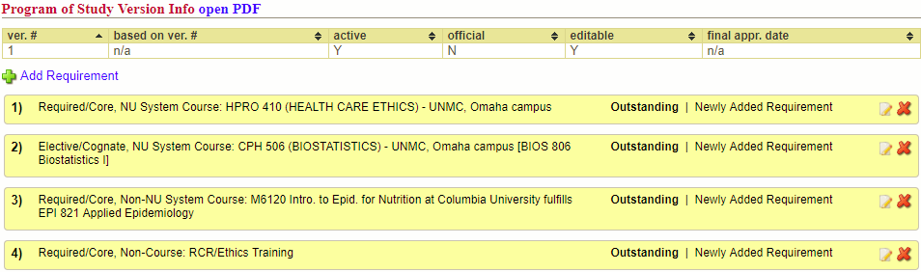

Important Note: All requirements will show Outstanding, even if the requirement has been completed, until the final approval has been processed by the Dean of Graduate Studies.

9. Click Submit Ⓐ at the bottom of the page, below your entries.

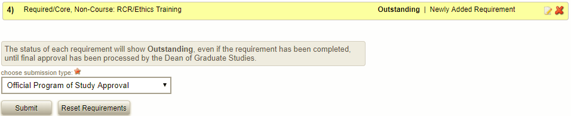
Ⓐ

10. A dialogue box will open. Click Ok to confirm that you want to submit.

Missing a Requirement

1. On the menu, click on Personal Ⓐ , Dashboard Ⓑ and My Dashboard Ⓒ, or click on your name.

Ⓒ
Ⓑ
Ⓐ

2. Click Add Requirement Ⓐ. and select the missing requirement. Note that the link to rule requirements will assist you with the process. You must enter each requirement individually in order to construct your Program of Study.

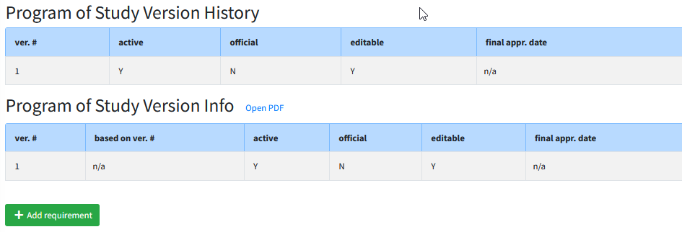
Ⓐ

Same as above: instruct the user to turn to Page 24, Step 4 (or whichever page that ends up being on)

3. Select requirement type Ⓐ.

There are three requirement type options (NU System Course, Non-NU System Course & Non-Course). Please see below for an explanation of each requirement type and further instructions on how to enter the specific requirement types.

Ⓐ

NU System Course – this requirement type is used to add a course from UNMC, UNO, UNL and/or UNK; including professional level courses (500-600 level). See the important note on the top of the next page if you have professional level courses.

Select Institution Ⓐ. Select Department Ⓑ.

Ⓑ
Ⓐ

Select Course Ⓒ. Select Required/Core or Elective/Cognate to appropriately classify the requirement Ⓓ. Enter requirement description, if applicable Ⓔ. Click Save Ⓕ.

Ⓕ
Ⓔ
Ⓓ
Ⓒ

Important Note: If you are transferring professional level courses (500-600 level) completed at UNMC, you need to select the appropriate 500-600 level course and in the requirement description note which graduate level course (800 level) requirement that the professional level course is fulfilling. See example below.

Non-NU System Course – this requirement type is used to add a course from an institution outside of the Nebraska University system. This is frequently referred to as transfer credit.

Important Note: You are to work with your Advisory/Supervisory Committee to determine which prior coursework, if any, is acceptable for transfer to UNMC and to designate the UNMC equivalent of the prior course.

Select Required/Core or Elective/Cognate to appropriately classify the requirement Ⓐ. Input course number & title, name of institution where the course was completed, the UNMC equivalent course number & title Ⓑ. Click Save Ⓒ.

Ⓒ
Ⓑ
Ⓐ

Non-Course – this requirement type is used to add a requirement outside of a course. Ph.D. students will use this requirement type to document the Responsible Conduct in Research (RCR) Program requirement.

Select Required/Core or Elective/Cognate to appropriately classify the requirement Ⓐ. Input requirement description Ⓑ. Click Save Ⓒ.

Ⓒ
Ⓑ
Ⓐ

4. Review the entries to ensure that you have satisfied the requirements (rule).

Click open PDF Ⓐ for a printable version of the Program of Study. Use the PDF to crosscheck with the rule requirements to ensure that you entered all of courses to satisfy the requirements for your graduate program.

The system allows you to edit a requirement by clicking the icon. A requirement added in error can be deleted by clicking the icon.
Ⓐ

Important Note: All requirements will show Outstanding, even if the requirement has been completed, until the final approval has been processed by the Dean of Graduate Studies.

5. Click Submit Ⓐ at the bottom of the page, below your entries.

Ⓐ

6. A dialogue box will open. Click Ok to confirm that you want to submit.

Edit your Program of Study

Any edits to the Program of Study must first be discussed with the Advisory/Supervisory Committee.
Important Note: No changes can be made to the Program of Study during the approval process.

1. On the menu, click on Personal Ⓐ , Dashboard Ⓑ and My Dashboard Ⓒ, or click on your name.

Ⓒ
Ⓑ
Ⓐ

2. Click Create New Version Ⓐ.

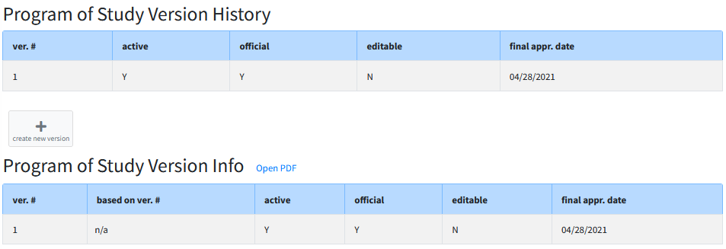
Ⓐ

3. Add, Remove or Edit a requirement.

ADD a requirement; click Add Requirement (Refer to step 5 outlined in section 6.1. for a refresher on requirement types).
REMOVE a requirement; click for the requirement.
EDIT a requirement; click for the requirement.

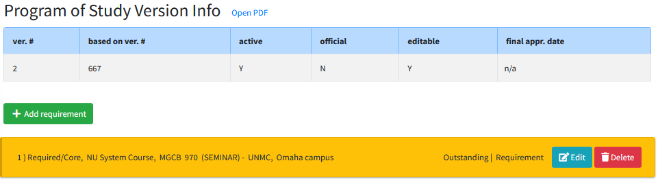

4. Review the entries to ensure that you have satisfied the requirements (rule).

Click open PDF Ⓐ for a printable version of the Program of Study. Use the PDF to crosscheck with the rule (requirements) title to ensure that you entered all of courses to satisfy the requirements for your graduate program.
Ⓐ
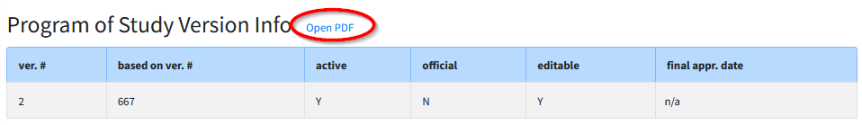

Important Note: All requirements will show Outstanding, even if the requirement has been completed, until the final approval has been processed by the Dean of Graduate Studies.

5. Click Submit Ⓐ at the bottom of the page, below your entries.

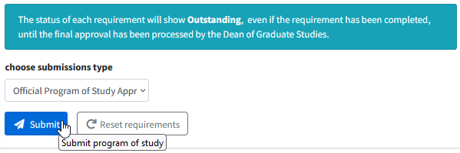
Ⓐ

6. A dialogue box will open. Click Ok to confirm that you want to submit.

View your Program of Study

After your Program of Study has been approved you may view your program of study at any time to track the completion of your requirements.

1. On the menu, click on Personal Ⓐ , Dashboard Ⓑ and My Dashboard Ⓒ, or click on your name.

Ⓒ
Ⓑ
Ⓐ

2. Click the Program of Study tab Ⓐ.

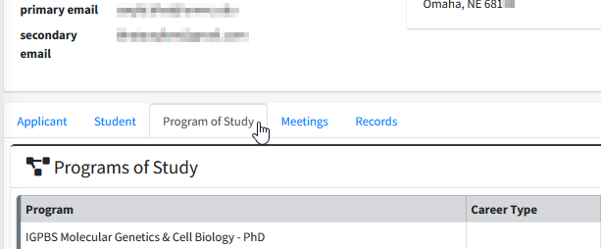
Ⓐ

3. Select the active version of the Program of Study.

The letter “Y” indicates the active version Ⓐ.

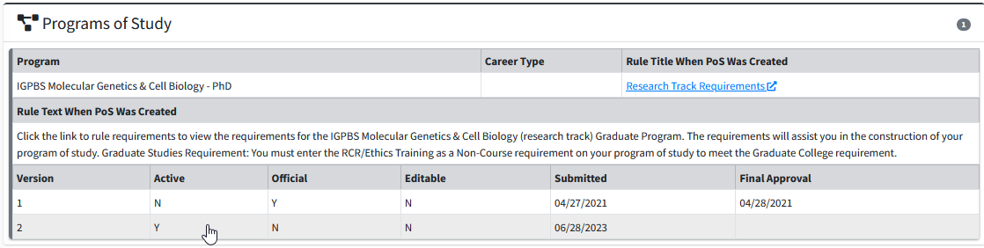
Ⓐ
4. Review the requirements Ⓐ.

After your Program of Study has been approved the status of each requirement will change as each requirement is completed, waived, or removed. The statuses are color coded to visibly show the status of each requirement.

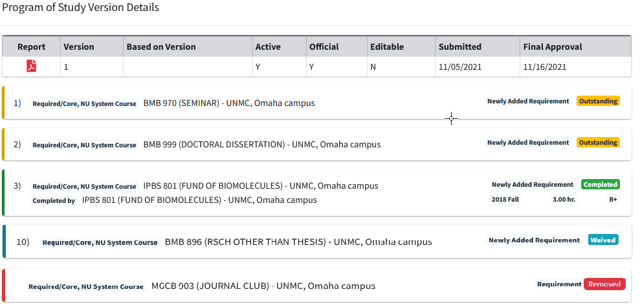
Ⓐ

Exam Committee / Schedule

If you are eligible to schedule a program exam (see requirements for your program) a pending action entitled Exam to Schedule will appear on your Seguidor home screen.
Click the pending action or click on GRADUATE STUDENTS, then on Committee Management, and then on Exam Committee/Schedule Ⓐ to access the Exam Committee set up and scheduling page.
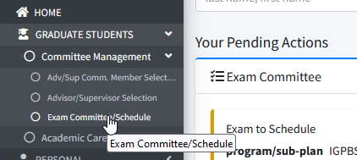
Ⓐ

Establish Exam Committee

The composition of your Examining Committee must fulfill the requirements of your academic program. Seguidor provides guidance in assisting you to meet these requirements by displaying the number of committee members and graders needed for each specific exam within your program. In addition, Seguidor will automatically populate your Exam Committee member list with existing members of your Advisory/Supervisory Committee, if required by your program. You have the opportunity to add and delete members of your Exam Committee only if your modifications fall within program requirements. If you have questions about these requirements please contact the Graduate Studies Office.

- Create an Exam Committee by choosing the program and exam to schedule.
Click Create CommitteeⒷ.
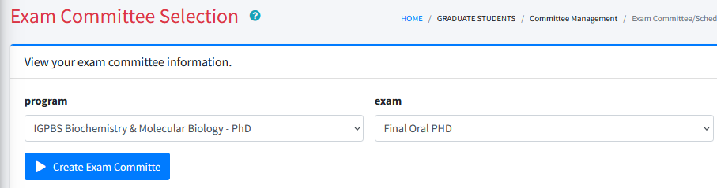
Ⓑ

Seguidor will automatically populate your Exam Committee member list with members of your Advisory/Supervisory Committee, if required by your program Ⓐ.
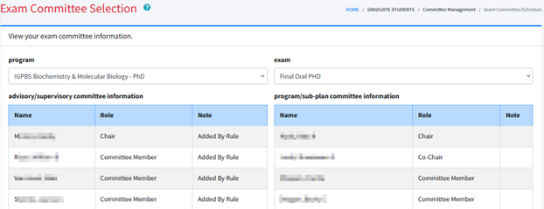
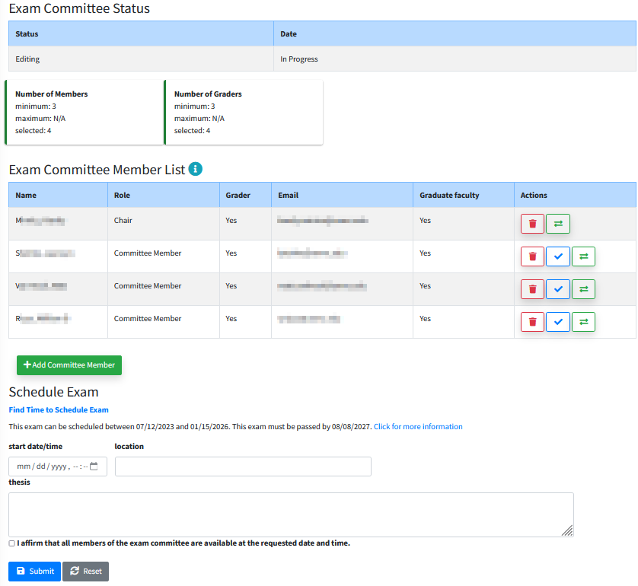
Ⓐ
Ⓑ
- Add committee members by following the same steps utilized to add Advisory/Supervisory Committee Members in Section 2.1.2. Modify the composition of your examining committee by clicking on the appropriate icons in the actions column of the exam committee member list. Ⓐ. The Exam Committee member requirements indicator bar Ⓑ will turn green when your committee meets the required number of members and graders for your exam and program.
Click to remove members
Click to change Exam Committee chair
Click to edit whether member is a grader or not
Note: Changes made to your Exam Committee are automatically saved in Seguidor.

Schedule Exam
After setting up your Exam Committee, you may schedule the date, time, and location for your exam. Seguidor will automatically calculate and display the earliest date the exam can be scheduled based on Graduate Studies and program policies. More information regarding the window of opportunity for the exam will be displayed in a pop-up window through the link Click for more information.
You are required to verify that the date, time, and location for your exam is acceptable to the members of your Exam Committee prior to submitting the exam request. A link is provided to UNMC Find Time to assist in the coordination; however, this service is not linked to Seguidor.
- Schedule the exam by entering the date, time, and location in the boxes provided.
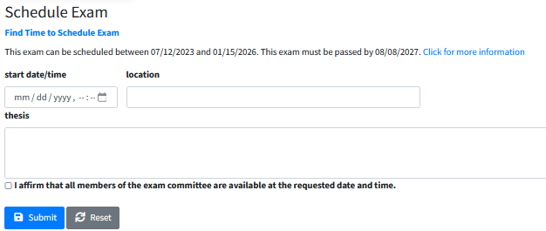
- Click the check box to affirm that all the members of the Exam Committee are available at the date, time, and the location requested.

- Click Submit to start the Exam Committee and scheduling approval process and email notifications of pending actions. No further actions by the student are required for the Exam process.
The typical order of approval is Advisor/Supervisor à Chair of Graduate Program Committee (Program Director) à Dean of Graduate Studies. The status of the committee is displayed in the Exam Committee status table. After all approvals have been processed the Approved status and the date will be displayed.

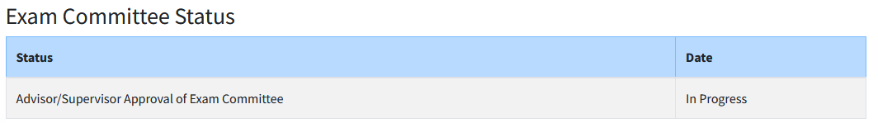

Reschedule Exam

In the event you need to make changes to your Exam Committee, or if your exam needs to be rescheduled, contact the Graduate Studies Office by email (unmcgraduatestudies@unmc.edu).

Notification of Exam Results

Following your exam, you should receive the results directly from your examining committee. After the grade has been finalized by your Exam Committee in Seguidor, an email notification of the result will be sent to you and the Dean of Graduate Studies and your Dashboard in Seguidor will be updated.

