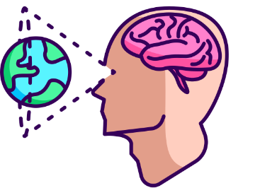
Visual Learning Preferences

Understanding Visual Learning
Visual learners grasp information best through seeing. This includes:

- Images: Diagrams, charts, infographics
- Spatial understanding: Relationships between things
- Color and design: Using visual cues to organize information

Characteristics of Visual Learners
- Prefer diagrams, charts, and written information.
- Learn better when information is presented visually.
- Strong sense of color and design.
- Benefit from mind maps and visual aids.
- May struggle with purely auditory lectures.
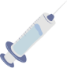

Applications for Nursing Students
- Concept Mapping: Create visual maps to connect diseases, symptoms, and treatments.
- Flashcards: Use images and colors to remember medications and their effects.
- Diagrams: Draw anatomical structures and physiological processes.
- Videos: Watch surgical procedures and patient care techniques.


Study Techniques
- Color-code notes: Use different colors for different topics.
- Create timelines: Visualize the progression of diseases or treatments.
- Use online resources: Explore interactive diagrams and animations.
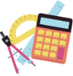
- Draw mind maps: Connect related concepts visually.

Tools and Resources
- Software: Mind mapping tools (e.g., MindMeister).
- Websites: Google Notebook LM (Flashcards, Mind-Maps, Infographics, Slide Decks and more!)
- Apps: Flashcard apps (e.g., Anki), visual learning apps.

Conclusion
By understanding and leveraging visual learning preferences, nursing students can enhance their comprehension, retention, and overall academic performance. Incorporate these strategies and tools into your study routine for greater success!

