The Ultimate Guide to Select All That Apply Questions (how to answer NCLEX questions)

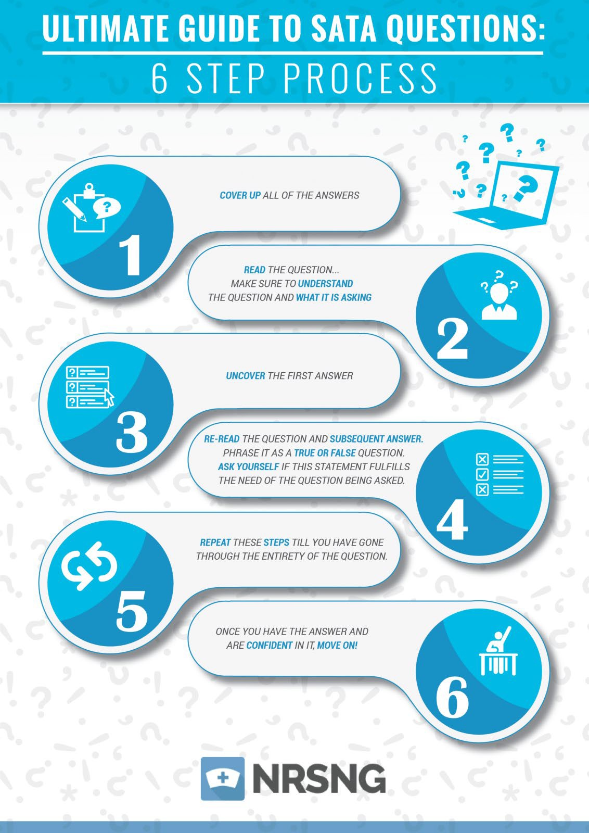

True/False Component
The following is a SATA question that I want you to read, and answer before moving on. Then after you have your answer read on to try to read this question a little differently.

Question:

You’re taking care of a 75-year-old female who is confused and keeps saying, “I need to get home because my husband needs to have dinner prepared for him. He will be scared if I’m not home! I have to get home.” She thinks the year is 1972 (getting angry when you reorient her) and she is convinced that the housekeeper is stealing her cookies. After walking in on her calling 911 to get a ride home, which of the following interventions should be implemented to help keep this client safe? Select all that apply

- A) Placing her in a room by the nurses station
- B) Grabbing the extra cookies in the pantry and giving them to her
- C) Reorienting her to the day and year
- D) Getting a sitter for her to talk to and help distract her from trying to leave
- E) Putting non-slip socks on

Got your answer?

Now let’s approach this a little differently…

Try to answer this question by turning this question into a series of true or false questions…

- A. Does “placing her in a room by the nurses station” help keep this client safe? True or False?

TRUE, It keeps the client from potential danger due to confusion by having people close by.

- B. Does “Grabbing the extra cookies in the pantry and giving them to her” help keep this client safe? True or False?

FALSE, This might be nice but it does not affect the patient’s’ safety.

- C. Does “Reorienting her to the day and year” help keep this client safe? True or False?

FALSE, Under normal circumstances this is a good thing, but it not only upsets the patient, but it also doesn’t address the issue of safety.

- D. Does “Getting a sitter for her to talk to and help distract her from trying to leave” help keep this client safe? True or False?

TRUE, This will certainly help keep the patient safe. But do we need to have a sitter if we moved her? Or should we not move her if we have a sitter? PLEASE TAKE NOTE: This is it’s own question, the prior question of moving the patient does not change the answer to this question even though it is all in one select all that apply question. Keep it separate.

- E. Does “Putting non-slip socks on” help keep this client safe? True or False?

TRUE, Non-slip socks are always a good idea but they also help keep the patient from falling thus keeps the patient safe.

See how we took one question and turned it into 5 smaller ones? If you take a second to break it up and ask yourself directly, “is this statement true or false?” it enables you to focus solely on each option, rather than getting confused and distracted by the other options. This method will force you to focus on answering the specific question being asked.

You know how when you’re watching a presidential debate and a very specific question is asked, and the candidate takes their entire 2 minutes answering a different question, rather than answering the question at hand? That’s kind of what we can do to ourselves when we get these huge questions with a ton of options. We see all of this information and it’s very easy to get distracted, create little thought-process rabbit holes that may have some merit, but they’re not answering the question that was asked.

Going back to that previous example… getting her cookies sounds like it would work to calm her down, but does that address the question being asked about safety most directly? No, it does not.

We have to force ourselves to directly focus on answering the question at hand when we look at each option individually.

If you work through all your select all that apply questions like this you can help break them down.

