Unhappy Feet: Understanding Common Foot Problems In Women (And Men!) Handout

Smitha E. Mathew, MBBS

Pediatric orthopaedic surgeon

Children’s Nebraska

Assistant Professor, Dept of Orthopaedic Surgery, UNMC

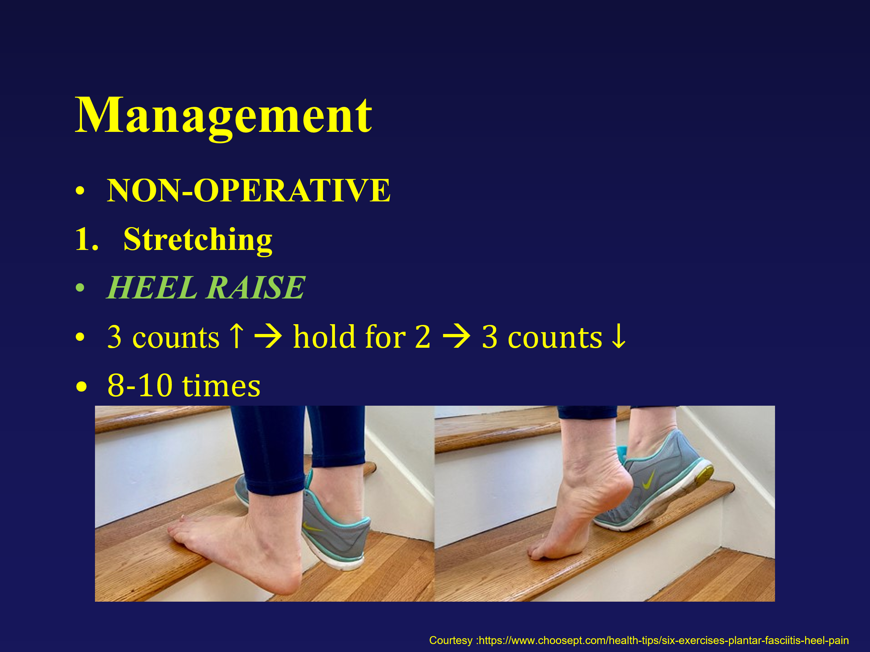
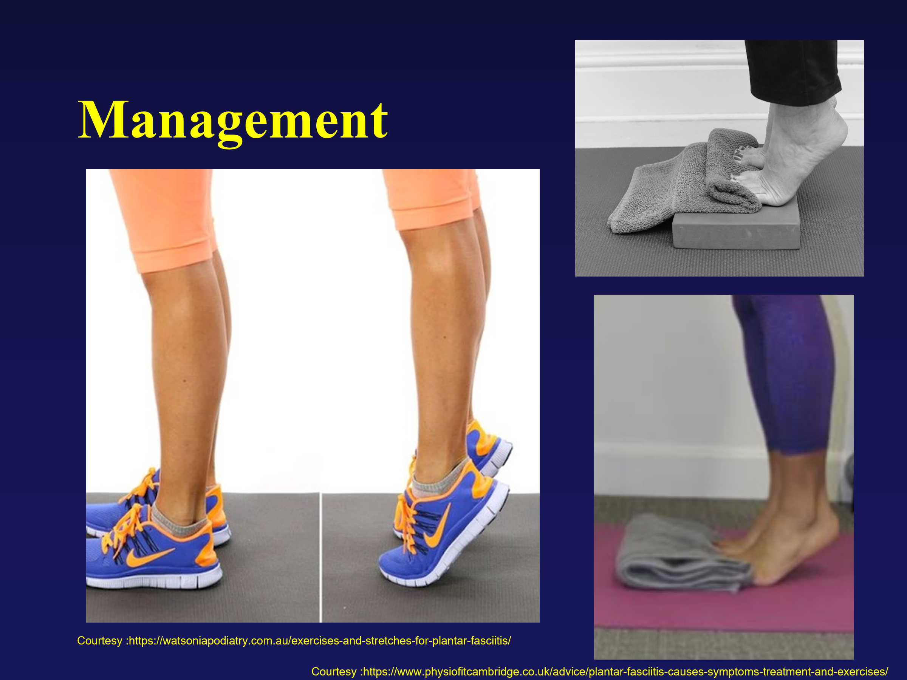
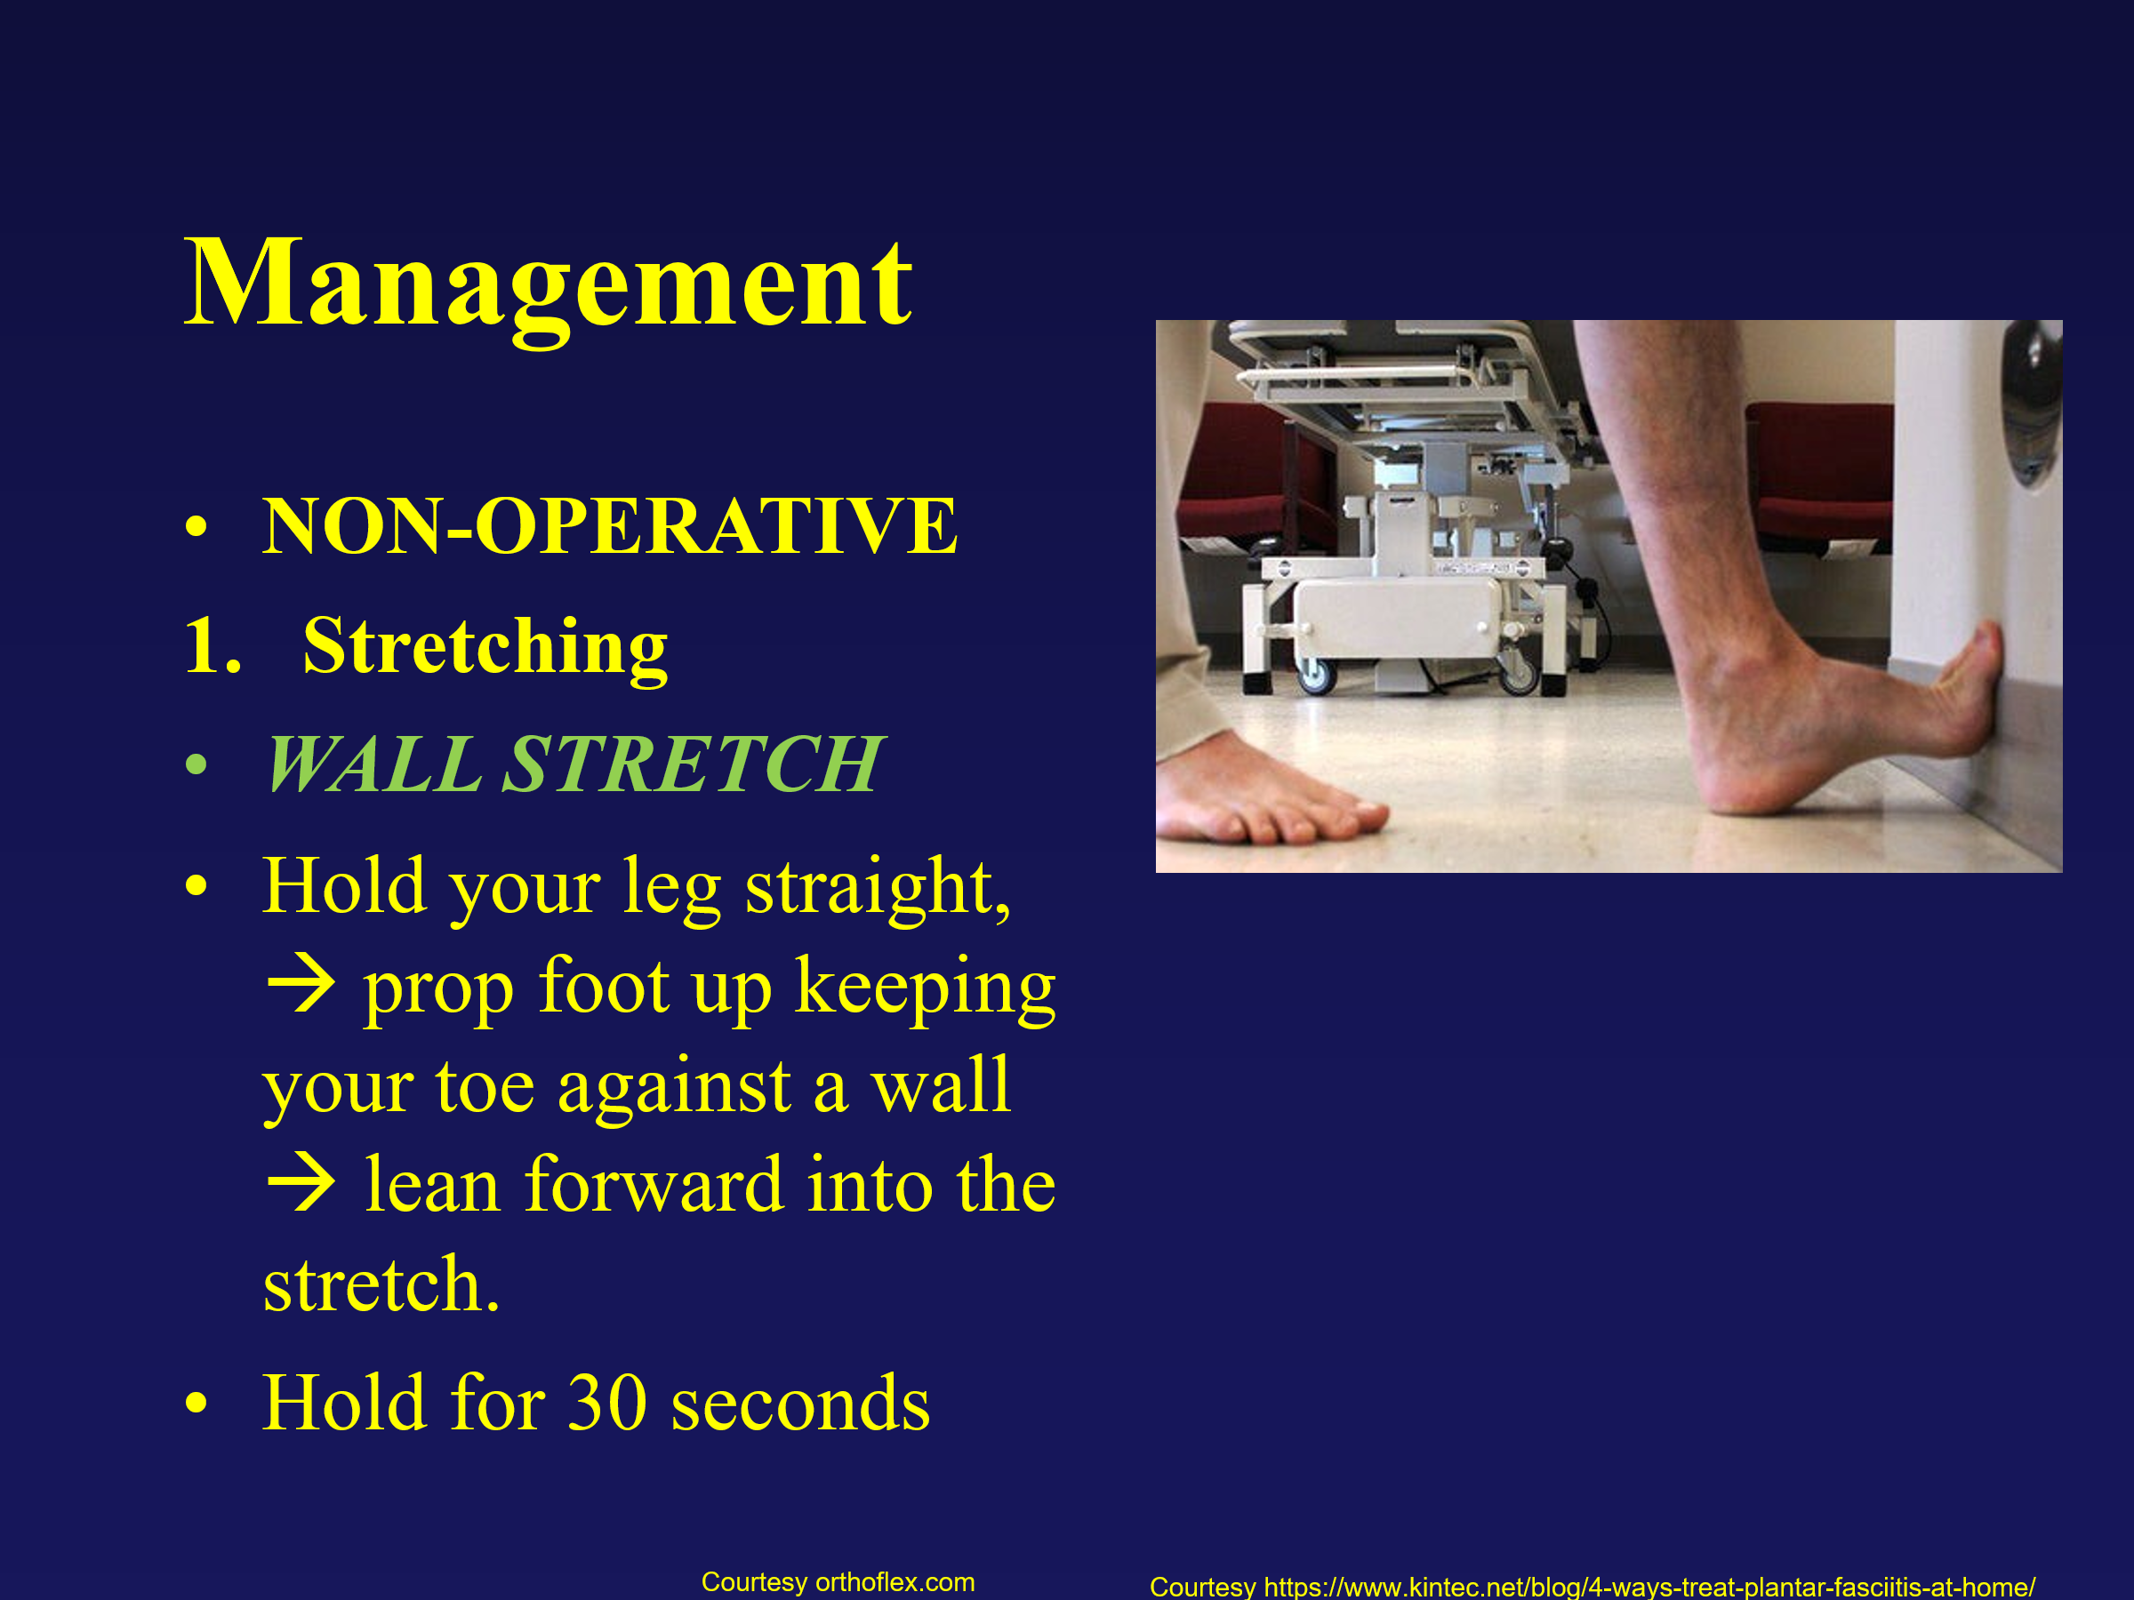

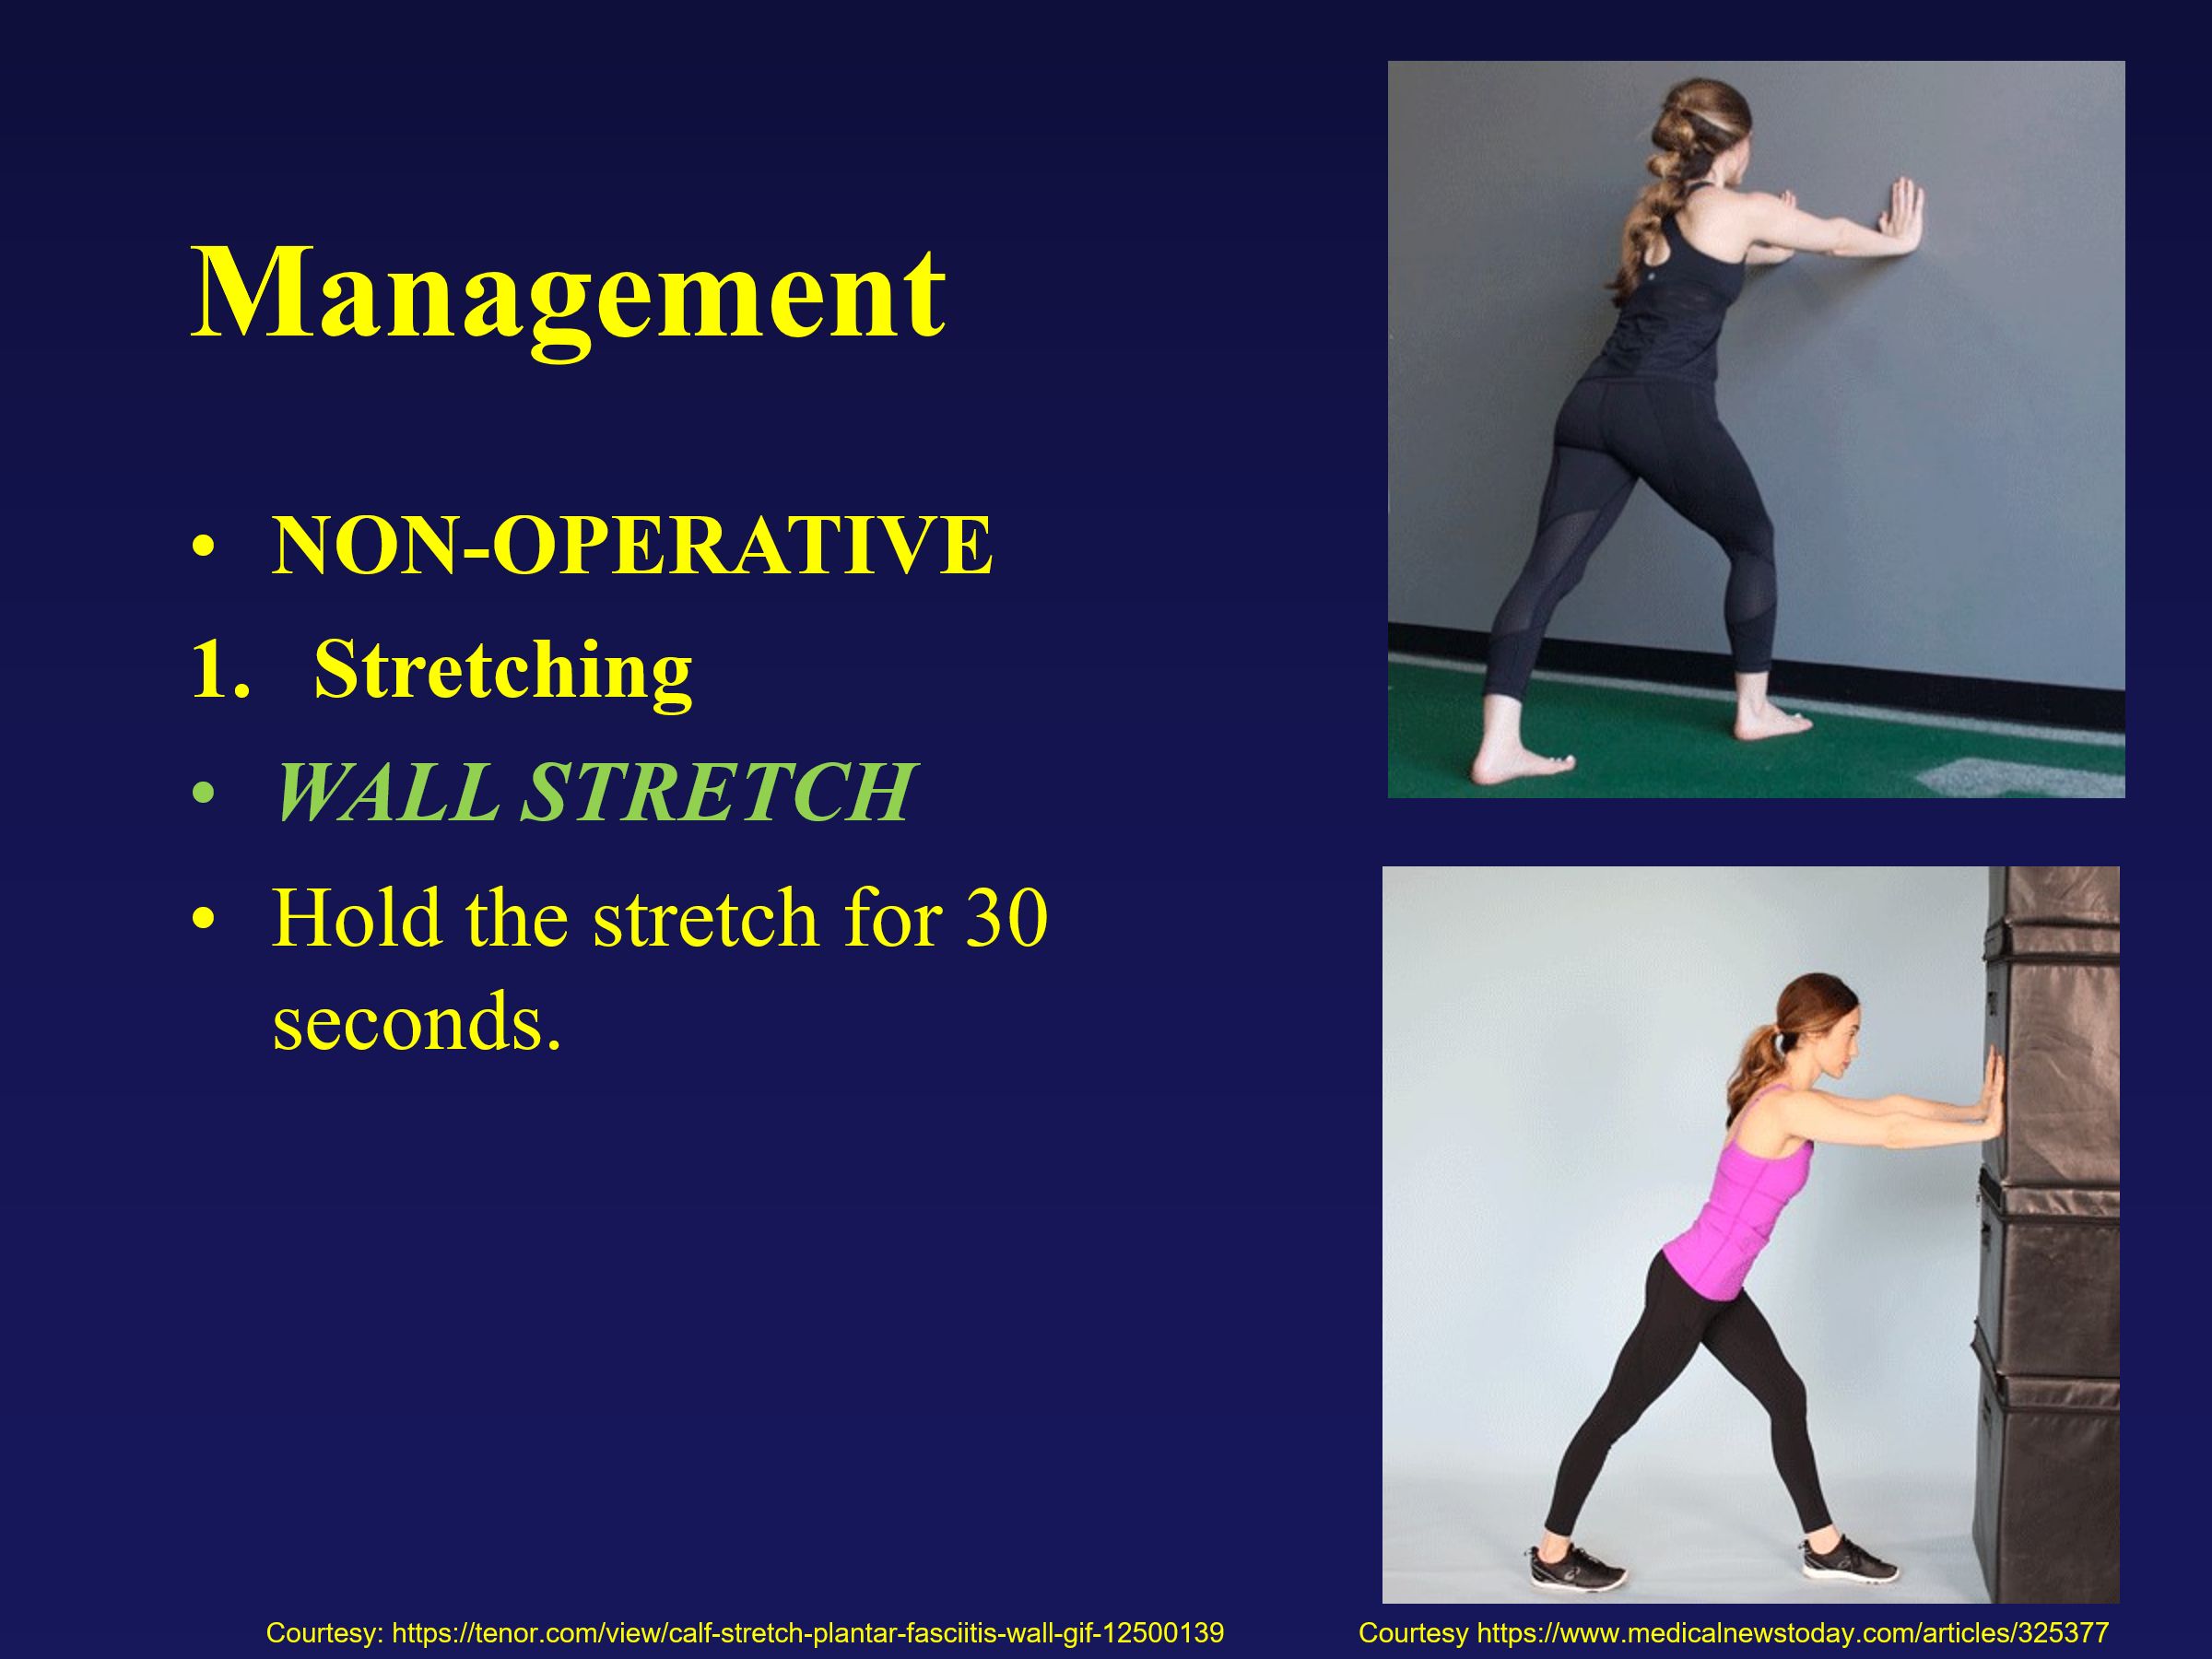
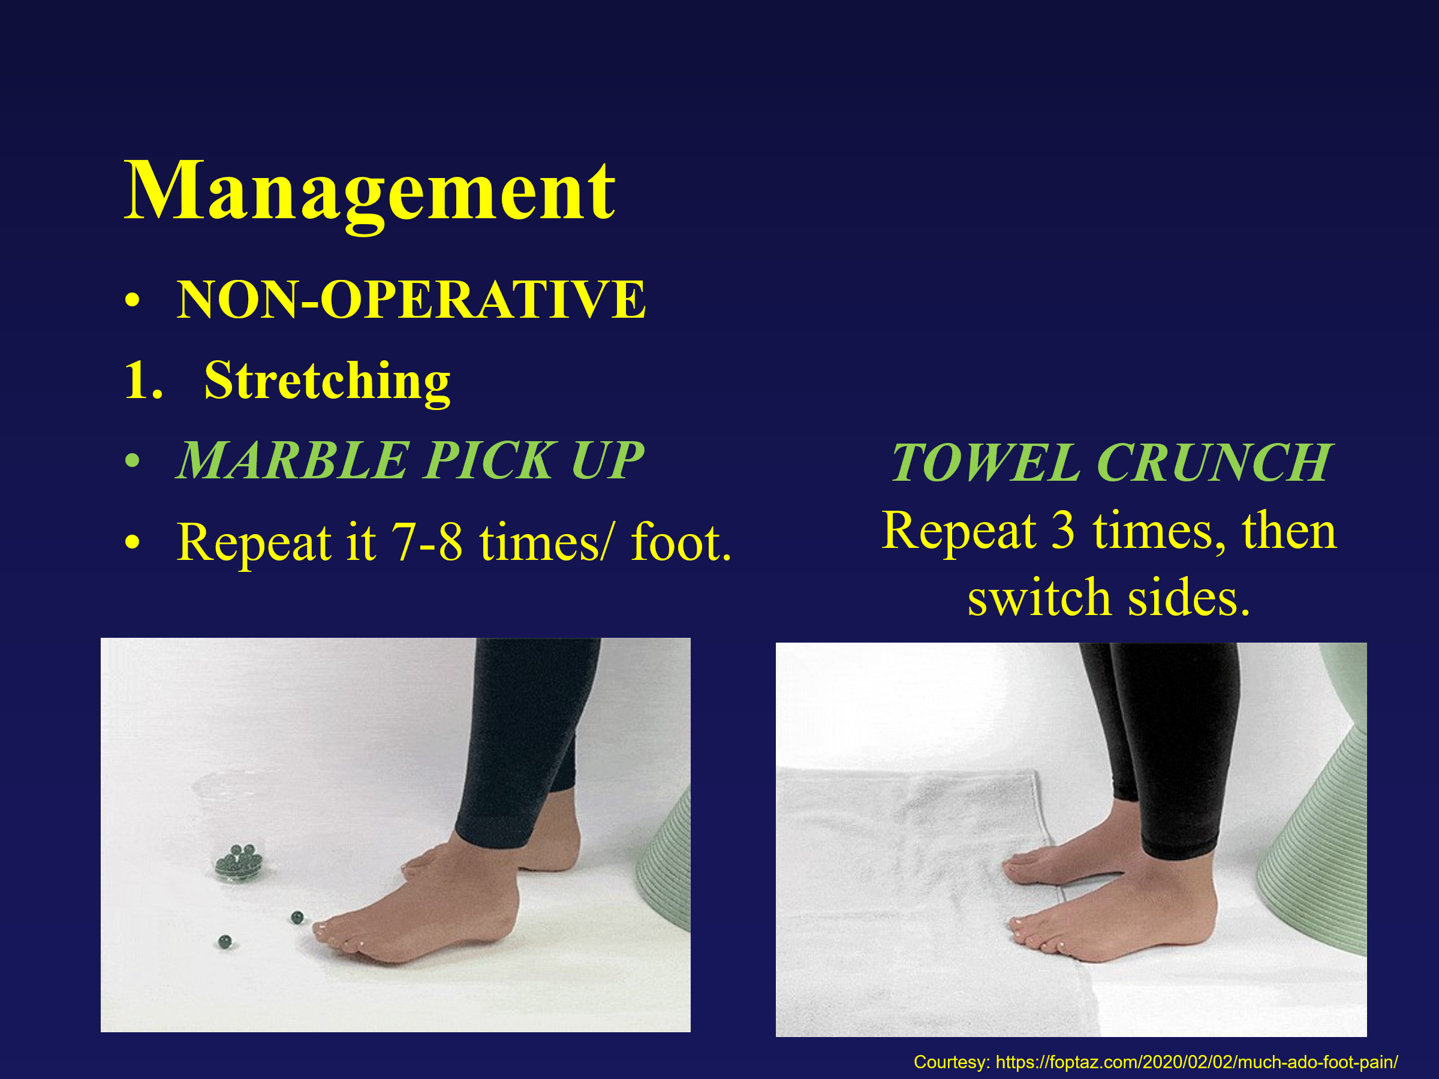

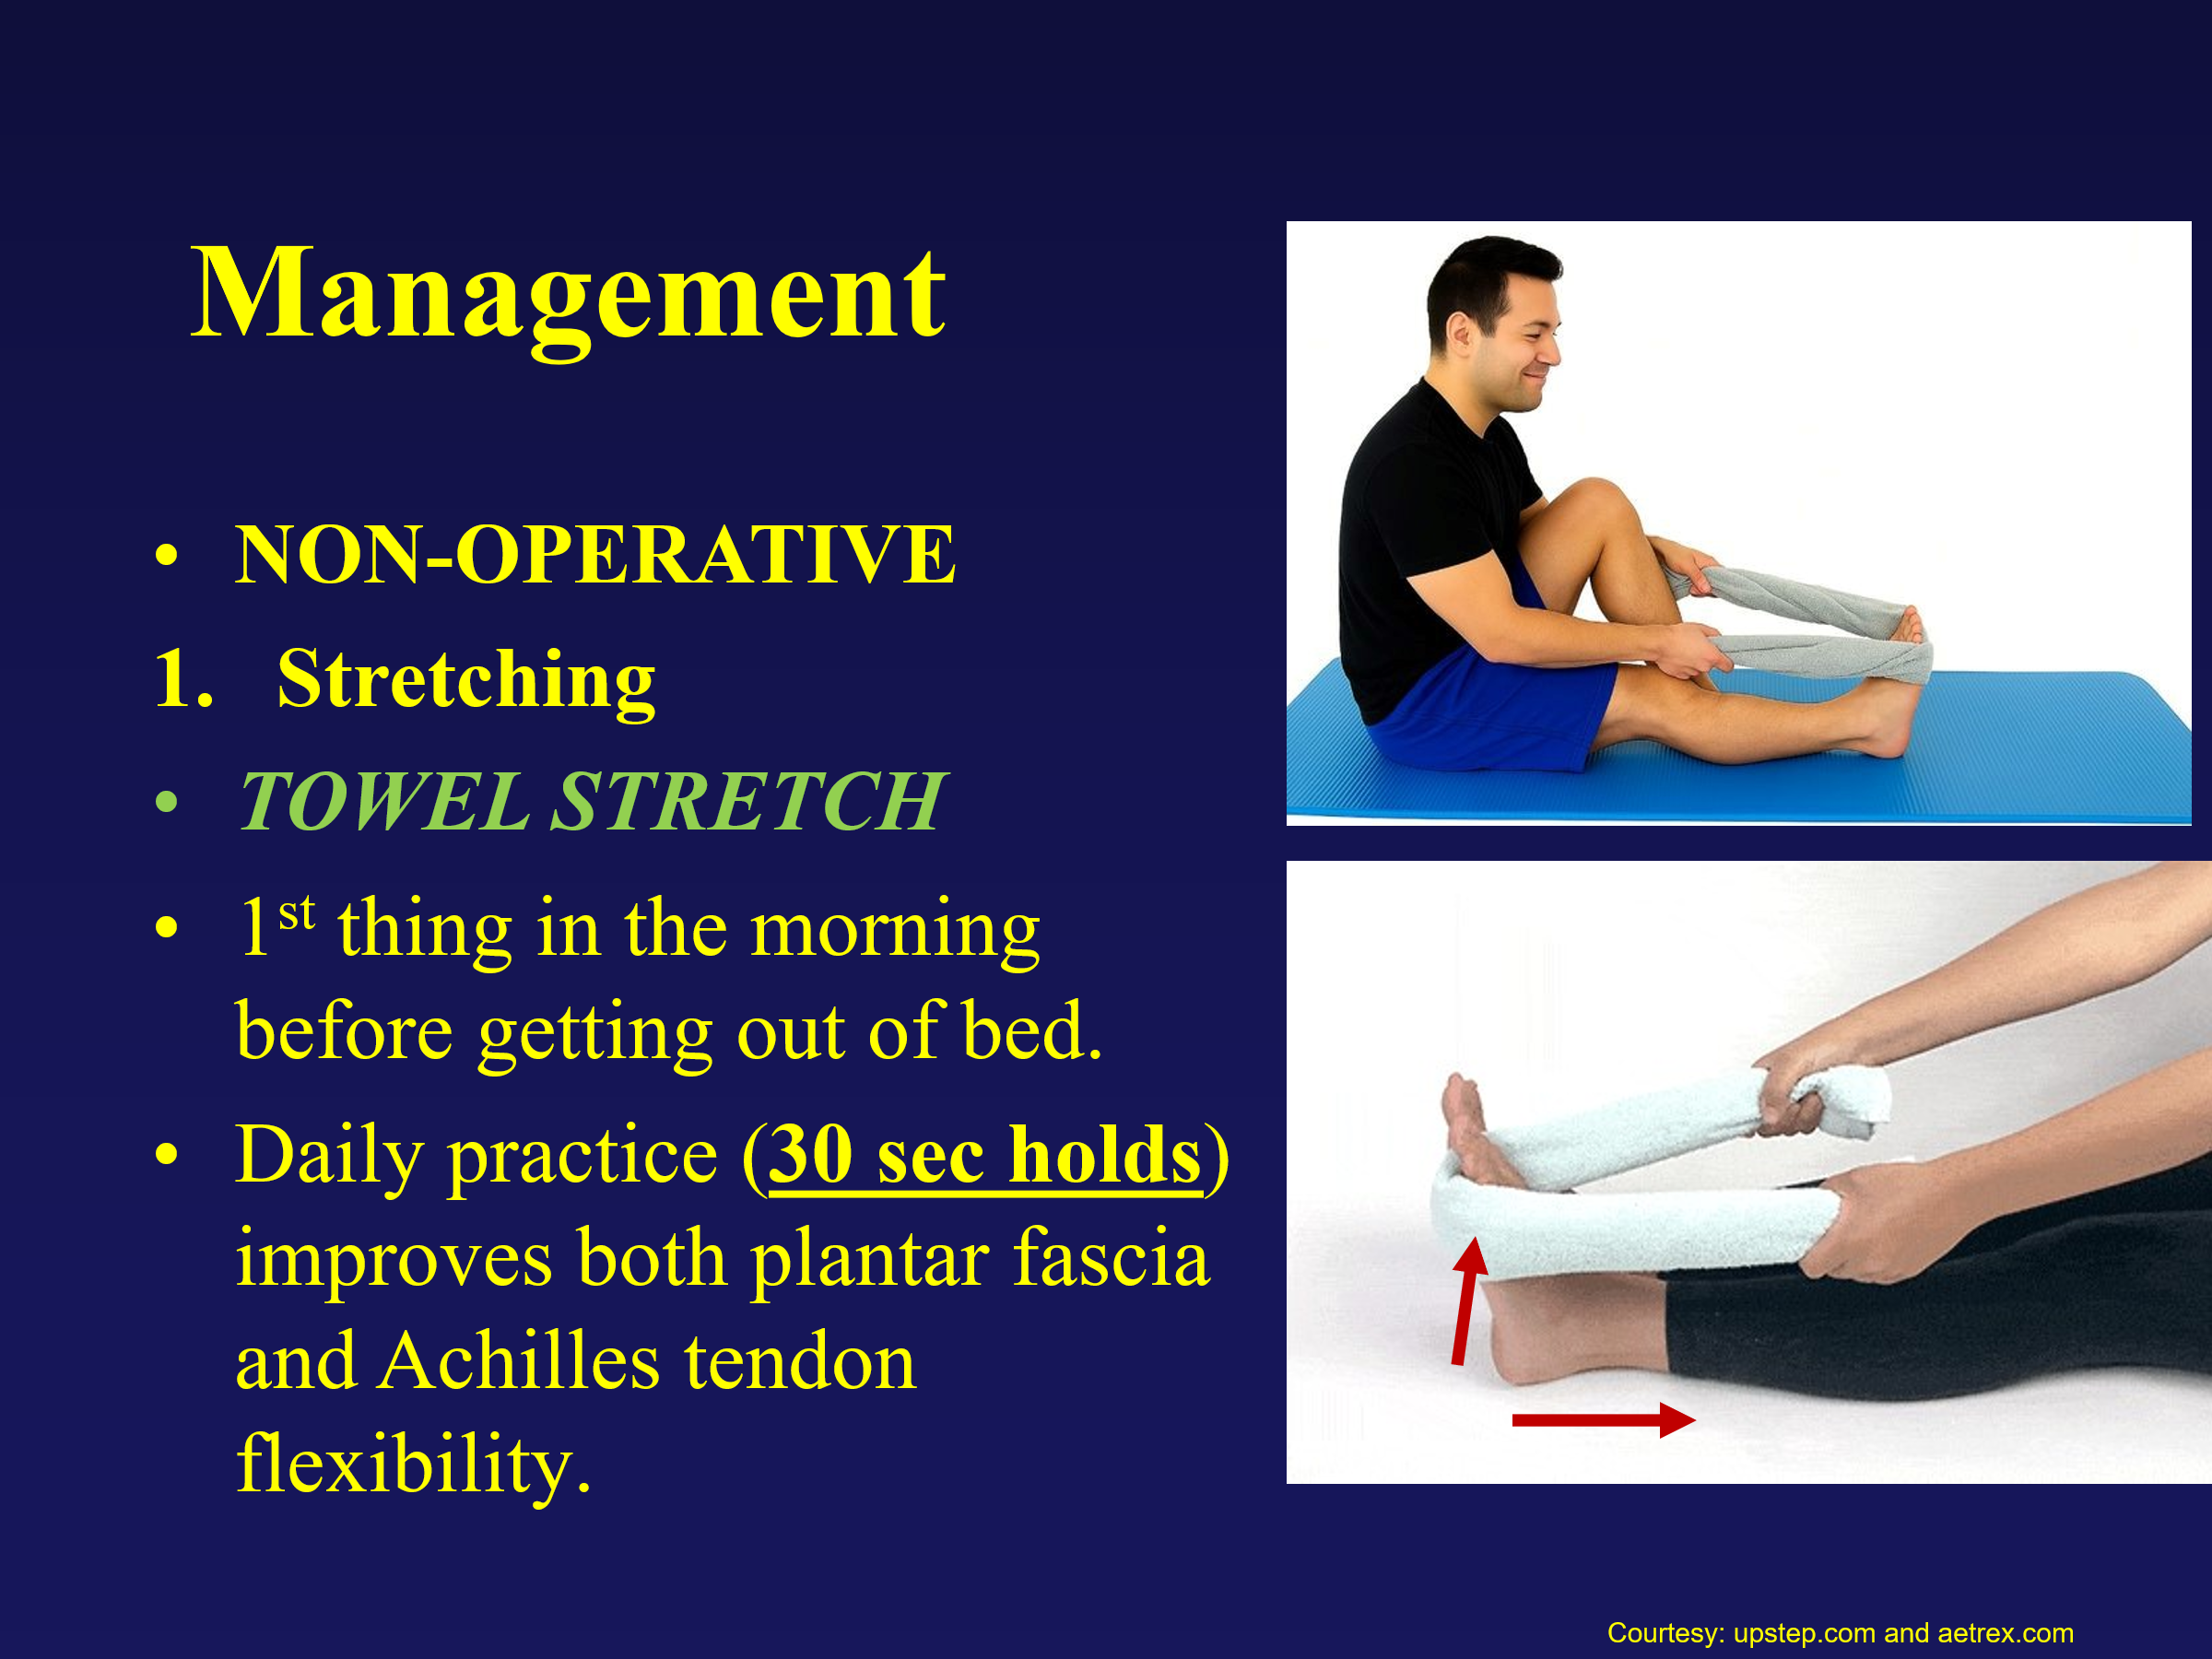
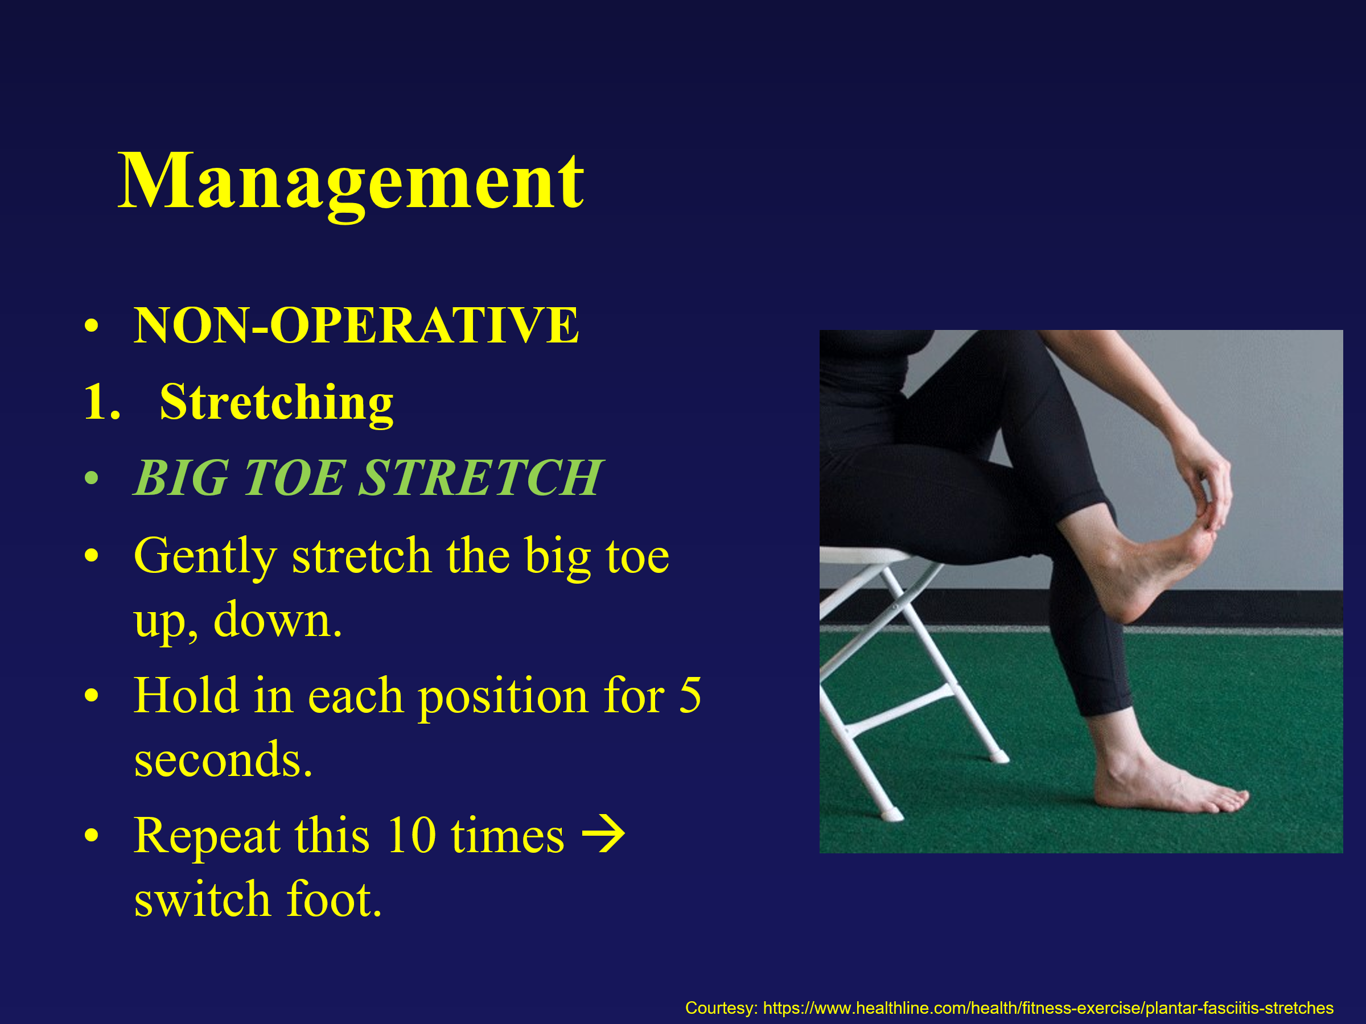

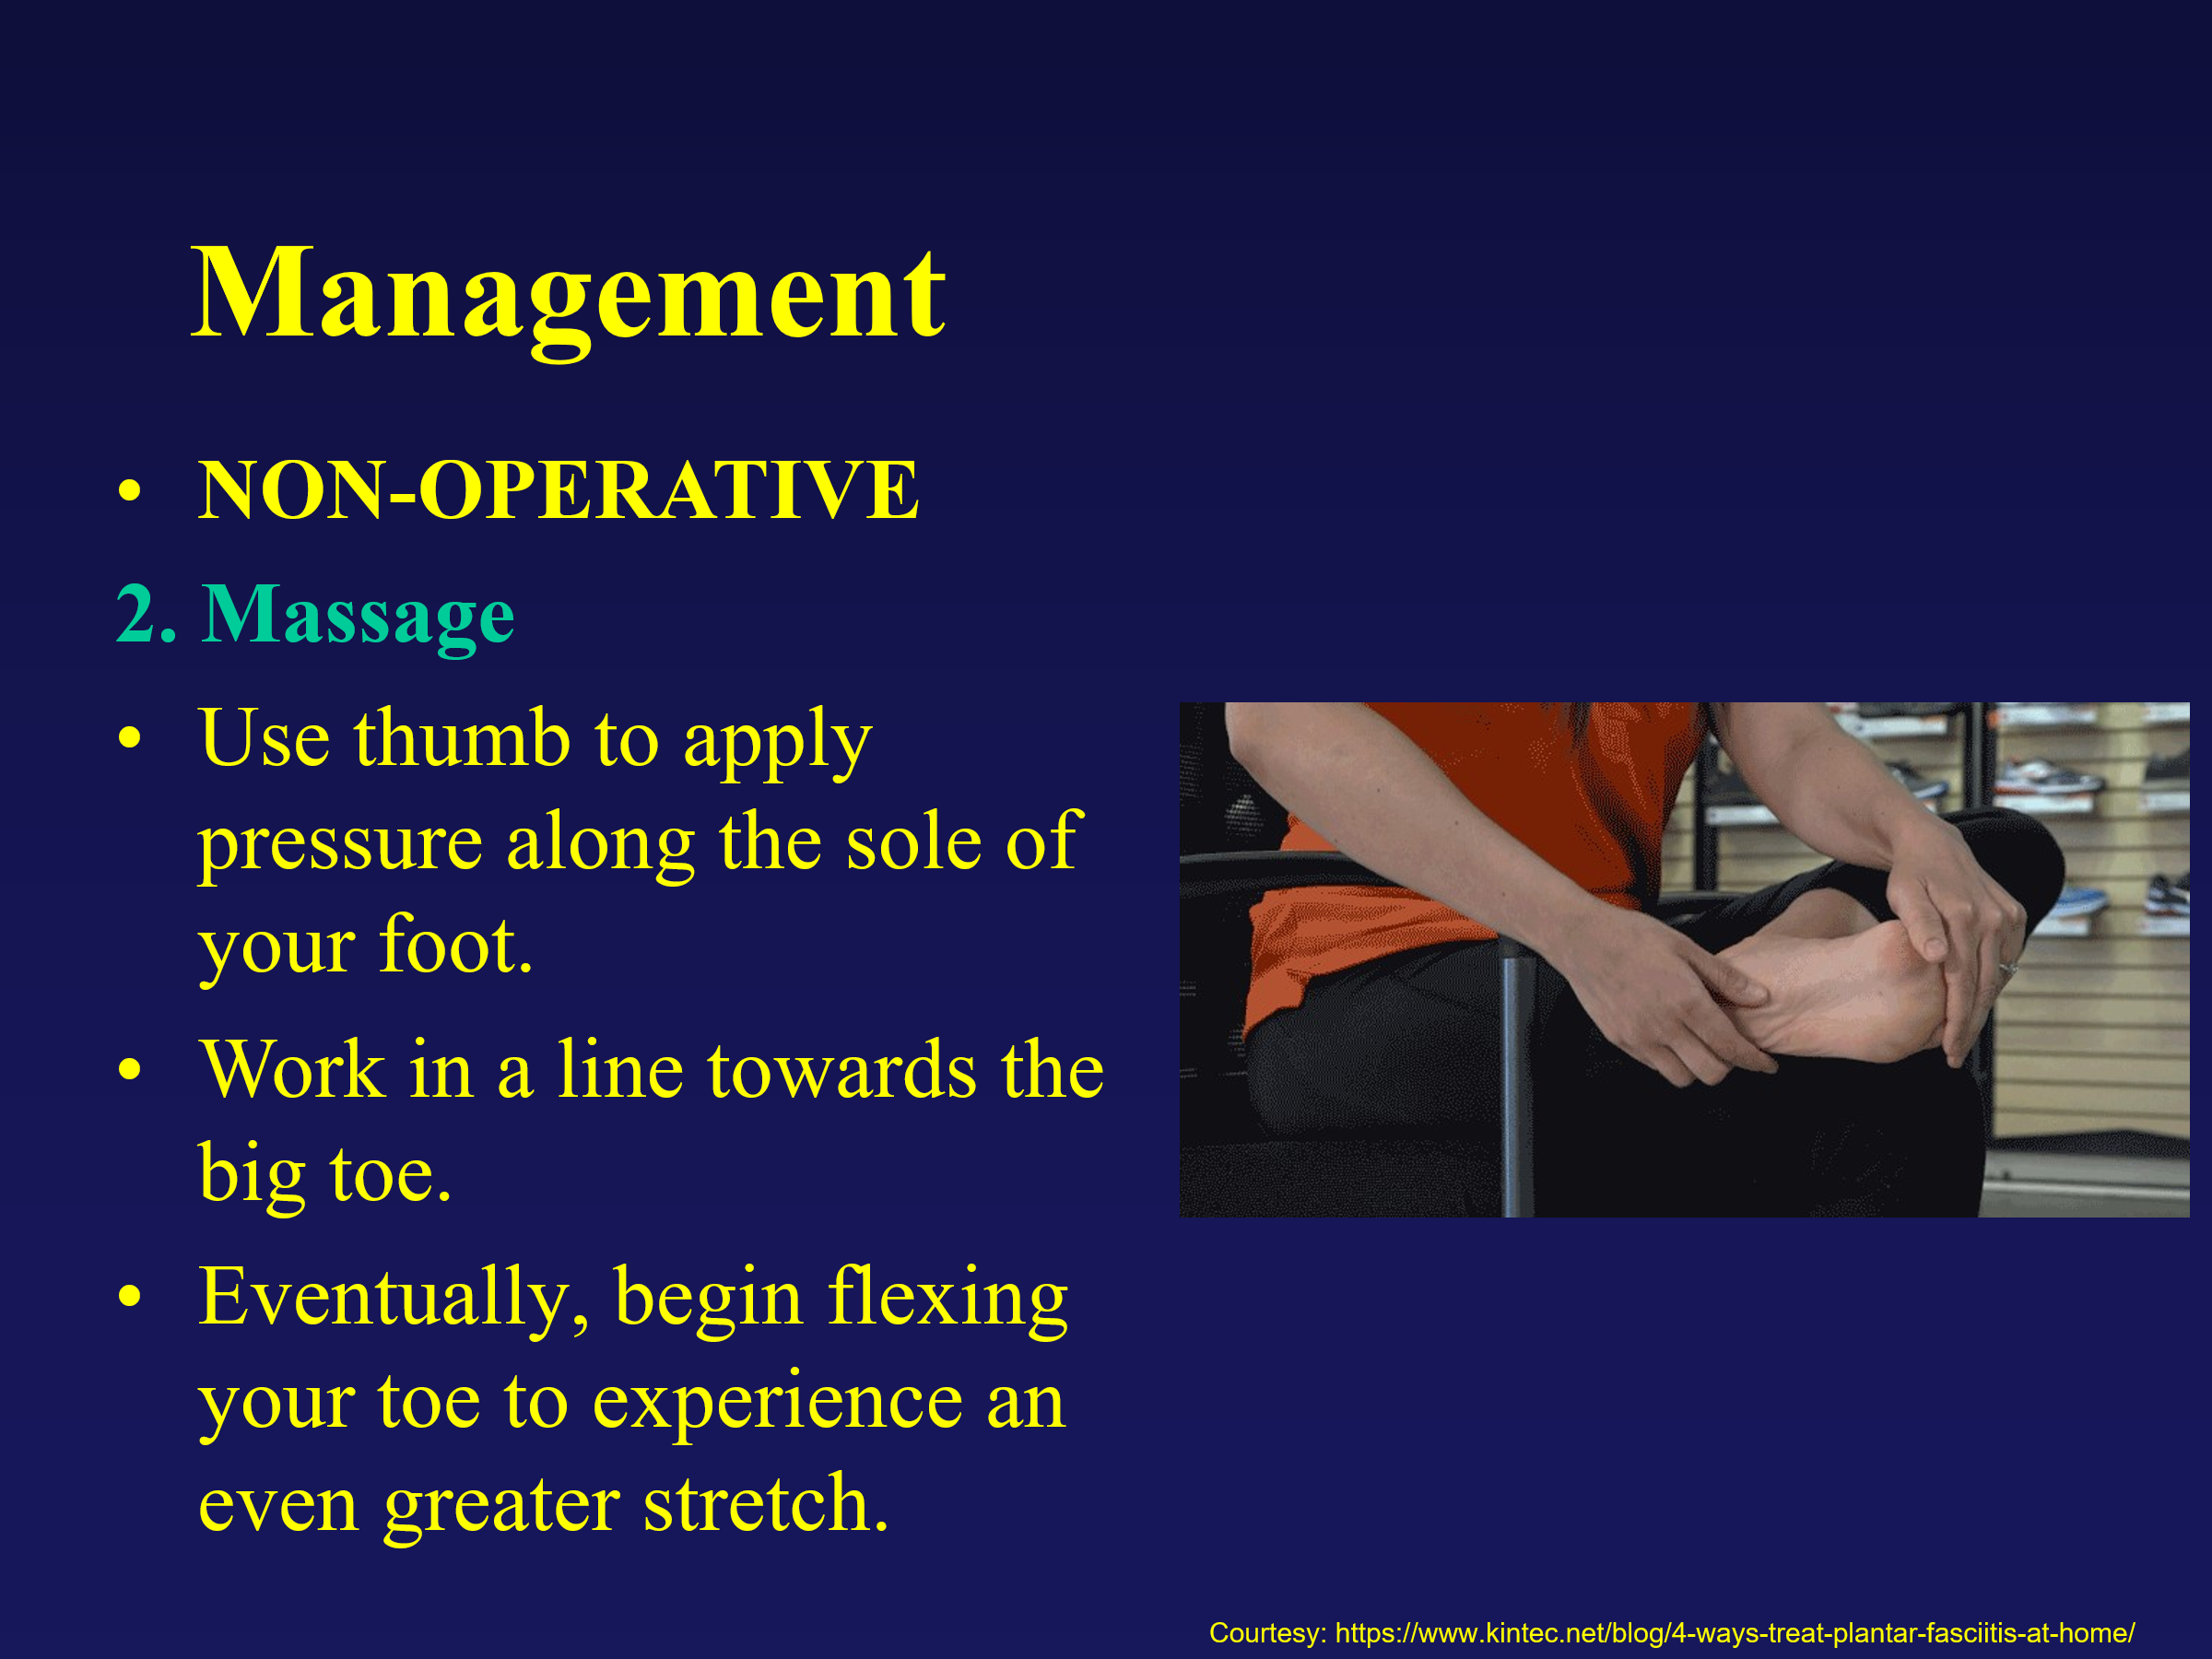

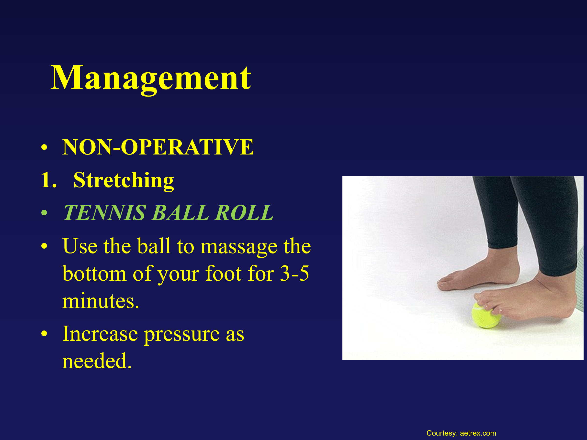

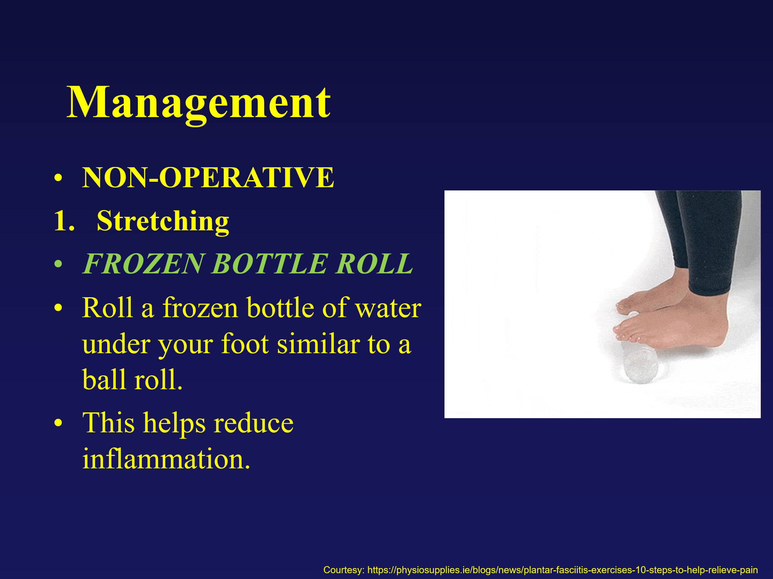

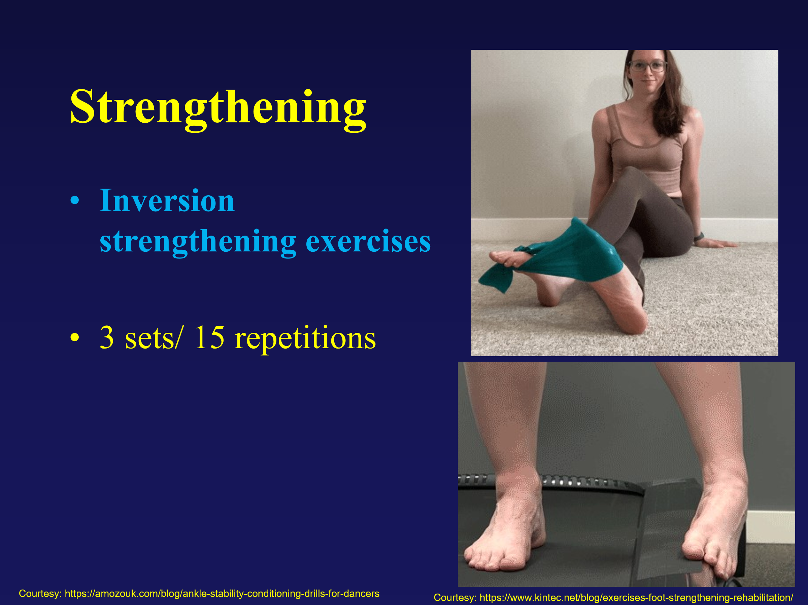

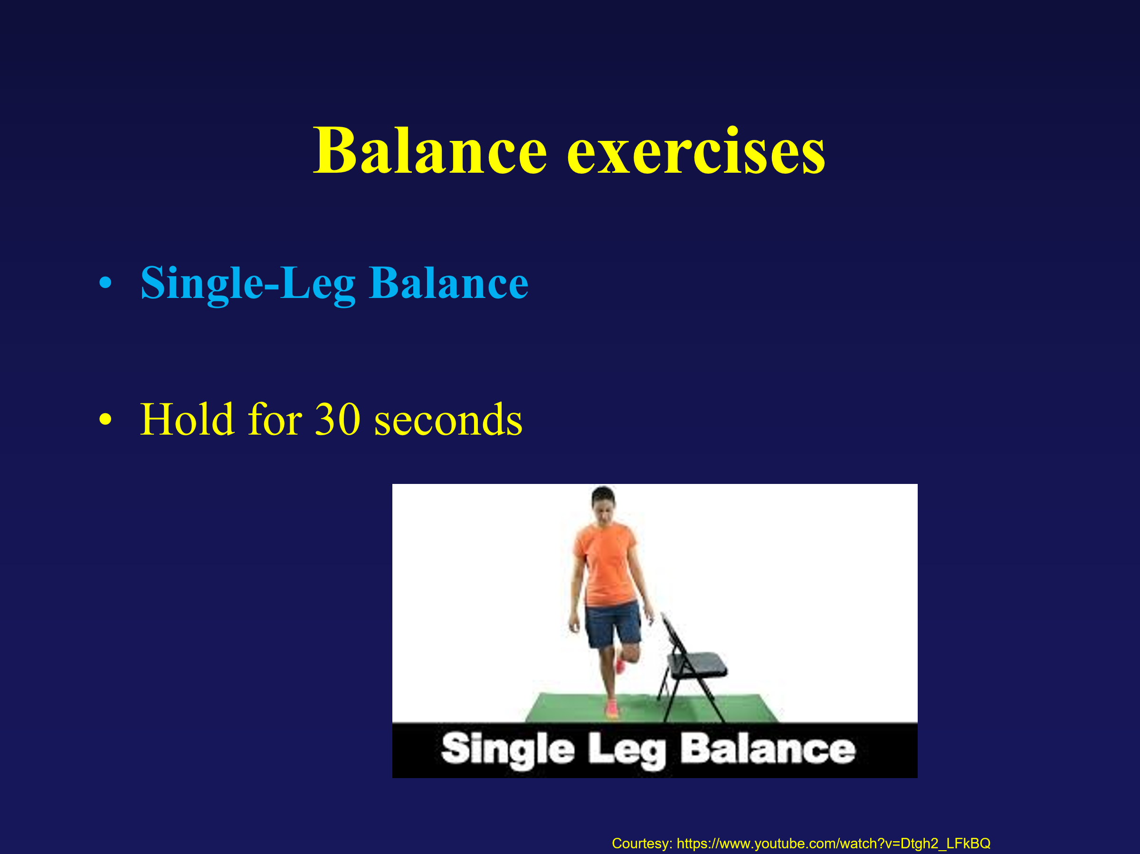

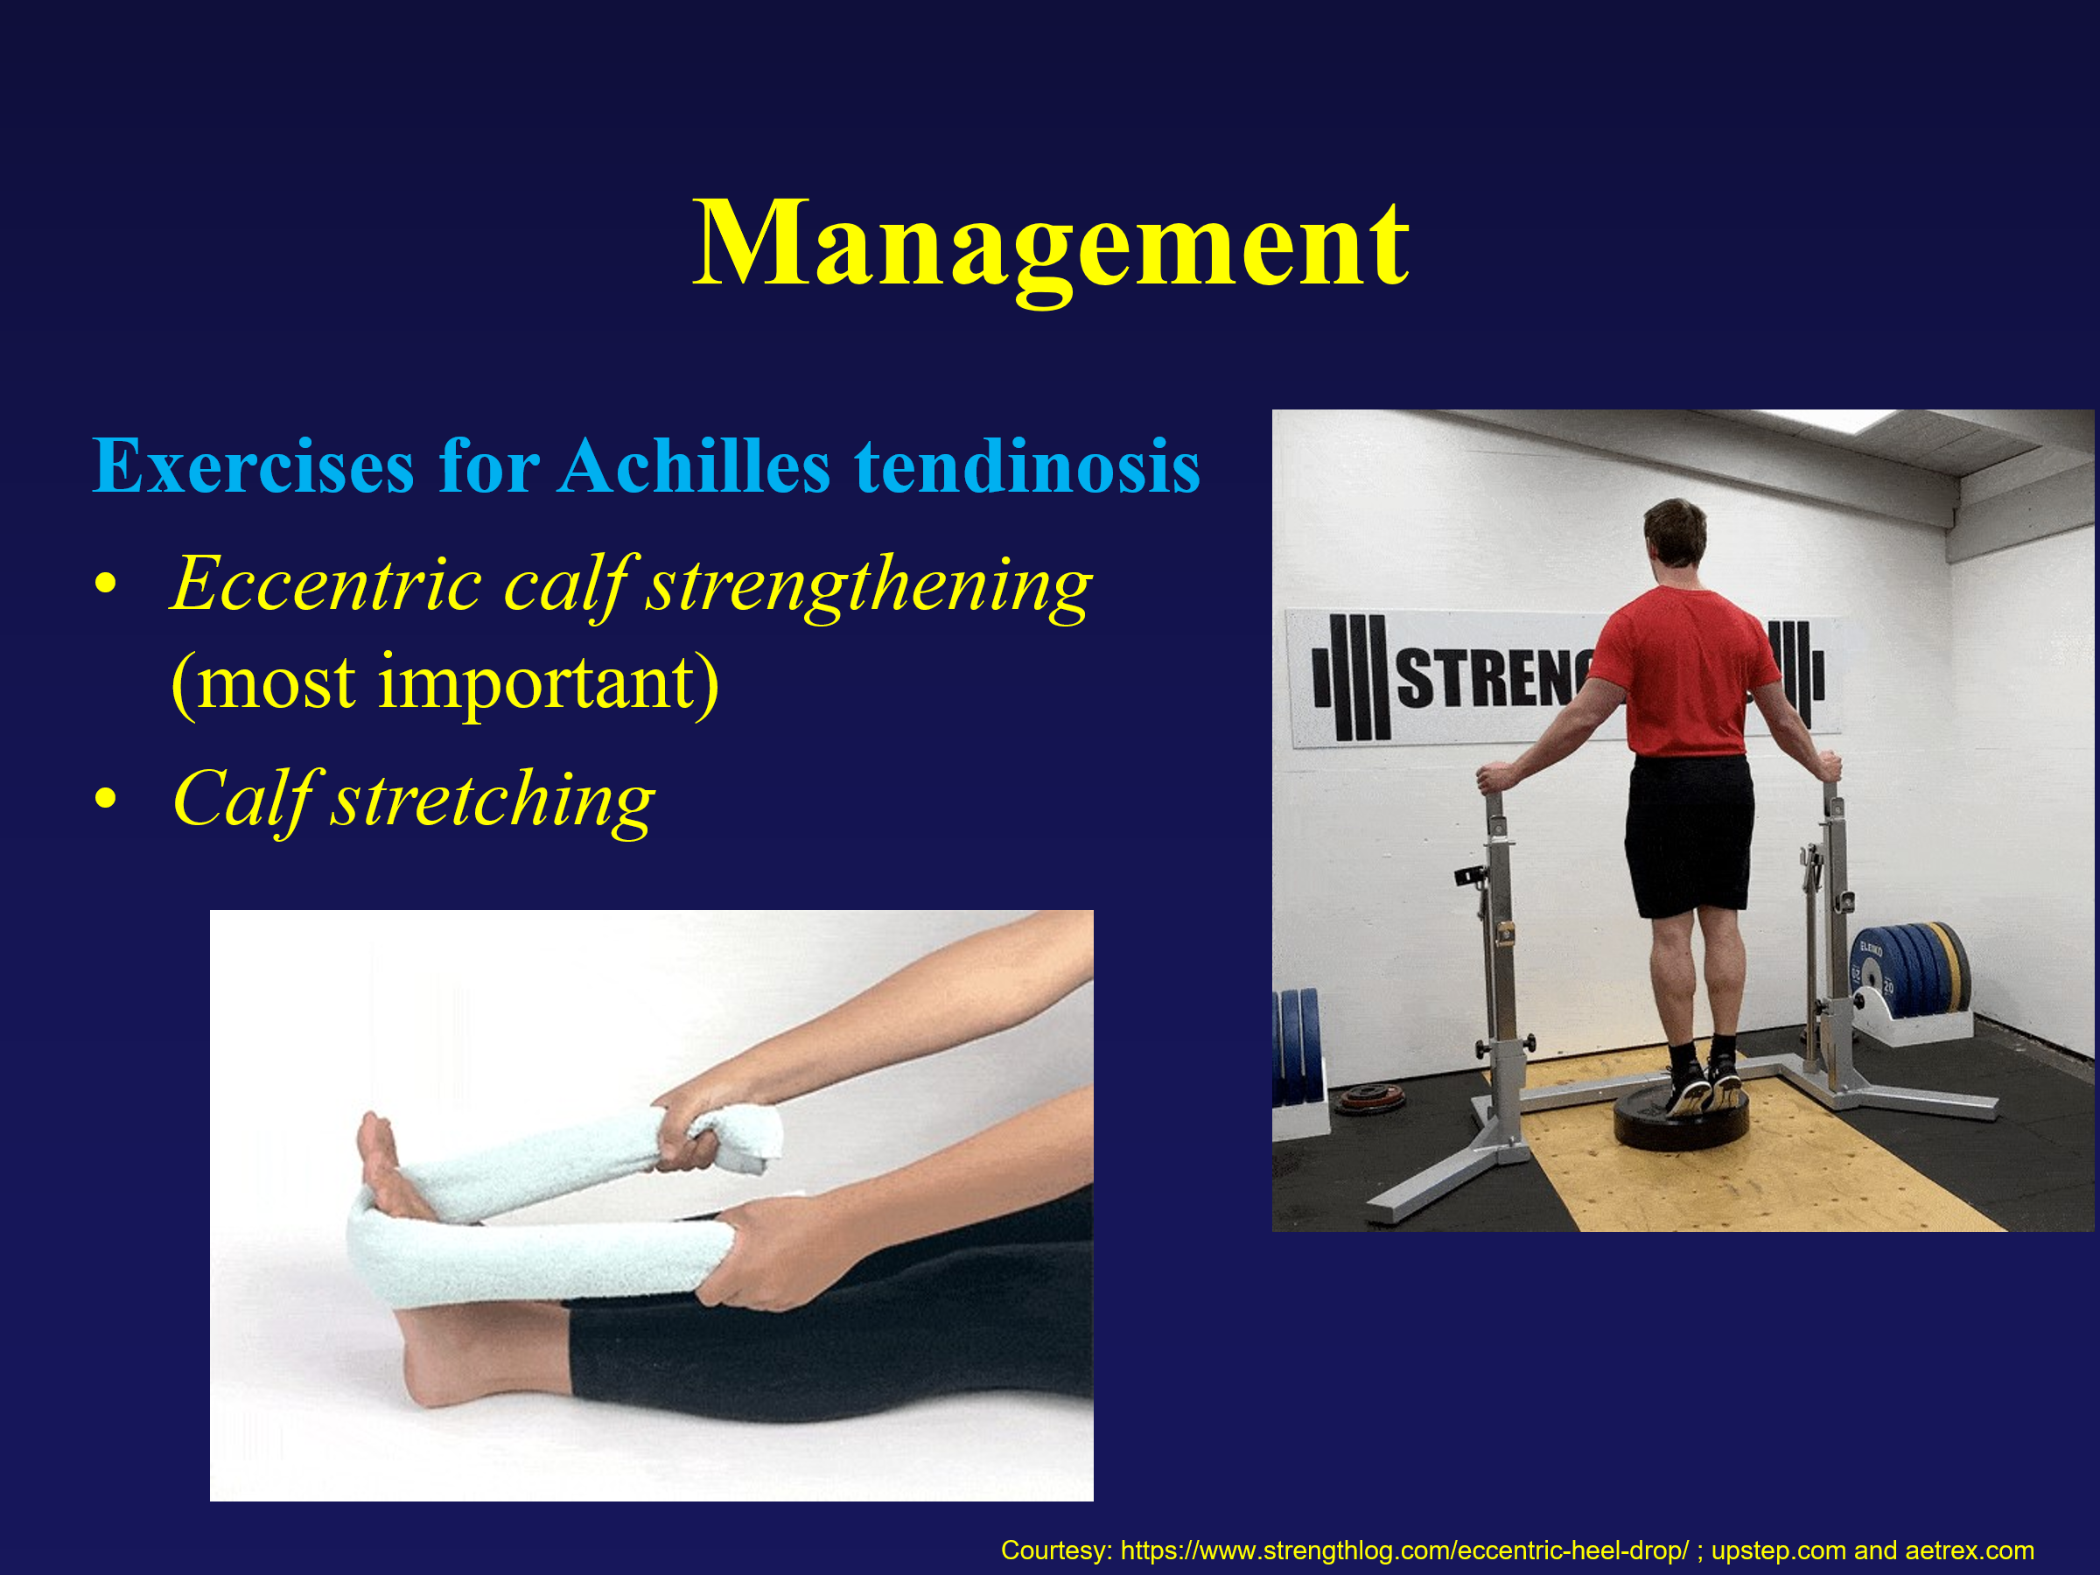

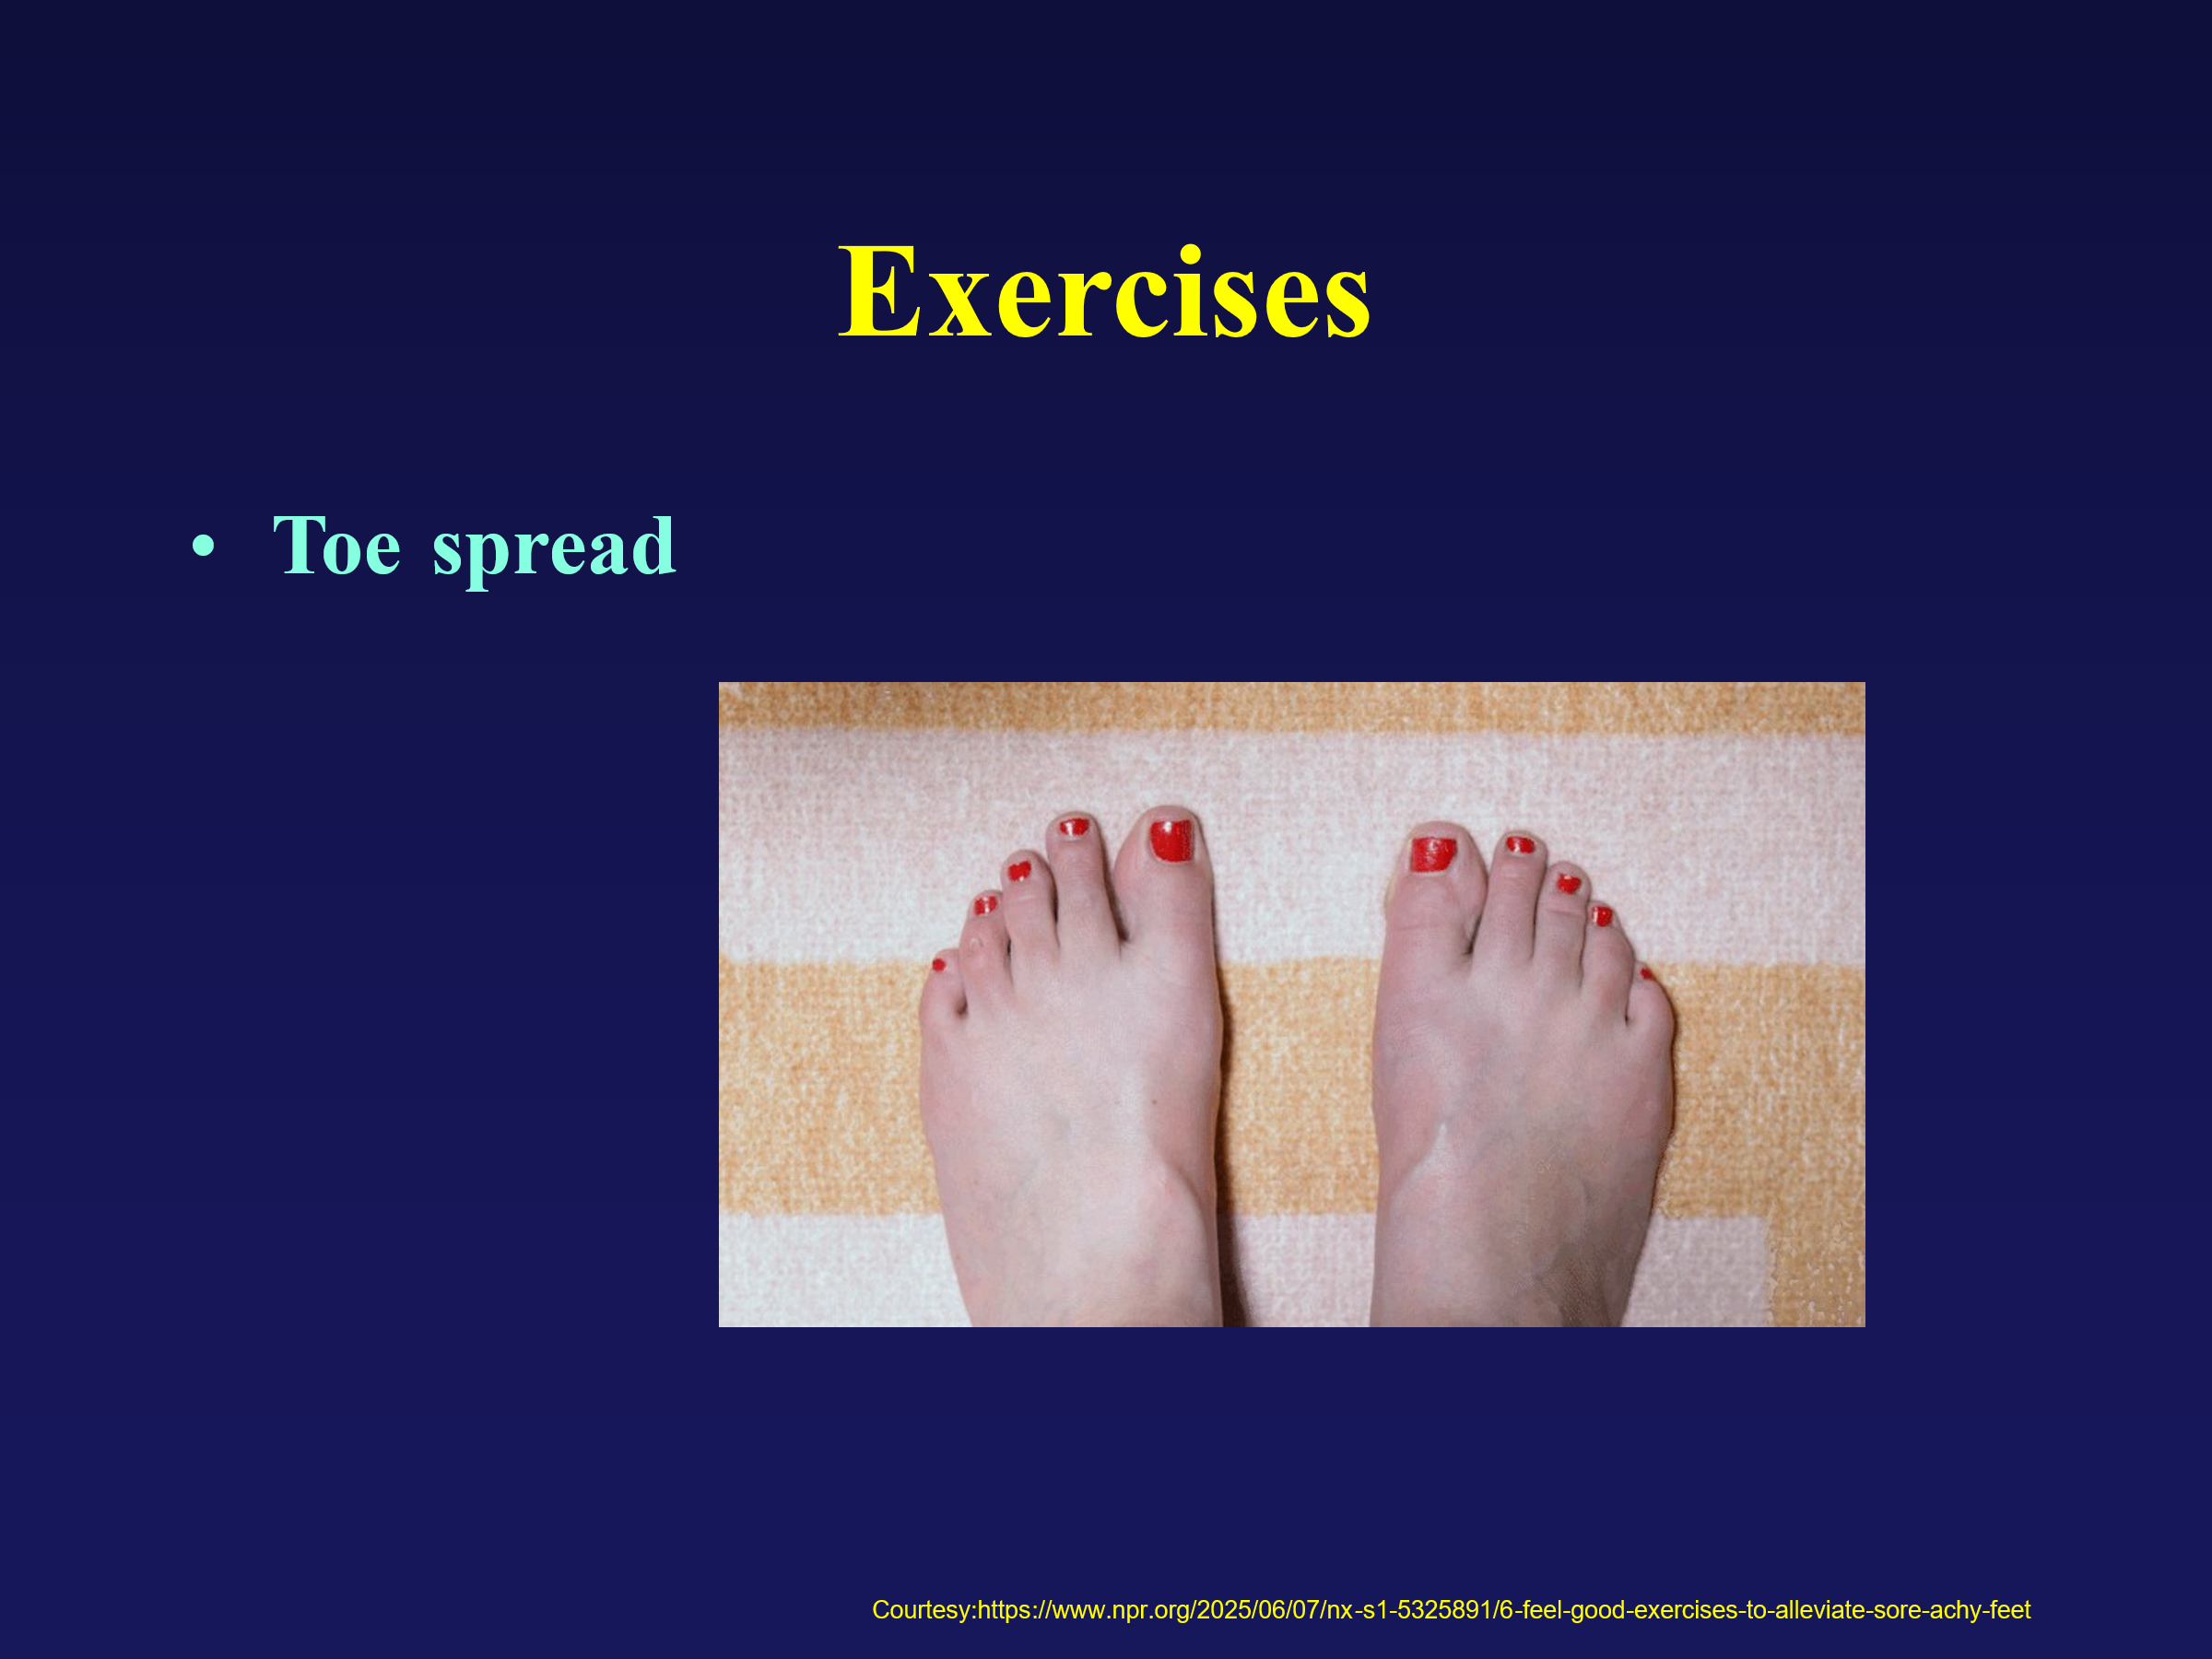

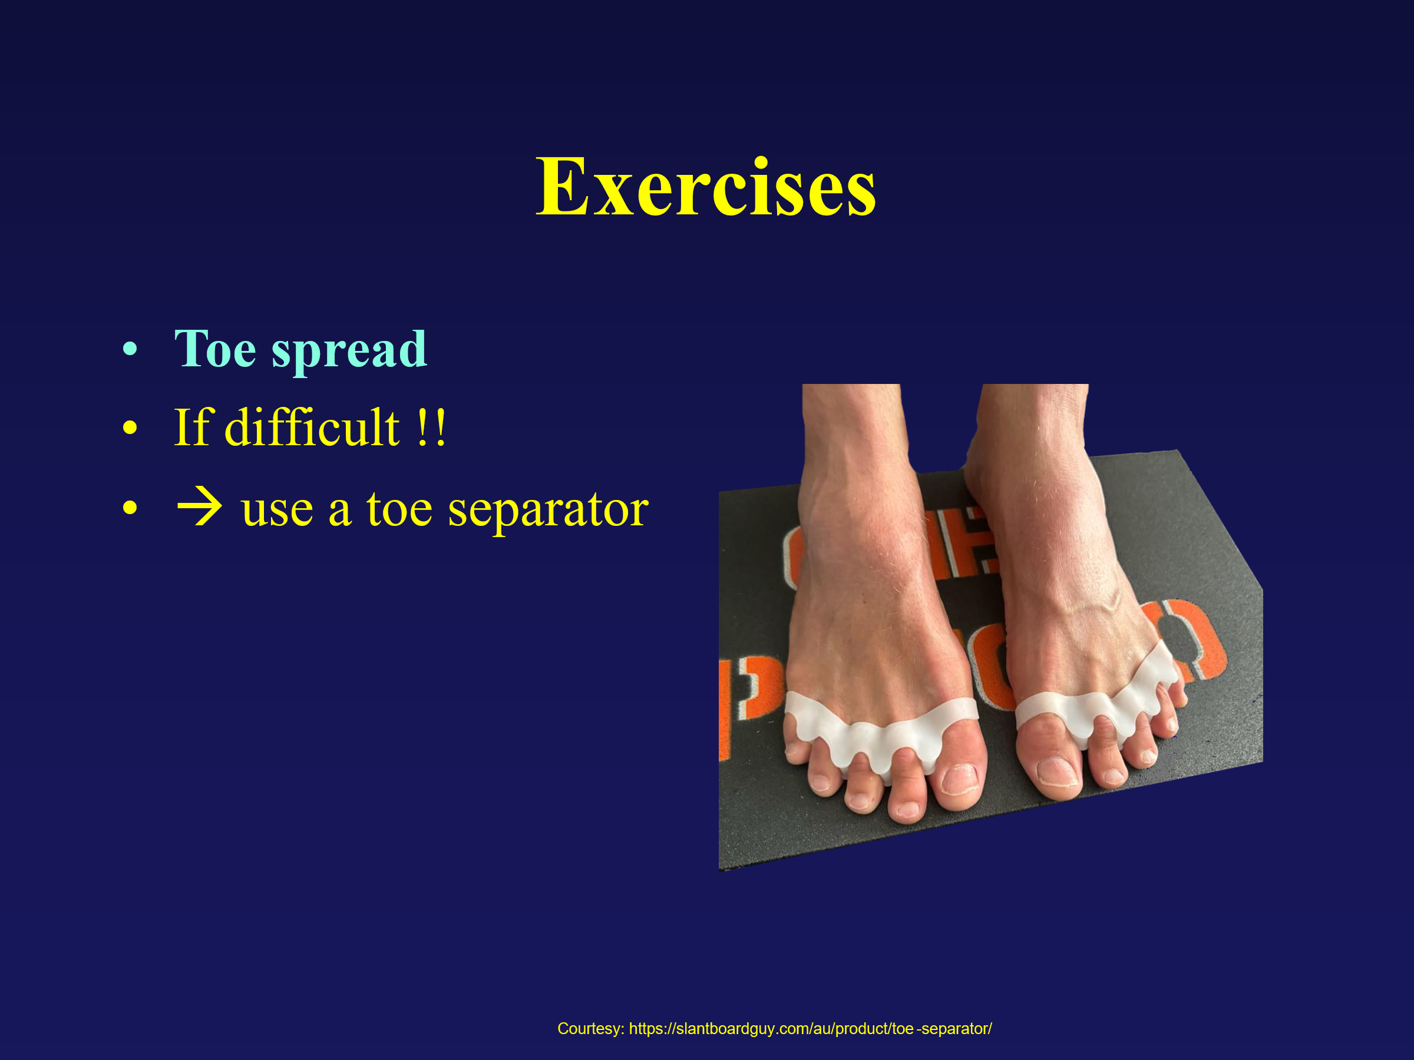

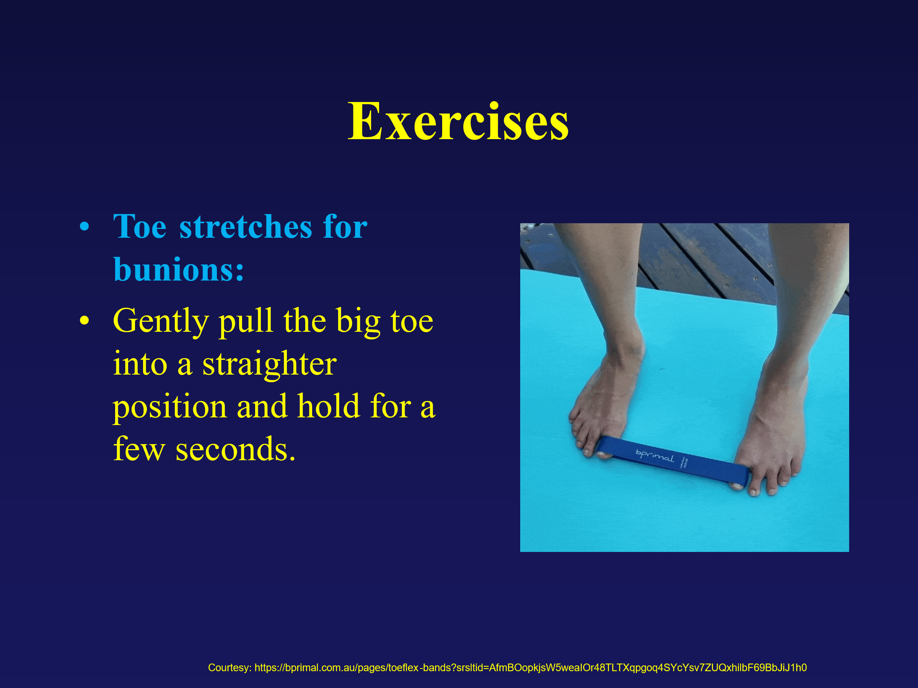

Plantar fasciitis:
- Most common cause of heel pain (especially age 40-60)
- Classic symptom: first-step morning pain
- Risk factors: obesity, tight calf, prolonged standing, poor footwear
- Treatment is mainly non-operative – stretching + orthotics + activity modification
- Surgery is rare
Flatfoot:
- Very common and often normal anatomical variant
- Treat only if symptomatic (pain, swelling, functional limitation)
- Flexible flatfoot ≠ disease; rigid or adult-acquired needs attention
- Management = support (orthotics) + strengthening + proper footwear
- Painful adult-onset flatfoot → think posterior tibial tendon dysfunction
Ankle sprain
- Most common inversion injury (ATFL)
- Differentiate low vs high ankle sprain (high = more serious, slower recovery)
- Early management = RICE (rest, ice, compression, elevation) + protected mobilization
- Rehab (strength + balance) is key to prevent chronic instability

Achilles tendinitis/tendinosis
- Tendinitis = acute inflammation
- Tendinosis = chronic degeneration
- Key symptom: pain + morning stiffness at back of heel
- Treatment differs →
  - Tendinitis: rest + anti-inflammatories
  - Tendinosis: eccentric strengthening
- Persistent pain → don’t ignore (↑ risk of rupture if untreated)

Bunion (Hallux Valgus)
- Progressive deformity: big toe drifts inward, bump forms outward
- More common in women: strong genetic + footwear component
- Symptoms driven by pressure from tight/narrow shoes
- Non-op care = wide shows, padding, orthotics (symptom control only)
- Surgery only if painful and functionally limiting – not cosmetic

