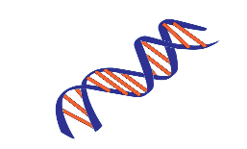HDI Laboratory, UNMC
This Photo by Unknown Author is licensed under CC BY-SA
Tissue Identification/Verification Testing

University of Nebraska Medical Center
Jesse Cox; ECI 6004
601 South Saddle Creek Road
Omaha, NE 68106

RESULTS CONTACT | INVOICE/BILLING CONTACT | Sample return address
Name of requestor: | Name: | Name:
Hospital/clinic: | Hospital/clinic: | Hospital/clinic:
Address to send report: | Address: | Address:
Phone number: | Phone Number: | Phone Number:
Email: | Email: | Email:

Instructions regarding testing/comparisons:

Questioned Samples:
Sample Name | Tissue/Source | Preserve or Consume sample?

Known/Reference Samples:
Sample Name | Tissue/Source | Preserve or Consume sample?

If you have any questions, please contact the lab at (402) 559-7220. Thank you!

