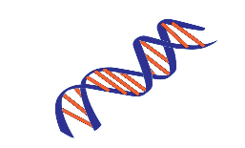HDI Laboratory, UNMC
This Photo by Unknown Author is licensed under CC BY-SA
Tissue Identification/ verification Testing

University of Nebraska Medical Center
Jesse Cox; ECI 6004
601 South Saddlecreek Road
Omaha, NE 68106

RESULTS CONTACT | INVOICE/BILLING CONTACT
Name of requestor: | Name:
Address to send report: | Address:
Phone number: | Phone Number:
Email: | Email:

Instructions regarding testing/ comparisons:

Questioned Samples:
Sample Name | Tissue/Source | Preserve or Consume sample?

Known/ Reference Samples:
Sample Name | Tissue/Source | Preserve or Consume sample?

If you have any questions, please contact the lab at (402) 559-7220. Thank you!

