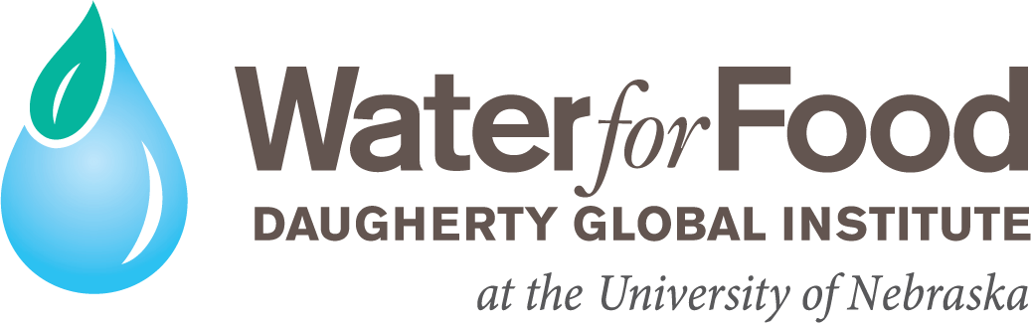

Claire M. Hubbard Water, Climate and Health Fellowships Request for Applications – FY 24

All applications must be electronically uploaded as a single PDF document to this website.

Application deadline: January 26, 2024 Start date: July 1, 2024 – January 1, 2025

Scope: Multiple awards up to $17,500 each will be awarded to support graduate students, either Master's or Ph.D., for FY 2024-2025, with the requirement that these funds are to be matched one to one by funds secured by the faculty applicant to cover the costs of maintaining a graduate student for a year or more. Faculty will be eligible for the continuation of the award in subsequent years (a potential additional year for Master's students or potential two additional years for Ph.D. students), based upon an annual review of the student's research project and progress towards completion. Awardees may apply for travel grants to present related research papers at national and international meetings, providing the student who is presenting and the abstract have both been accepted (up to $1000 awarded per student annually)

BACKGROUND
Ensuring water and food security for our growing world is an audacious goal - exactly what Bob Daugherty sought to achieve by creating the Daugherty Water for Food Global Institute (DWFI) at the University of Nebraska in 2010.

DWFI is committed to advancing its focus on water and public health. New this year, the Institute will support the Claire M. Hubbard Water, Climate and Health Fellowships for students researching topics that address the nexus of water and health. Special consideration will be given to applications that deal with issues focusing on Nebraska. This initiative supports the Institute’s focus area of “supporting freshwater and agricultural ecosystems and public health.”

Potential research topics of interest to the Institute include, but are not limited to:
  - Link between water quality and pediatric cancer or birth defects
  - Health outcomes related to flooding or drought
  - Mapping of at-risk populations and environmental exposures
  - The impact of technology, such as precision application of nitrogen fertilizer, on soil and water quality

¹ Note: A Master’s student who wants to become a Ph.D. student can receive a third year of funding under the same project. Faculty may request this change in the annual report. However, no student can be funded for more than 3 years ($52,500). Students cannot be funded on two consecutive projects.

ELIGIBILITY
University of Nebraska faculty who are not currently receiving graduate student or postdoctoral scholar support from DWFI are eligible to submit applications for Master’s and Ph.D. student support in response to this call.

REVIEW PROCESS
Proposals will be reviewed by a panel of experts including global and distinguished fellows, emeritus faculty fellows, donors, university administrators, and others (as needed) with expertise in the institute’s focus areas along with a clear understanding of the institute’s mission. The panel will prioritize applications for funding based upon their potential to result in contributions to, and measurable outcomes addressing topics related to water and health. Final selections will be reviewed by the DWFI leadership team.

EXPECTATIONS
Successfully funded applications will require faculty advisors and students to meet several expectations, including the following:
- Recipients are expected to participate in an annual spring research forum.
- Recipients are expected to demonstrate impact by:
  - Sharing their research at professional conferences and events.
  - Sharing their research in refereed journals and publications and acknowledging DWFI funding. (resources available at: https://waterforfood.nebraska.edu/our-work/education/student- support/student-support-resources)
- An annual report is due May 15th, 202. This report should include:
  - a summary of all relevant research activities, partners, participants, and outcomes, along with any variances or deviations from the project proposal;
  - results of the project from inception to date;
  - an assessment of the project's success to date;
    - a description of how close the student is to completing his/her degree program;
    - SAP summary and financial detail report. If you expect to have a balance remaining from the current year of support, please describe how you will spend those monies towards the completion of the student degree and the project objectives during the following year.
- If applicable (and in most years), you may include a request for an additional year of student support funds as part of this report. Confirmation of this will be sent in the spring. Otherwise a final report is required and due to the institute no later than one month following the conclusion of funding. Final payment will be contingent on the submittal of the report.

FUNDING LIMITATIONS
Funds may be used for wages and salaries of graduate students and travel that is directly related to the project. Funds may not be used for any of the following purposes:
- Purchasing equipment;
- To replace current funding;
- Items for purposes not exclusive to the project, such as desktops or laptop computers, printers, software and related accessories and general office supplies.

PROPOSAL SUBMISSION INSTRUCTIONS AND APPLICATION FORMAT:
Go to https://waterforfood.nebraska.edu/ems-registration?EMSEventUUID=4df2c406-5204-4c02-ae64-bb1ff0a5ccb0 :
- Enter title page information using the online form

- Upload proposal information as a single PDF document

Title Page Information: (entered online, required for submission)
- Faculty Advisor – Name and Contact Information and 2-page NSF style CV
- Project Title
- Student Name and CV or resume (if student has been identified)
- Total Request Amount ($)
- Matching Fund Amount ($) - given the requested award amount, show the source of the matching funds and their availability. A one to one match of institute funds is required. Questions on allowable match sources can be directed to Christine Allmon Vetro (callmon@unmc.edu) or Rachael Herpel (rherpel@nebraska.edu).

Application Information: The formats for both applications are limited to three single-spaced pages. A brief outline is below. Please upload your application as a single PDF document.

  - Project Title
  - Project Description: Describe the research and clearly state its relevance to the institute's mission, focus areas and outcome targets. The project description should include goals and objectives, a timeline, and deliverables.
  - Anticipated Impacts: Describe how impacts from this project tie in directly to the institute's target outcomes. Projects that clearly address how this research intentionally works towards changes in behavior and condition, rather than just knowledge, will be rated higher.
  - Project Status: Specify if the research project is on-going or new. If on-going, list recent publications, presentations, etc.
  - Student Status: Specify whether the student is current or new. If current, describe the student's graduate work to date and submit the student's resume. If new, describe the process by which the student will be recruited and/or gain admission to the University of Nebraska.
  - Project Budget: The award amount ceiling has been set at $17,500 per year. In addition to providing a detailed budget narrative, please specify the source and amount of all matching funds. A one-to-one match of institute funds is required. To date matching funds have generally included grant funds and department funds (i.e., graduate/teaching assistant funds), but may also include other student awards and stipends.
  - Anticipated Start Date: specify Fall 2024 or Spring 2025

If you have questions about the application process, please contact Christine Allmon Vetro (callmon@unmc.edu) or Rachael Herpel (rherpel@nebraska.edu).

