Box.com Cloud Data Storage – Enterprise User
Welcome to Box! Here are some brief instructions for getting started with your account.
There are two types of users on UNMC Box environment. It is very IMPORTANT to identify yourself based on the information provided below.
UNMC Box Enterprise User: These users are provisioned by Research IT Office (RITO).
Any UNMC email account holder can purchase an Enterprise Box account, however, these accounts are intended for storing large amounts of data and the requesting person should be an approved custodian of the data to be stored.
In case if you don’t have Enterprise paid account and want to open a paid Box account, make a request from RITO (rito@unmc.edu) to create an UNMC Enterprise account for a monthly fee (provide cost center while making a request, visit RITO web site for fee details).

Enterprise User accounts (Setup through RITO)
When RITO receives a request to create paid Enterprise Box account from you, RITO will create your account in Box UNMC Enterprise environment and will integrate your UNMC Login NetID and Password with Box account.
Log in to https://unmcresearch.app.box.com/ with your UNMC NetID and password. Please see section 2.1 below for visual instructions with screenshots.
- Once logged in, the Enterprise User has the option to create folders for collaborators and share those folders with them.
- Sharing folders and files requires that your collaborators have an existing a Box account.
- To share data, you must first request from your collaborator for their Box account ID, which is the email address of record for the account. These will be person.name@unmc.edu for collaborations with other Enterprise Users but may be Gmail/Hotmail/etc. or other organization’s email addresses for external collaborators.
- Share folders with collaborators using the “Invite Collaborators” function, and specifying the pre-existing Box IDs of the collaborators when prompted. Enterprise Users MUST NOT invite new collaborators to their data BEFORE the collaborator has established their own Box account (Individual or UNMC Enterprise account). Otherwise, the new collaborators are created automatically by Box as Enterprise users for which you will be expected to pay.
- All data and folders created by an Enterprise User in her/his own account are stored in compliance with HIPAA, but you must share data in accordance with your IRB and other regulating entities and policies.
- The Enterprise User is responsible for managing the collaborators and sharing settings on their data. Similarly, they are also responsible for removing collaborators that leave their organization, or for any other situation where a collaborator should no longer access the data.

Visual Logon Instructions

2.1. Visual instructions for Enterprise Box User logons
If you requested RITO to upgrade an existing Individual Box account (that is registered to a UNMC email address) to a UNMC Enterprise account, then you will receive an email invitation from Box. Upon clicking the link from the email, you will be prompted to login, and you must login to the Individual account (see section 2.2) in order to perform the upgrade – use that account’s password reset function if you cannot remember the password. After the upgrade has completed your account is a UNMC Enterprise Account and you must use the instructions in this section for subsequent logons.
Please visit https://unmcresearch.app.box.com/ to begin the log on process. Click the blue “Continue” button (circled in RED) on the first page:
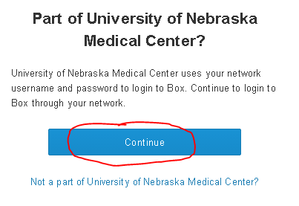
Enter your UNMC NetID and password to login.
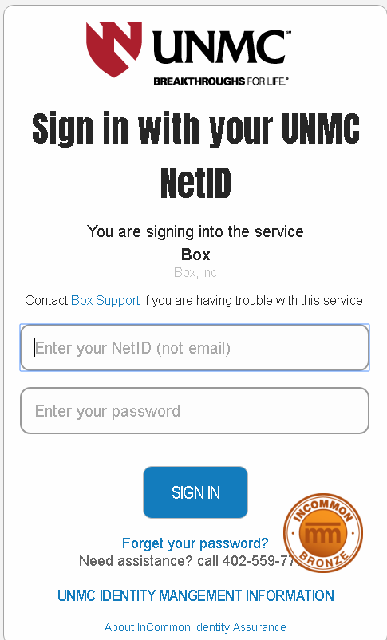
If you are unable to log in, please see information below before calling the ITS Help Desk at 402-559-7700.
Before reporting a log on problem, please check if you are able to log in to other UNMC services that use the campus “Single Sign-On” (SSO) and tell the help desk if that does or does not work. Some examples are: Blackboard (https://my.unmc.edu), Campus Records (https://net.unmc.edu/care), and REDCap (https://unmcredcap.unmc.edu). To reset your campus password, visit (https://net.unmc.edu/netid/).

