Box.com Cloud Data Storage – Personal Account
Welcome to UNMC Box! Here are some brief instructions for getting started with your account.
Collaborator: If you didn't make a request to RITO to create a paid UNMC Enterprise account, then you are not an UNMC Enterprise account holder. Typically, this group includes lab members, internal and external researchers, research coordinators, administrative staff and sometimes industry research partners.
To get started, go to Box.com to sign up for a free Individual Box account (follow instructions below). These accounts are created by UNMC and non-UNMC users without the involvement of RITO and it comes with 10 GB of personal Box storage space. Establishing an Individual Box account with Box.com enables you to collaborate with an Enterprise Box user, including storing data in the Enterprise Box user’s storage space. RITO is not responsible for managing your Box Individual account nor your data parked in your personal Box storage space.

Individual Box accounts for lab members and collaborators

Visual Logon Instructions

Visual instructions for Personal (Individual) User logons
Users intending to sign up for free personal Box account, please ignore yellow crossed area, and focus on next section (“Attention free/personal Box users”) and click on “red circle” below to sign up for free personal Box account.
- UNMC staff may use their unmc.edu email address or a personal email address (such as Gmail, Hotmail) as their Box user ID.
- UNMC staff may use any strong password (but not their UNMC password) when creating an Individual Box account. The campus single sign-on service does not work for non-Enterprise Box accounts.
- RITO and ITS are not responsible for the support services on Individual Box accounts. An Enterprise User who is requires support services for his/her collaborators should negotiate a separate service contract with RITO.
- Any data and folders within the individual Box storage space are not HIPAA compliant – you must store PHI directly only into a folder shared to you by an Enterprise Box user.
- Individual accounts are not managed by RITO and we are unable to reset your password or perform any other administrative duties on these accounts.

On the other hand, if you want to sign into your personal Box account, please use “blue circle”,

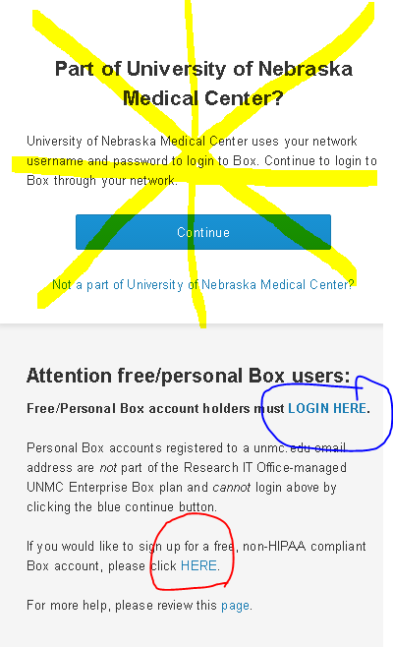

Please visit https://account.box.com/login to log on or click on “blue circle” as shown above. You should see this page where you must enter your Box ID (the account’s email address of record, even if it is a unmc.edu address):
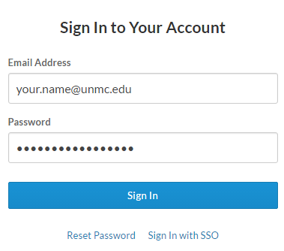

The Individual Box account user should login using the email and password they have previously used to register. If an Individual Box user forgets their password, they may click on the “Reset Password” link, which prompts the Box system to reset your password and notify you. RITO and UNMC ITS are not able to reset passwords for Individual Box accounts because these accounts are not managed by UNMC.

Issues and Solutions
(Issue 1) A new user tries to create an Individual Box account but the system complains, “Email Already Registered.”
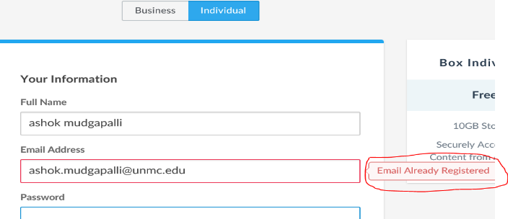

(Solution 1)
- You (or perhaps your staff) may have previously created a Box free Individual account that is registered to the email address in question; or
- Your research partner holding a UNMC Enterprise account may have invited your email address to share data, and you accepted the invitation by clicking a link from the invitation email. Doing so created a Box account registered to that email address.
In either case, you must log in to the existing account or reset the password on the Individual Box account at https://account.box.com/login:
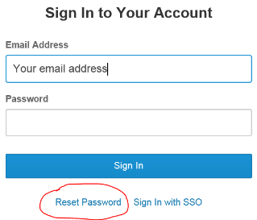
After clicking the Reset Password link, you will be emailed a temporary password for logging into the Individual Box account. Using the temporary password, log into https://account.box.com/login and start using personal Box account.

